Hip-Hop Producer Bkorn Employs RME’s Babyface Pro for Plug ’n Play Capability
The producer and musician also praises the USB audio interface for its pristine sound quality

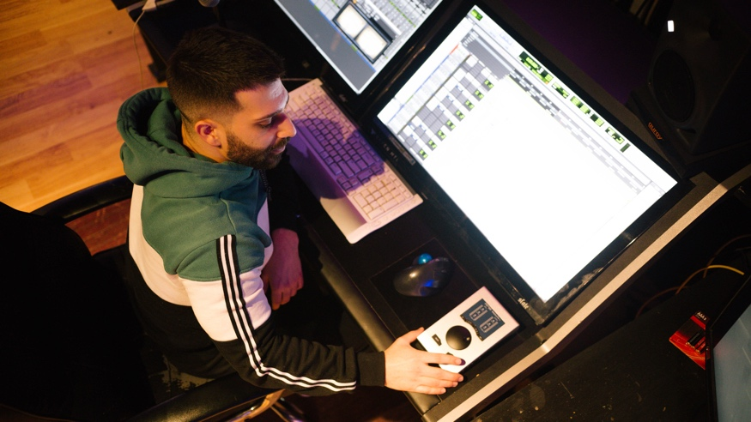
New York, New York, January 19, 2021 — Brandon Korn, known in the industry as Bkorn, started as an intern at Puff Daddy & Bad Boy Record’s recording studio in New York City in 2012 making hip-hop beats and quickly connected with some of the most influential artists in the genre — from DJ Khaled to Chris Brown. In 2020, Korn took on a project with hip-hop/classical fusion artist Ezinma and needed a USB audio interface with high sound quality that could capture the nuances of the classical and hip-hop mashups.
“Since the pandemic started, I can’t go into too many studios anymore, so I really wanted to raise the stakes with my home studio and the Babyface Pro has helped me do just that,” Korn said, adding that he’s a musician himself. “I love being able to plug my guitar into the interface and have a clean signal right from the jump instead of having to finagle it. The Babyface Pro is literally plug and play — you get clean tone and clean levels every time.”
A Studio Must
With production credits on Travis Scott’s Grammy-nominated album ASTROWORLD under his belt, one of Korn’s favorite features of the Babyface Pro as a musician himself is that the levels are just right.
“They are not too low or too high. I can literally plug my guitar straight into the interface, and I’m ready to record right away. It’s amazing,” he explained. “The large volume wheel allows me to adjust gains and levels quickly and easily. It’s all built right into the Babyface.”
Korn also likes that the Babyface Pro allows him to simply switch between headphones and monitors with the click of a button.
“Being able to switch between headphones and monitors and having all the levels there is a big plus,” he said, sharing that he currently hooks his Babyface Pro up to his MacBook Pro and channels the audio through KRK speakers.
“The Babyface Pro has truly been a game-changer for me,” Korn said. “It has advanced my production and mixing capabilities substantially.”
For more on RME, visit rme-usa.com

About Synthax, Incorporated
Synthax Inc. is the exclusive USA distributor for RME digital audio solutions, Digigram broadcast audio systems, Appsys digital audio tools, Ferrofish advanced audio applications, myMix personal monitoring systems and ALVA cableware. We supply a nationwide network of dealers with these products for professional audio, broadcast, music industry, commercial audio, theater, military and government applications. For additional information, visit the company online at http://www.synthax.com.

Media Contacts:
Katie Kailus
Public Relations
Hummingbird Media
+1 (630) 319-5226
katie@hummingbirdmedia.com

Jeff Touzeau
Public Relations
Hummingbird Media
+1 (914) 602 2913
jeff@hummingbirdmedia.com

