New RME Instructional Video Series Helps Users Unleash the Power of TotalMix FX
Applications in Studio Recording and Live Sound include DSP-based EQ, reverb, echo effect and dynamics — all inside a powerful, intuitive routing and mixing platform

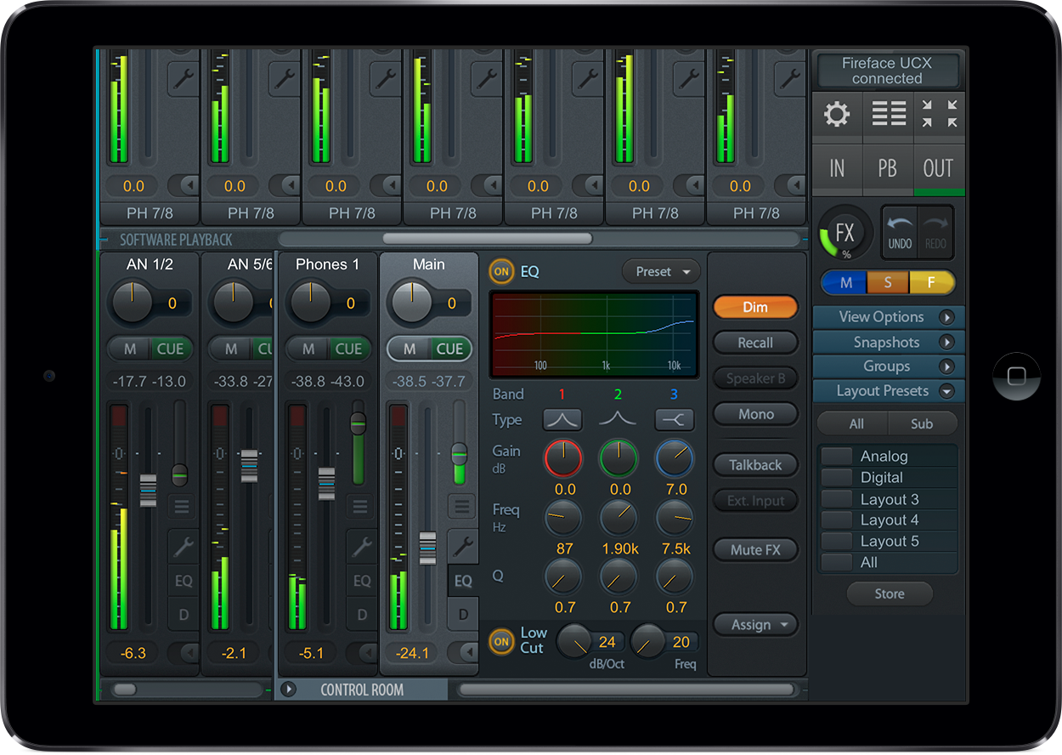
Fort Lauderdale, FL, December 6, 2017 – Premium German interface manufacturer RME [http://www.rme-usa.com] has introduced a new series of instructional videos that walk users through the various features of its powerful TotalMix FX routing and mixing software. TotalMix FX — which is included at no charge with any RME interface product — simplifies workflow and makes mixing more intuitive for both studio recording and lives sound environments.
Each detailed video ushers users through a step-by-step process on topics like with DSP-based EQ, mixing with reverb, applying delay and echo effects and working with dynamic processing in its TotalMix FX software environment.
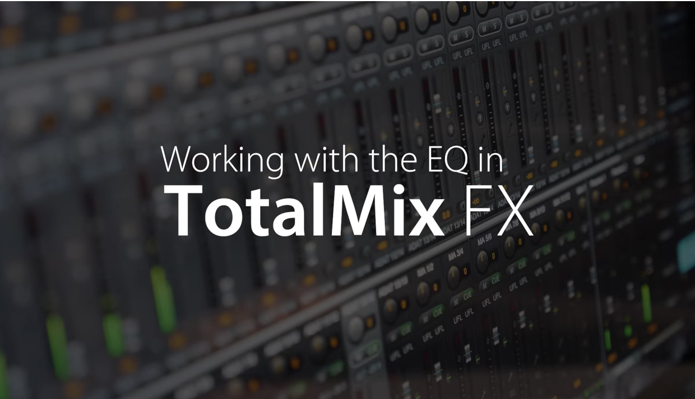
“With our new video series on TotalMix FX, we have created an informational resource that users can readily refer to increase their grasp of TotalMix FX, no matter what their current understanding level,” said Mathias von Heydekampf, managing director of Synthax, distributor of RME. “Perhaps the most powerful aspect of TotalMix FX is how it can be an enormous time-saver with almost infinite routing capabilities. These videos will help customers better manage workflow while streamlining the overall mixing process."
Working with DSP Equalizer
The first video in the series [https://www.youtube.com/watch?v=VJwH6lvDg54] walks users through working with the DSP-based EQ within TotalMix FX, which comes equipped with a 3-band parametric equalizer plus an additional low cut. The slope of the low cut is adjustable between 20 Hz to 500 threads and has a 6 dB to 24 dB cut per octave, and all three bands can change the amplification between 20 dB to -20 dB. This kind of flexibility is ideal not only for shaping instrument tracks, but also cleaning out unwanted frequencies, and adding punch and definition to entire mixes. The video explains to users how to narrow or widen the bandwidth by lowering or raising the Q and walks users through the Q menu and the EQ presets.
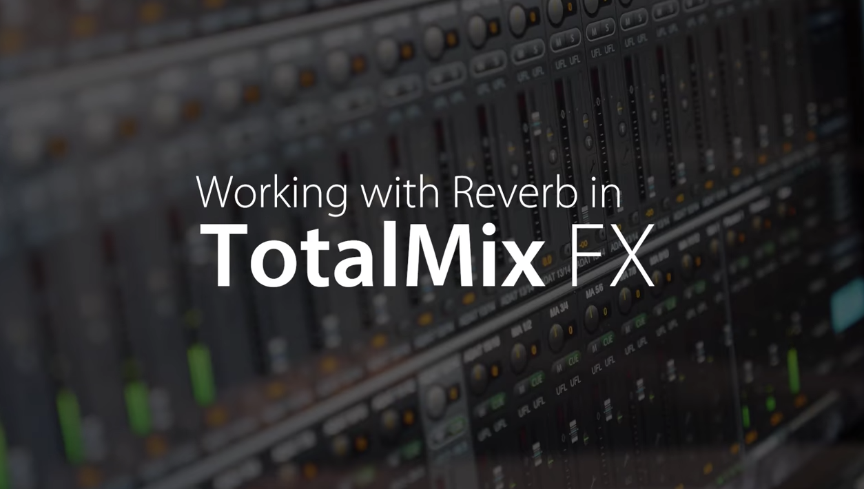
Working with Reverb
[https://www.youtube.com/watch?v=uyUOJ5scg7w] TotalMix FX offers a flexible reverb for adding dimension and space to a variety of sound sources. The program lets users add a massive or nuanced amount of reverb to vocals — as well as detailed, reverberant rooms for drums, or a touch of added dimension for final mixes. Working with Reverb walks viewers through the entire process — from adding pre-delay to a plethora of other useful examples.
The video describes how to adjust the stereo field — from stereo to full mono — while explaining envelope and gated effects. Gated effects deploy a attack/hold/release envelope for shaping the reverb tail for added rhythmic effect.
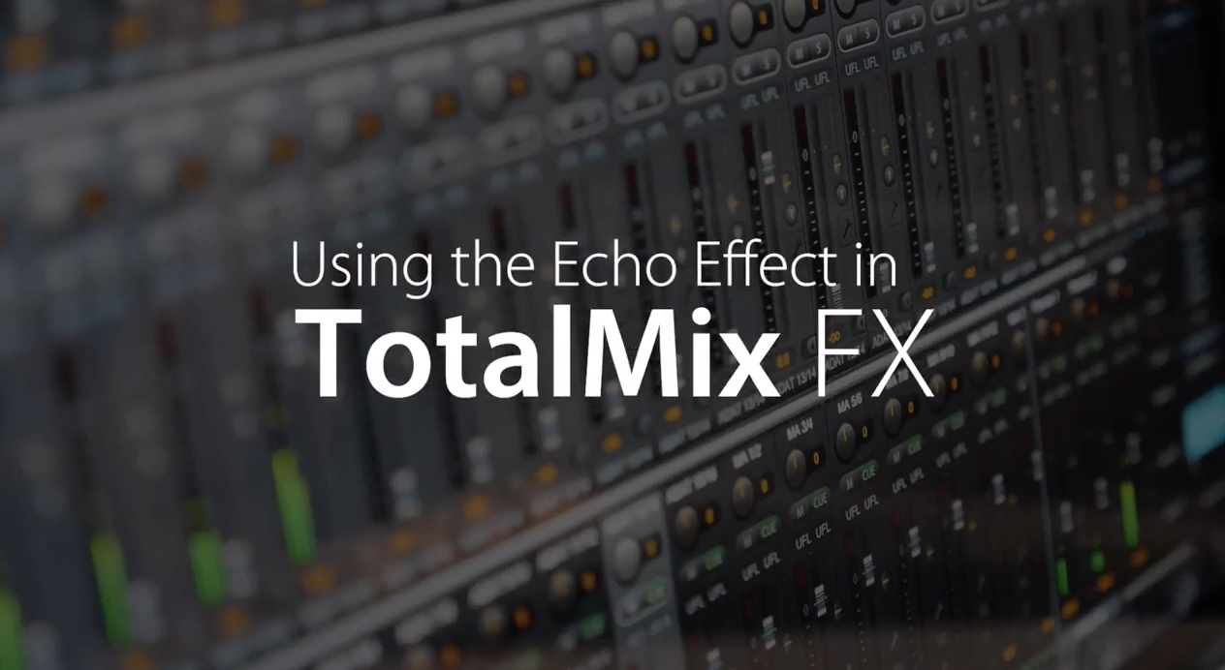
Working with the Echo Effect
[https://www.youtube.com/watch?v=hw2XsKp47dA]
The Echo in TotalMix FX is ideal for a variety of spatial and rhythmic effects. With only a few parameters, the echo can enhance a vocals, add more heft to instrument tracks or act as a sound generator. This video walks users through how to achieve this process while explaining the three types of available Echo and how to adjust the levels.

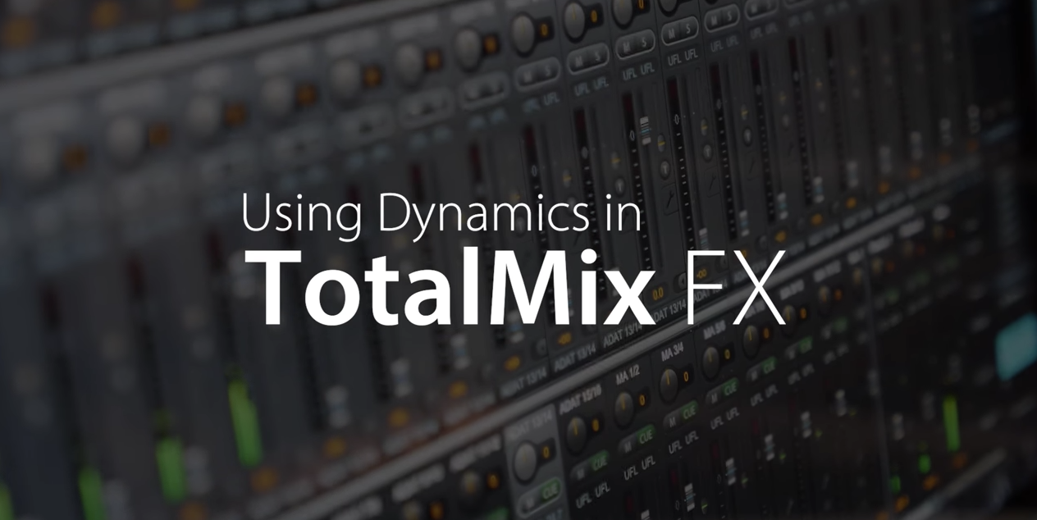
Using Dynamics
[https://www.youtube.com/watch?v=VJwH6lvDg54]
The fourth video explains how the compressor, expander and auto level offers a comprehensive toolset for advanced sound sculpting. The Dynamics in TotalMx FX allows users to add more punch and attack to drums, control the dynamics of incoming and outgoing signals, and completely alter the sound. The video walks users through how to operate the compressor, expander and auto level as well as breaks down its attack and release functions.

Find links to all four videos here:
RME Audio TotalMix FX - DSP based Equalizer
RME Audio TotalMix FX DSP - Mixing with Reverb
RME Audio TotalMix FX DSP - Echo Effects
RME Audio TotalMix FX DSP - Dynamics
To visit RME’s YouTube channel, click here. For more information, visit http://www.rme-usa.com/

About Synthax, Incorporated
Synthax Inc. is the exclusive USA distributor for RME digital audio solutions, Ferrofish advanced audio applications, myMix audio products, and ALVA cableware. We supply a nationwide network of dealers with these products for professional audio, broadcast, music industry, commercial audio, theater, military and government applications. For additional information, visit the company online at http://www.synthax.com.

Media contact
Jeff Touzeau
Public Relations
Hummingbird Media
+1 (914) 602 2913
jeff@hummingbirdmedia.com

Katie Kailus
Public Relations
Hummingbird Media
+1 (630) 319-5226
katie@hummingbirdmedia.com

