NAMM 2019: WSDG’s Sergio Molho Discusses Latin American Recording Studio Innovation and What the Future May Hold
Discussion Highlights an Increasing Trend in Education Facility Design
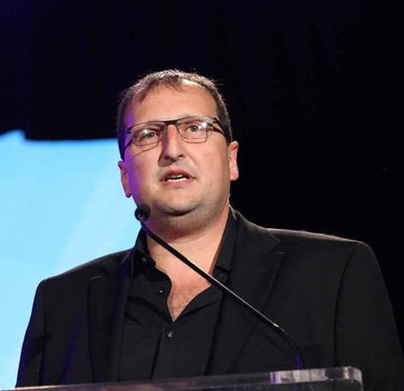
Anaheim, CA – January 31, 2019 – The 2019 NAMM Show saw an enormous gathering of the best and brightest minds within the musical instrument and pro audio worlds. In the world of architectural acoustic consulting and media integration services, innovative thought leader WSDG (Walters-Storyk Design Group) has thrived over the past fifty years by anticipating change to remain ahead of the curve.

Indeed, the company’s first project, the design of Jimi Hendrix’s Electric Lady Studios, 50 years ago continues to record hits in its original location. Today, WSDG has branched out to a wide range of vertical markets, including education institutions, sporting arenas and performance spaces. At the 2019 NAMM Show, WSDG Director of Business Development Sergio Molho presented an insightful lecture on the evolution of the Latin American recording industry. One which has seen unprecedented innovation and growth over the last quarter century.

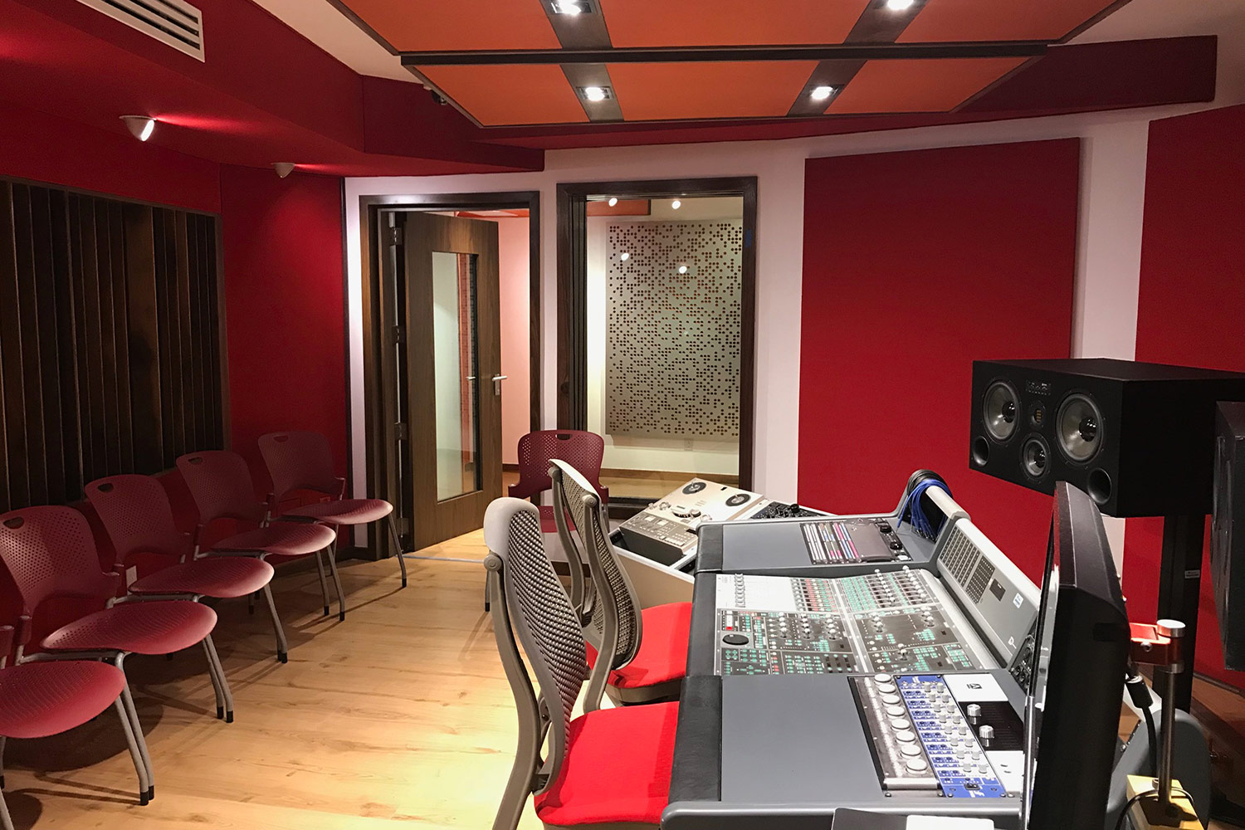
From projects like TEC de Monterrey’s new pro audio educational complex in Monterrey, Mexico and NAMM TEC Award- winning Studio Circo Beat Studios in Buenos Aires, Argentina these studios vary widely in size, shape, and client application. The common thread they share however is WSDG’s design and systems integration expertise, a process the company has continually refined since completing Sonovision its first Latin American-based recording studio in Colombia, in the mid-1980s. According to Molho, who joined the firm to represent the Latin American region in 1994, the evolutionary process reflects the gradual transformation of the entire Latin American recording industry: from the scattered and cash-strapped recording studios of the past to a growing assemblage of best-in-class recording spaces that have catapulted Latin America’s recording industry onto the global stage.

“It was all about creating a greater bank of knowledge,” Molho explains. “For a long time, studio design know-how was confined to a small group of individuals. We realized there was an opportunity here to help share what we’d learned over our history, as well as design spaces worthy of the art that these musicians wanted to create.”

In his panel at The 2019 NAMM Show, Molho explained how WSDG’s careful study of the region’s recording studios and their builders revealed that acoustic design knowledge overall was low by comparison — and that the educational resources were not available to create the type of high-end spaces that were common in North America and Europe. Sensing the opportunity to enhance audio education in the marketplace, WSDG began a concerted effort to share knowledge and began work on the series of projects to spark the recording studio renaissance that Latin America is currently experiencing.

In addition to the growth in know-how, Molho also explained how its projects have likewise benefited from the emerging economies of their host countries — which have historically not been as robust as the U.S. and Europe. “Building costs for these projects have been 20-30% less than similar global projects.,” Molho observes. “These differences in cost have allowed us to create less costly high-quality work and state of the art facilities that are both beautiful and unique.”

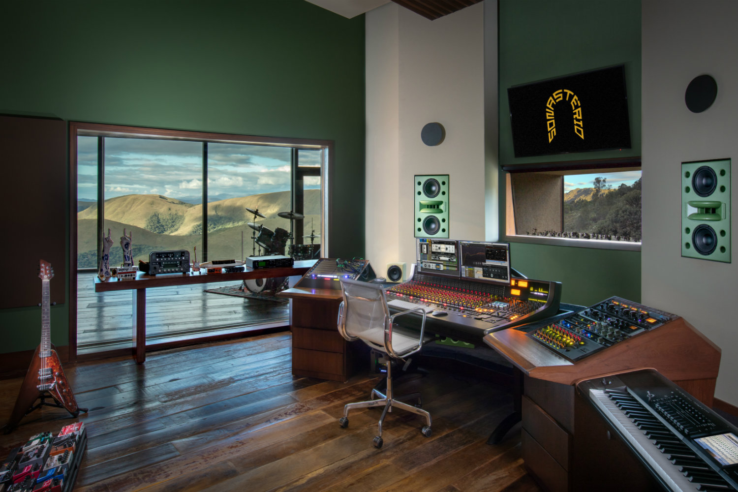
In the past year alone, WSDG has broken ground on dozens of these unique spaces. For example, Mix2Go in Sao Paulo, Brazil is a pioneering, miniature mix facility designed to meet the growing demands for 3D (immersive) audio as well as standard 5.1 and stereo mixes. At 440 square feet it is among the smallest such spaces in the world, while still achieving WSDG’s discriminating standards for acoustic excellence and pristine aesthetics. Nominated for a NAMM TEC Award in Creative Studio Design, Sonastério Studios in Belo Horizonte is Brazil’s first world-class destination studio, ensconced in a luxury 8,000 square foot home, sitting atop a breathtaking mountain range.

Meantime, the aforementioned TEC de Monterrey in Mexico and University ICESI in Cali, Colombia are holistic educational complexes focused on audio engineering and music production — offering the promise of preparing future generations for next generation audio challenges. These institutions — and others like them — are creating the fertile ground that will ultimately help students find successful audio careers in the Latin American region and beyond.

WSDG says its projects in the region show no signs of slowing down and, fueled by a diversity of new content and passion are proliferating. “The democratization of information and the lowering costs of technology make projects like this possible — not just in Latin America, but also in other regions like China, India and the Middle East,” Molho explains. “We’re very proud of the work we’ve accomplished in Latin America, and we are convinced this is only the beginning.”

ABOUT WSDG, LLC
For nearly 50 years WSDG has been designing media production facilities worldwide, over 3500, and counting. Projects range from Jimi Hendrix’s Electric Lady Studio and Jazz At Lincoln Center in New York, to broadcast facilities for The Food Network, CBS and WNET, over twenty teaching studios for The Art Institutes, and corporate clients such as Sony, IBM and Novartis. Recent credits include Jungle City in New York, The Church Studio, in London, private studios for Green Day, Jay-Z, Bruce Springsteen, Alicia Keys and Academy Award-nominated film composer Carter Burwell. WSDG has collaborated with such noted architects as Frank Gehry, Philippe Stark, Rafael Viñoly, Santiago Calatrava, Grimshaw, and Norman Foster. An eleven-time winner of the prestigious pro audio NAMM TEC Award for outstanding achievement in Acoustics/Facility Design, WSDG maintains U.S. offices in New York, Washington, DC, San Francisco and Miami and global offices in Barcelona, Basel, Berlin, Belo Horizonte, Buenos Aires, Guangzhou, Mexico City and Mumbai.

Contact:
Steve Bailey
Hummingbird Media, Inc.
+1 (508) 596-9321
steve@hummingbirdmedia.com

Jeff Touzeau
Hummingbird Media, Inc.
+1 (914) 602-2913
jeff@hummingbirdmedia.com

