For more information, please contact Marta de Paco
On +34 670 780 664 or email press@comunicahair.com

Important:
These images are only available for editorial content.
Credits must be included.
Notification of their publication is expected.

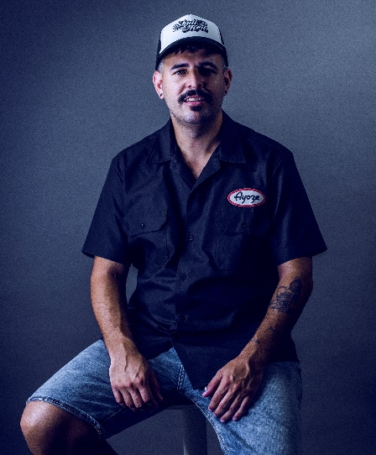
AYOZE MEDINA
PETRIFIED Collection

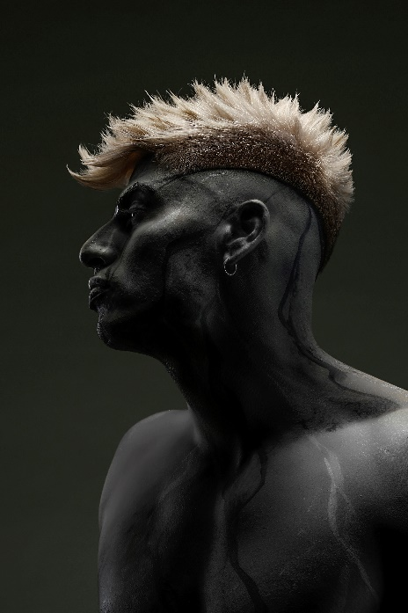
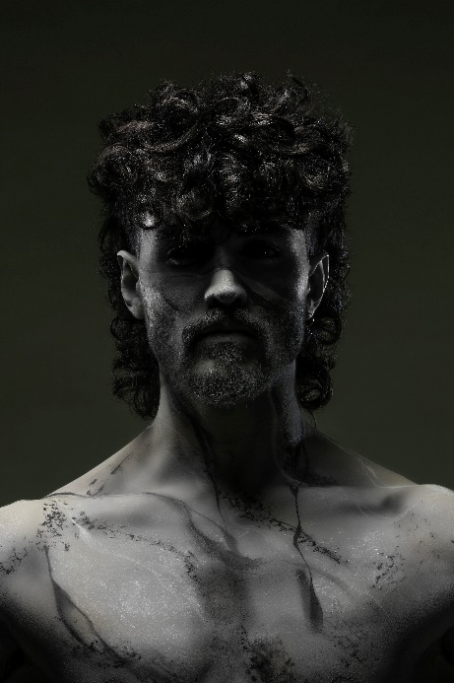
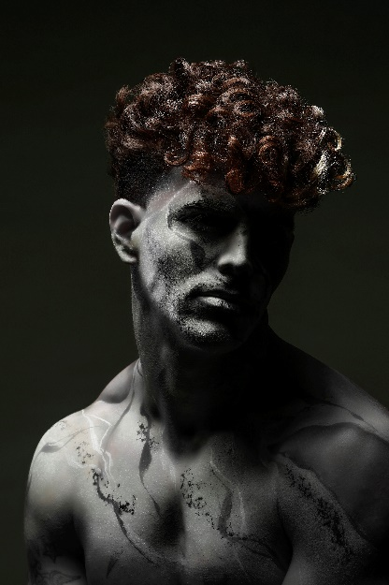
Hair: Barberia Ayoze Medina
Hair Instagram: @barberiaayozemedina
Photography: Marcos cabrera
Photography Instagram: @masrciscabrera_fotografo
MUA: Ana Lidia Alonso
MUA Instagram: @analidiaalonsomua
Styling: Ayoze Medina
Models: Adan Gonzalez @mr.adangonzalez.g
Onan Medina @onanmedina_ocr
Diego Balmaceda. @im.diegobalmaceda
David martin. @sr.martinramirez
Products: Skullmen
Products Instagram: @skullmen_k89

AYOZE MEDINA
PETRIFIED Collection

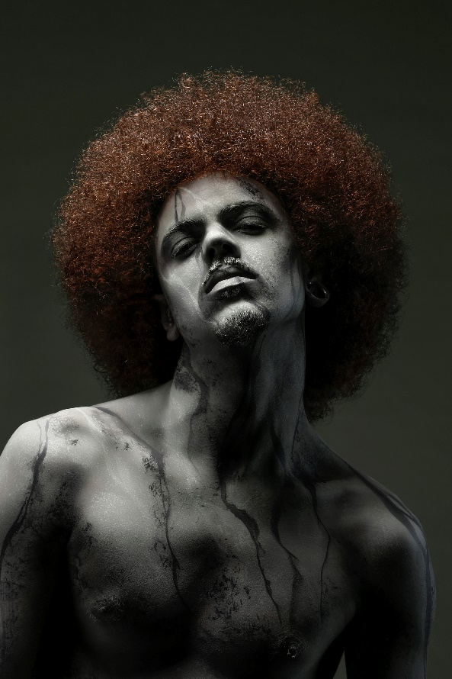

The collection delves into the sensation of 2020 as a year that we have barely lived, as if we were stunned or petrified within that anomaly that has prevented us from celebrating life in each of its aspects. That same situation has led its creators to go one step further and create their first most creative collection, changing the previous style to achieve an elegant and masculine vision and managing to convey their passion for the industry. The result offers looks in which hair is the main protagonist, clearly standing out in the image by distancing itself from the petrified finish of the skin, whatever its tone, with rich and complex textures that express the power of hair.

