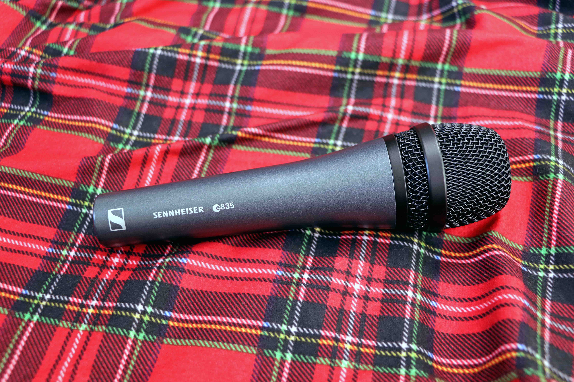Great gifts for music makers
Mics and headphones for the passionate musician

Wedemark, November 2022 – This festive season, why not help the musician in your life to advance their art? Sennheiser has the perfect gifts for live gigs, streaming and recording.

MK 4  With the typical warmth of a studio condenser mic, the MK 4 is a great all-rounder for recording vocals and instruments and is also great on the live stage, for example on guitar amps. It delivers fantastic sound, while still being an affordable choice. | 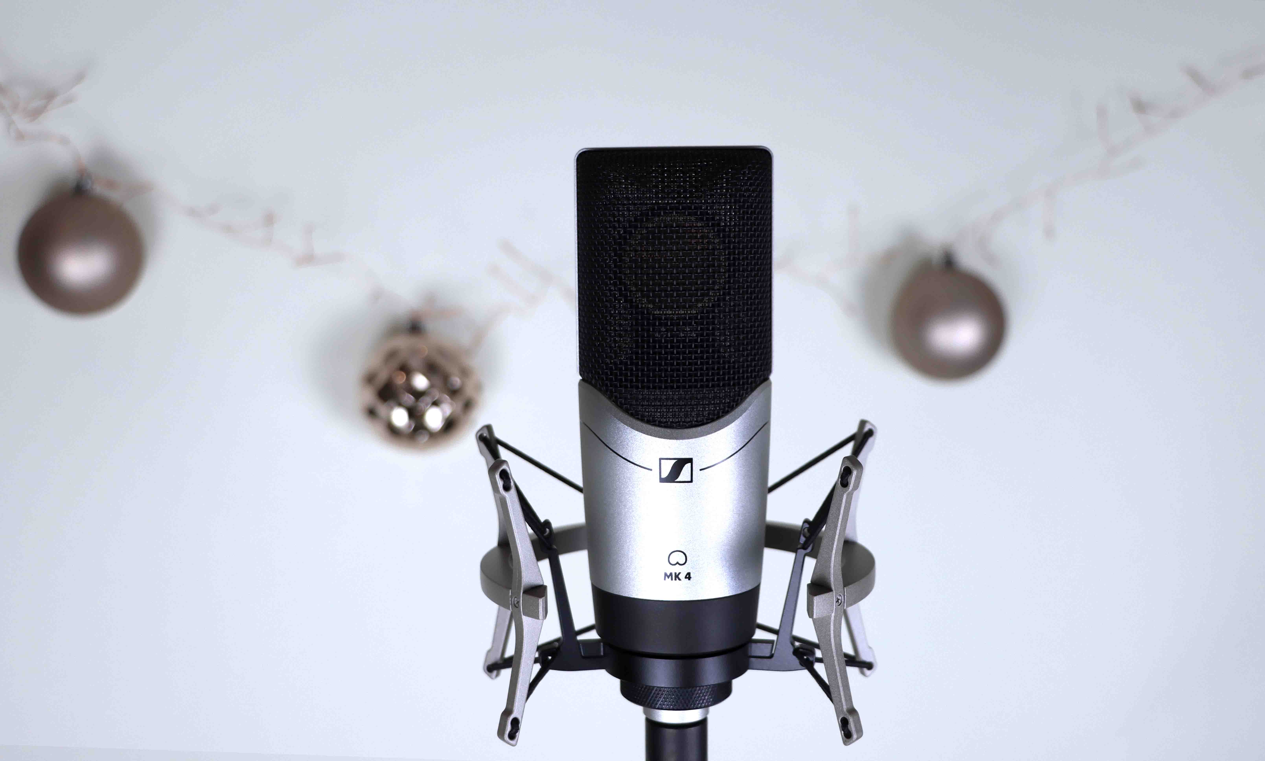  MK 4 pictured with optional MKS 4 shock-mount

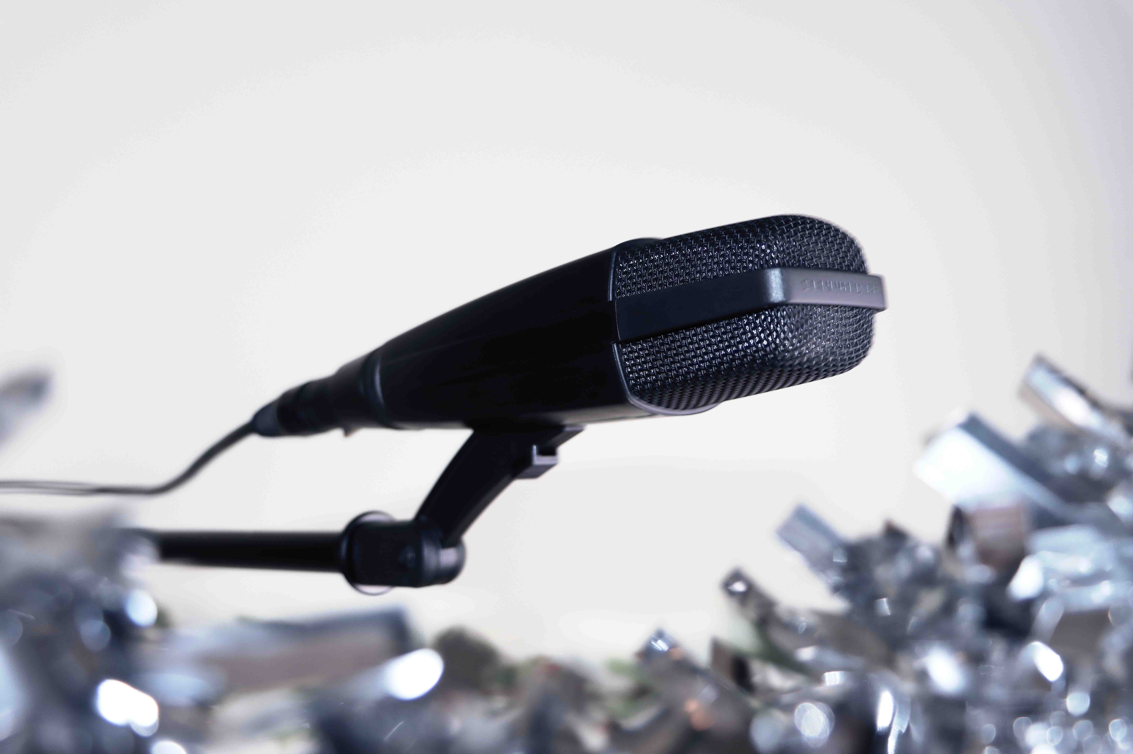 | MD 421-II  One of the best-known microphones in the world, the cardioid MD 421's full-bodied sound and five-position bass control make it an excellent choice for most instruments, as well as group vocals and broadcast audio.

e 835
From outdoor live events to home recordings, the e 835 dynamic cardioid microphone is ideal for all kinds of vocal applications and is a solid choice for performers.

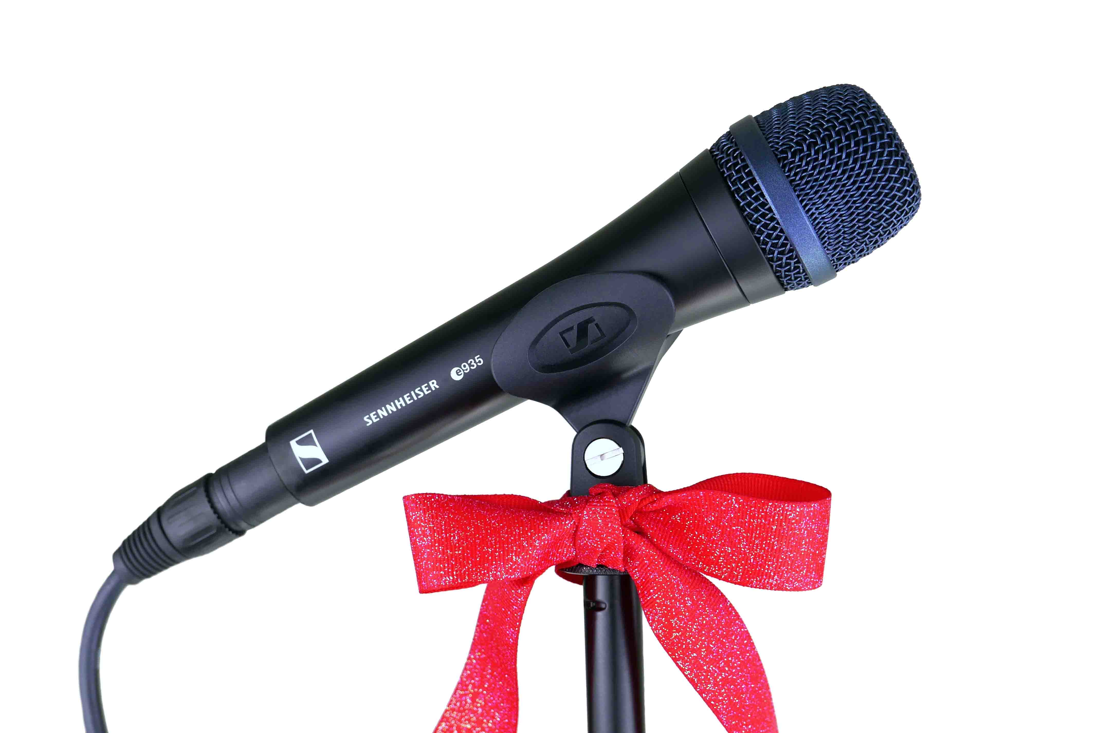 | e 935  The e 935 cardioid vocal stage microphone is designed to perform under pressure. It will always give your vocals plenty of room on a loud stage and position them cleanly out of the mix.

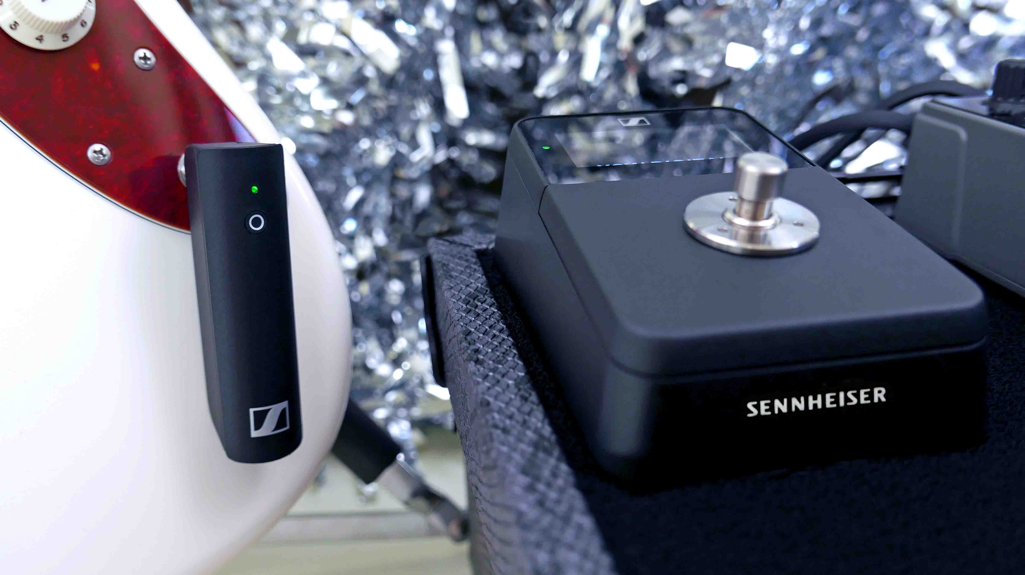 | XSW-D Pedalboard Set  The Sennheiser XSW-D Pedalboard Set makes going wireless child’s play. It’s as easy as plugging in a guitar cable, so you can concentrate on what’s most important – your performance.

XSW IEM  As a complete starter set for in-ear monitoring, the XSW IEM includes everything you need for an easy start with personal monitoring - letting you focus on playing your best. | 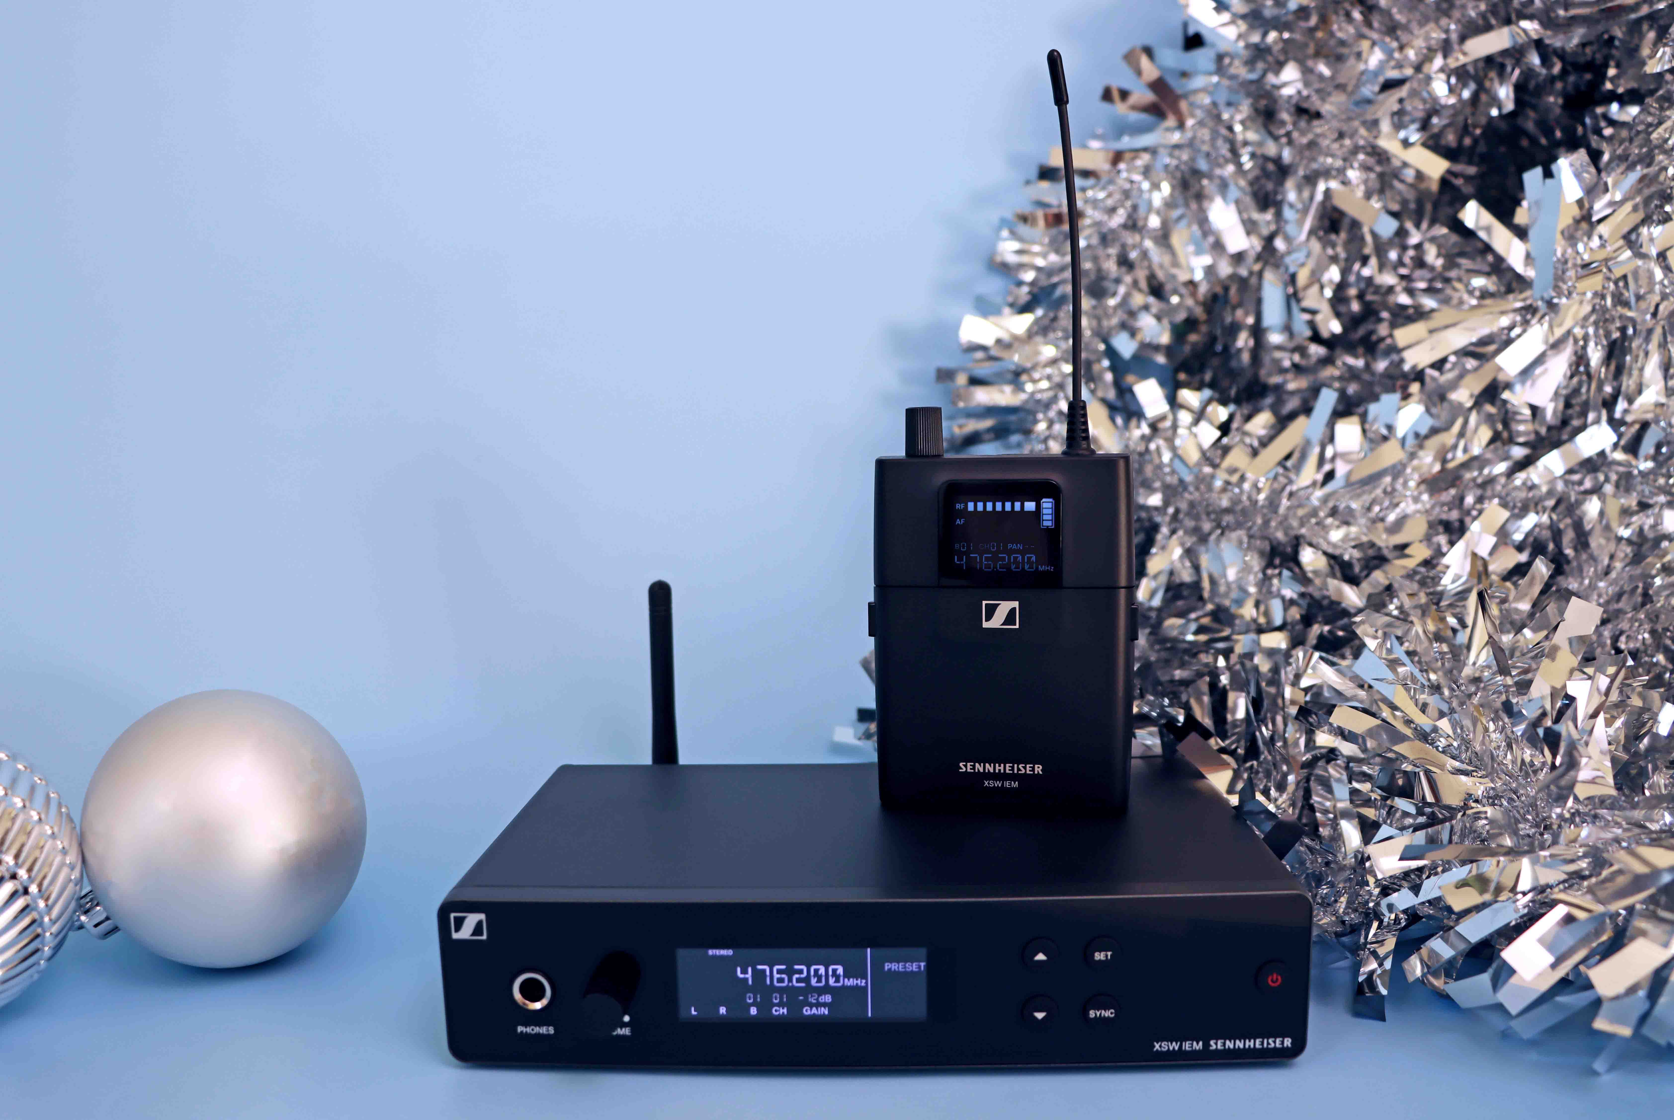

HD 25  Great sound, super-rugged and lightweight! The iconic HD 25 is one of the most widely used headphones among DJs and other audio professionals. | 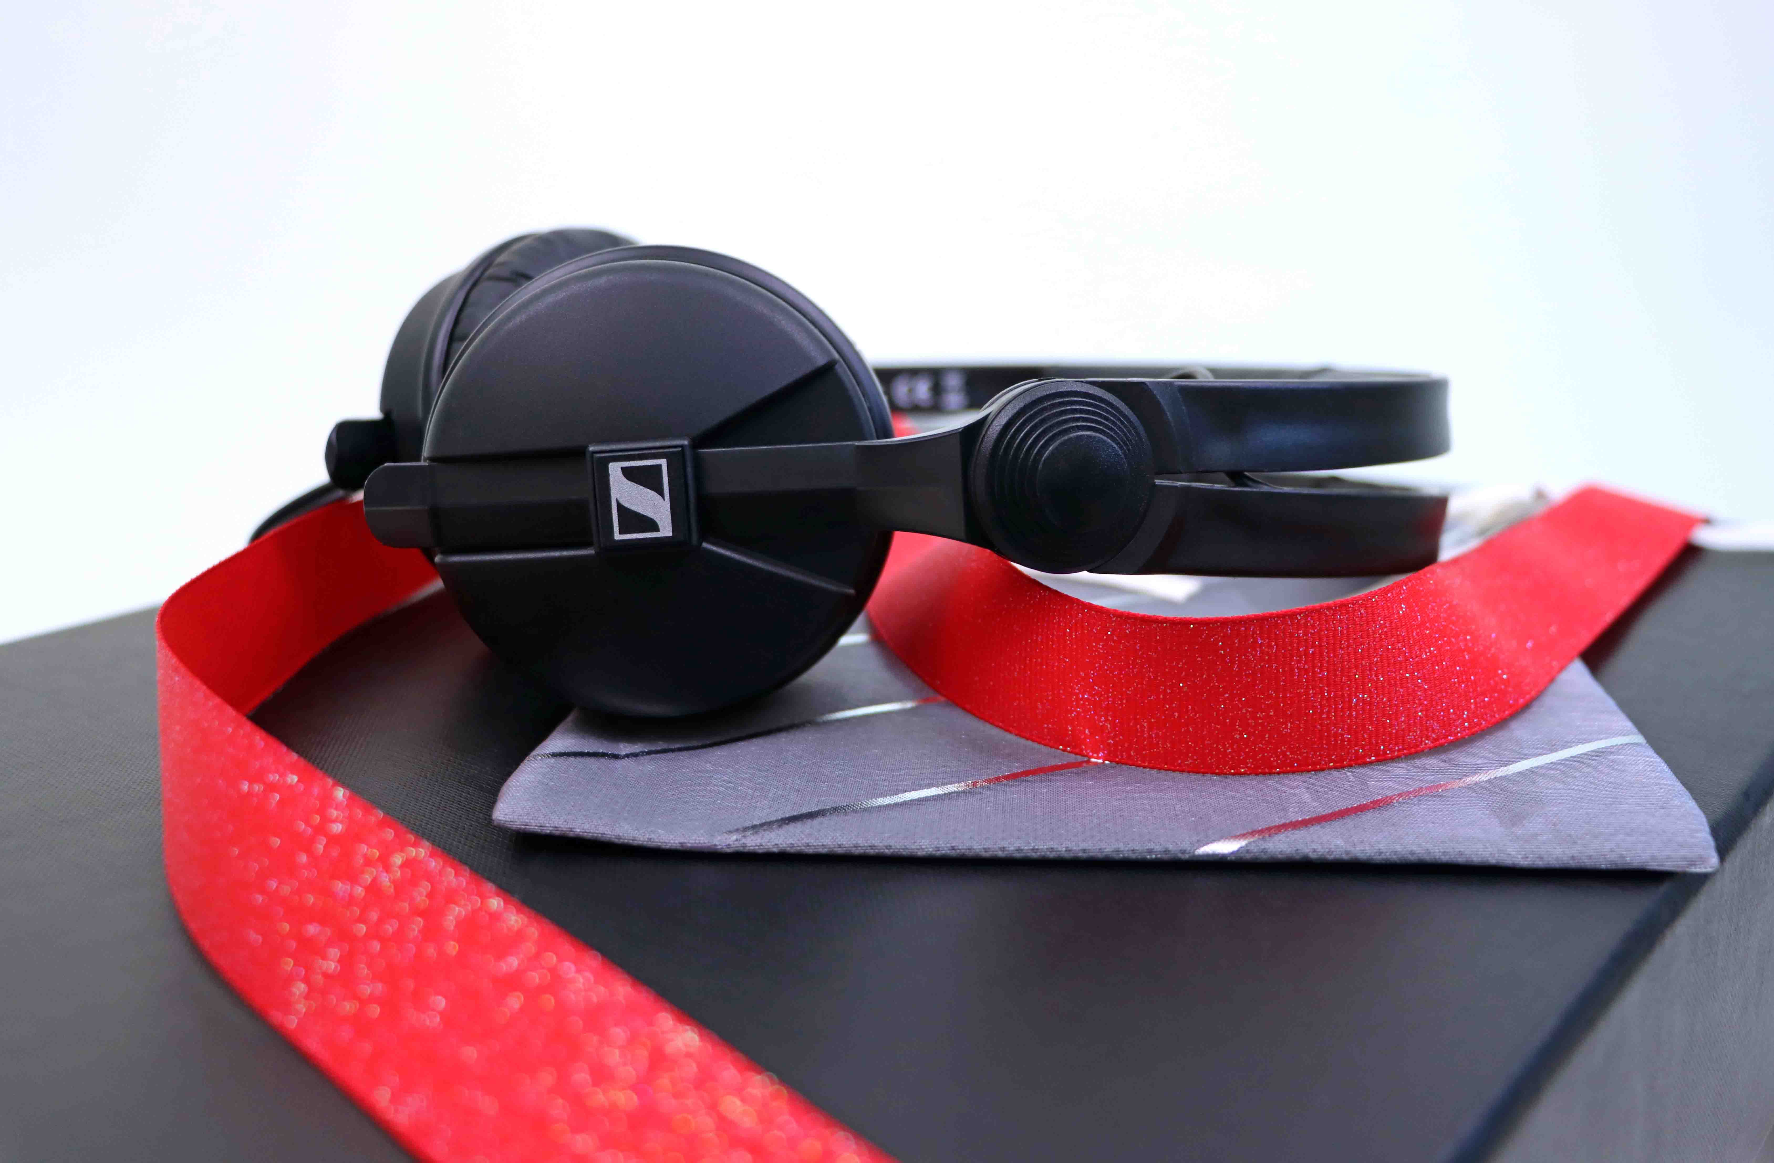

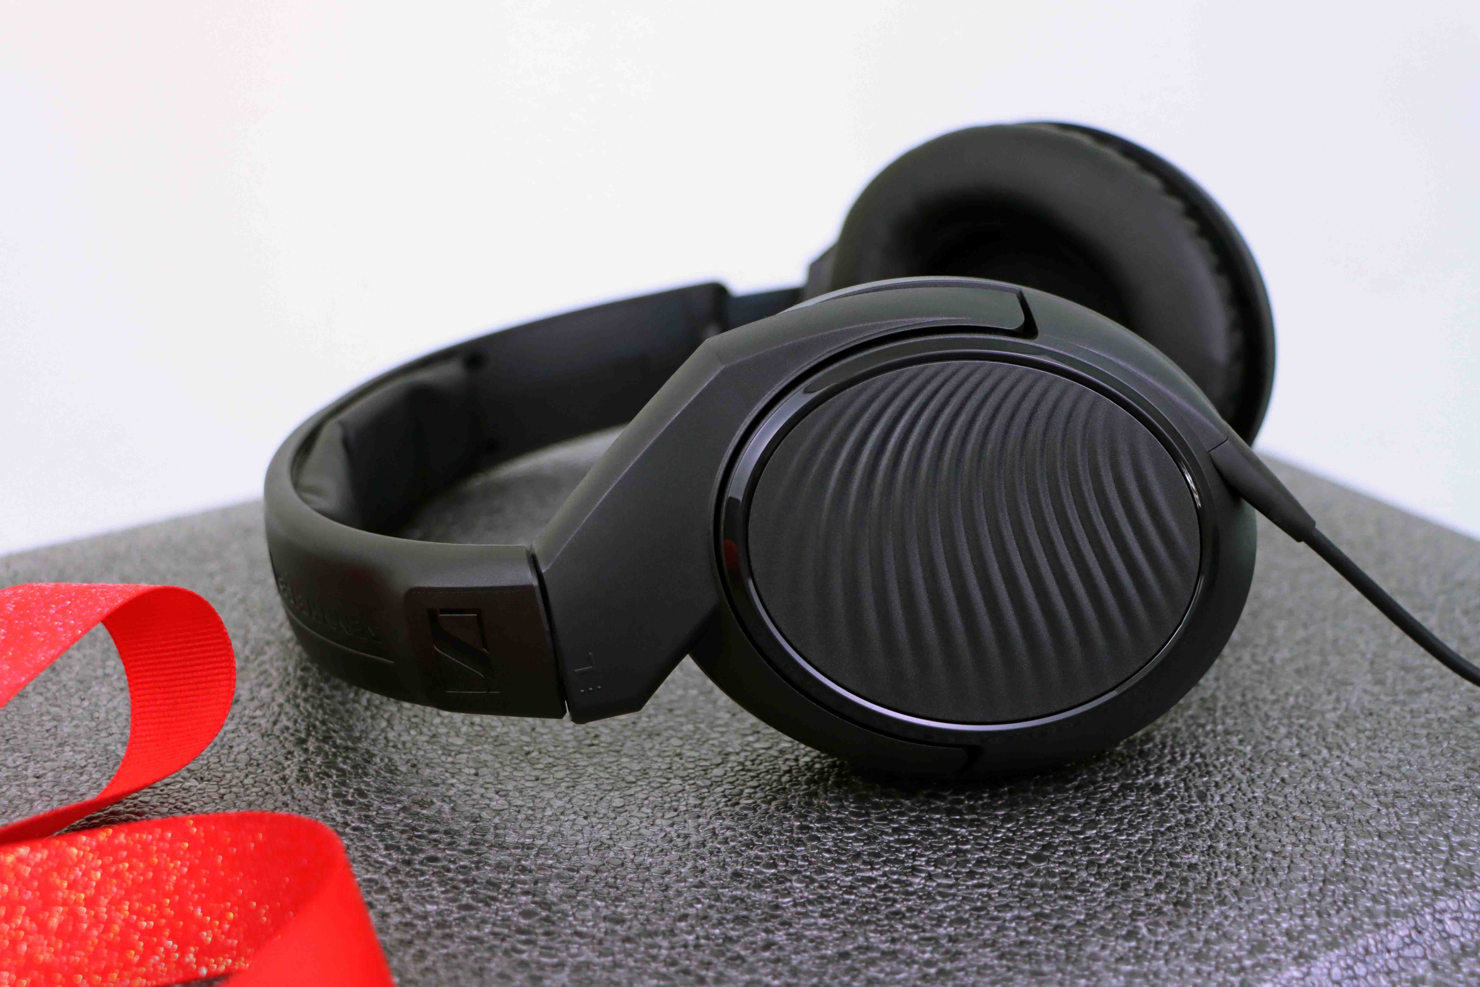 | HD 200 PRO  Sennheiser’s entry into circumaural closed back headphones offers powerful sound for studio monitoring – or when listening to your favourite tunes.

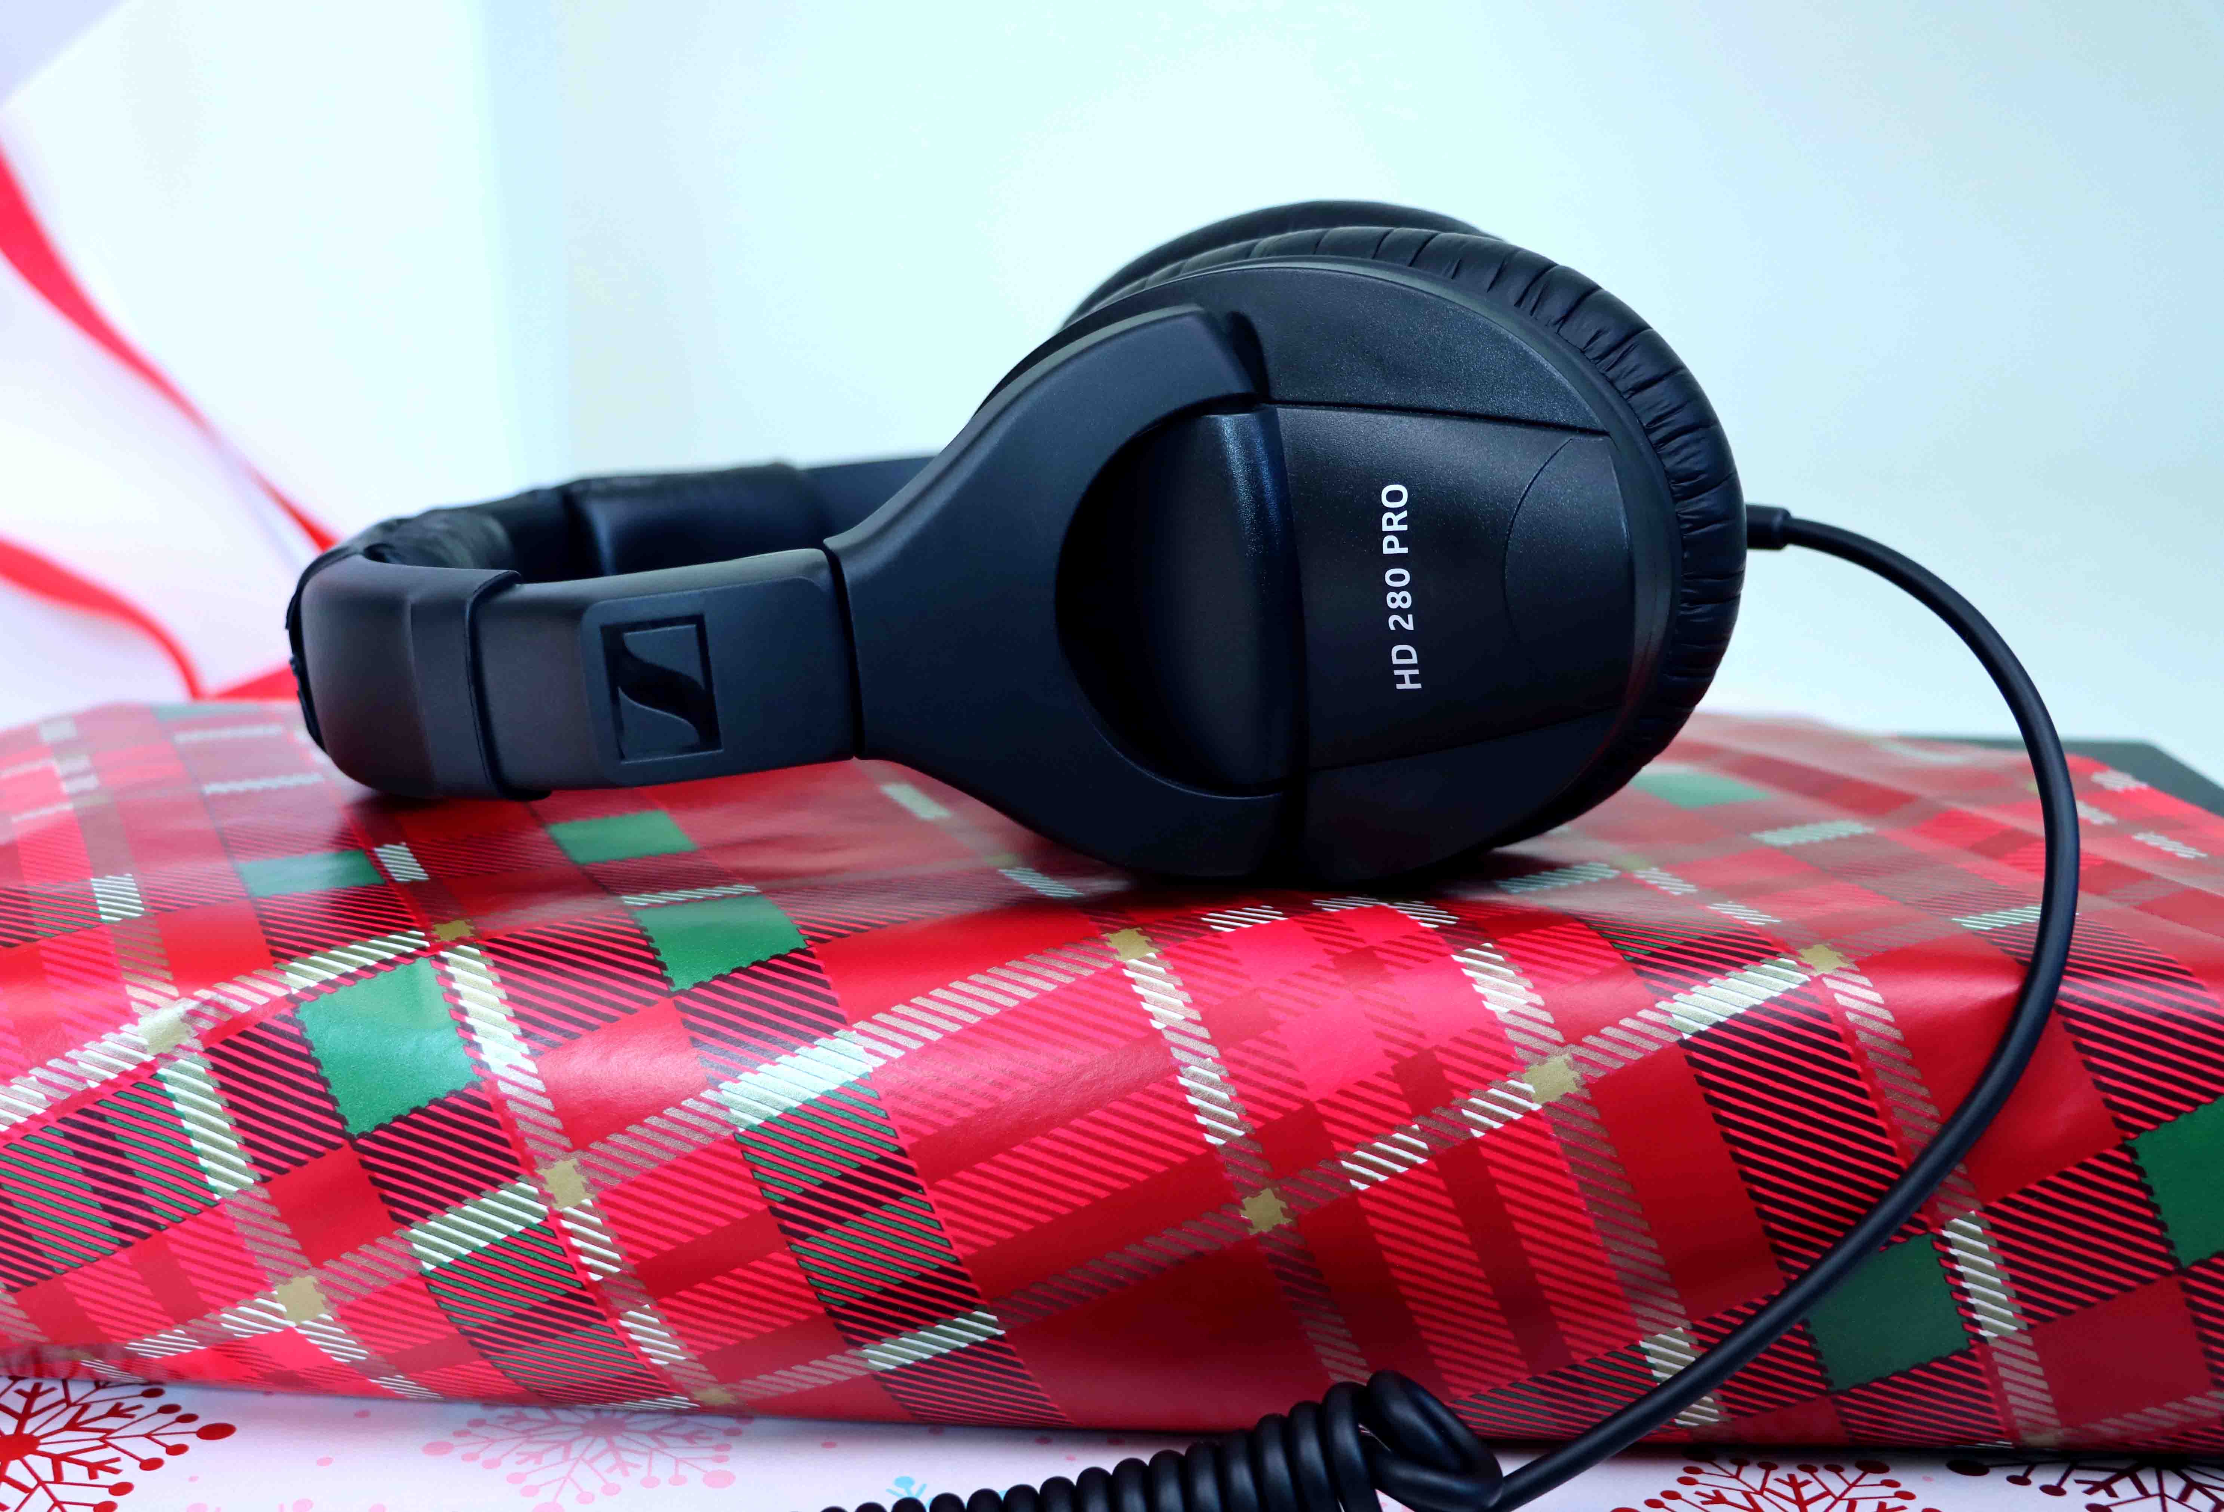 | HD 280 PRO  The closed-back HD 280 PRO monitoring headphones boast extremely robust construction combined with the sound quality, modular design and isolation you need to focus on the mix.

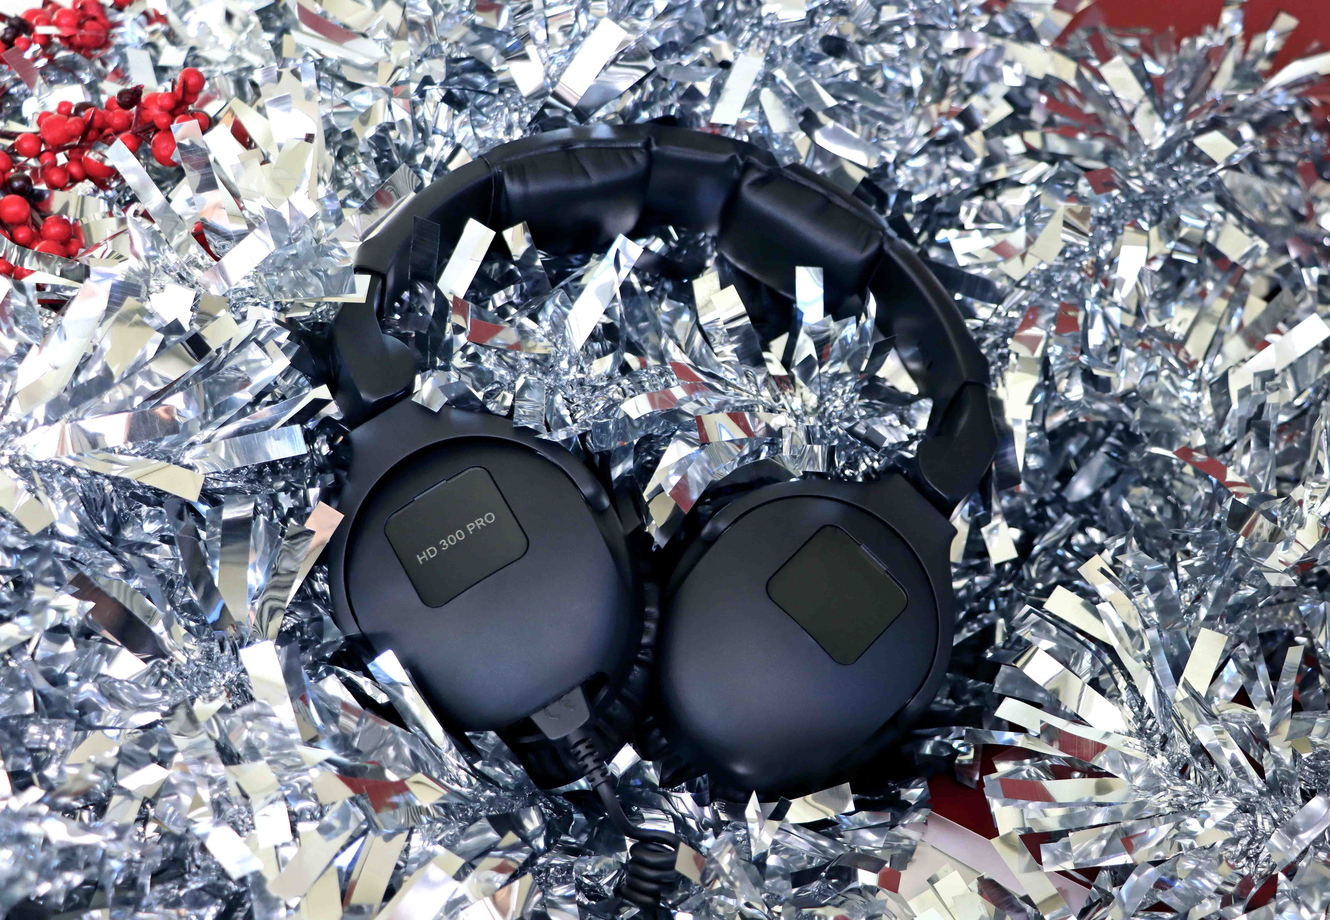 | HD 300 PRO  Modelled on the legendary HD 250 Linear headphones, the closed-back HD 300 PRO delivers a neutral, high-resolution sound, at the same level of precision you apply to your production. Its sound pattern remains delicate and accurate in every application.

HD 400 PRO  Why not upgrade your studio monitoring with the HD 400 PRO? Thanks to their angled transducers, these open-back headphones provide a natural and accurate listening experience with a wide and transparent soundstage. | 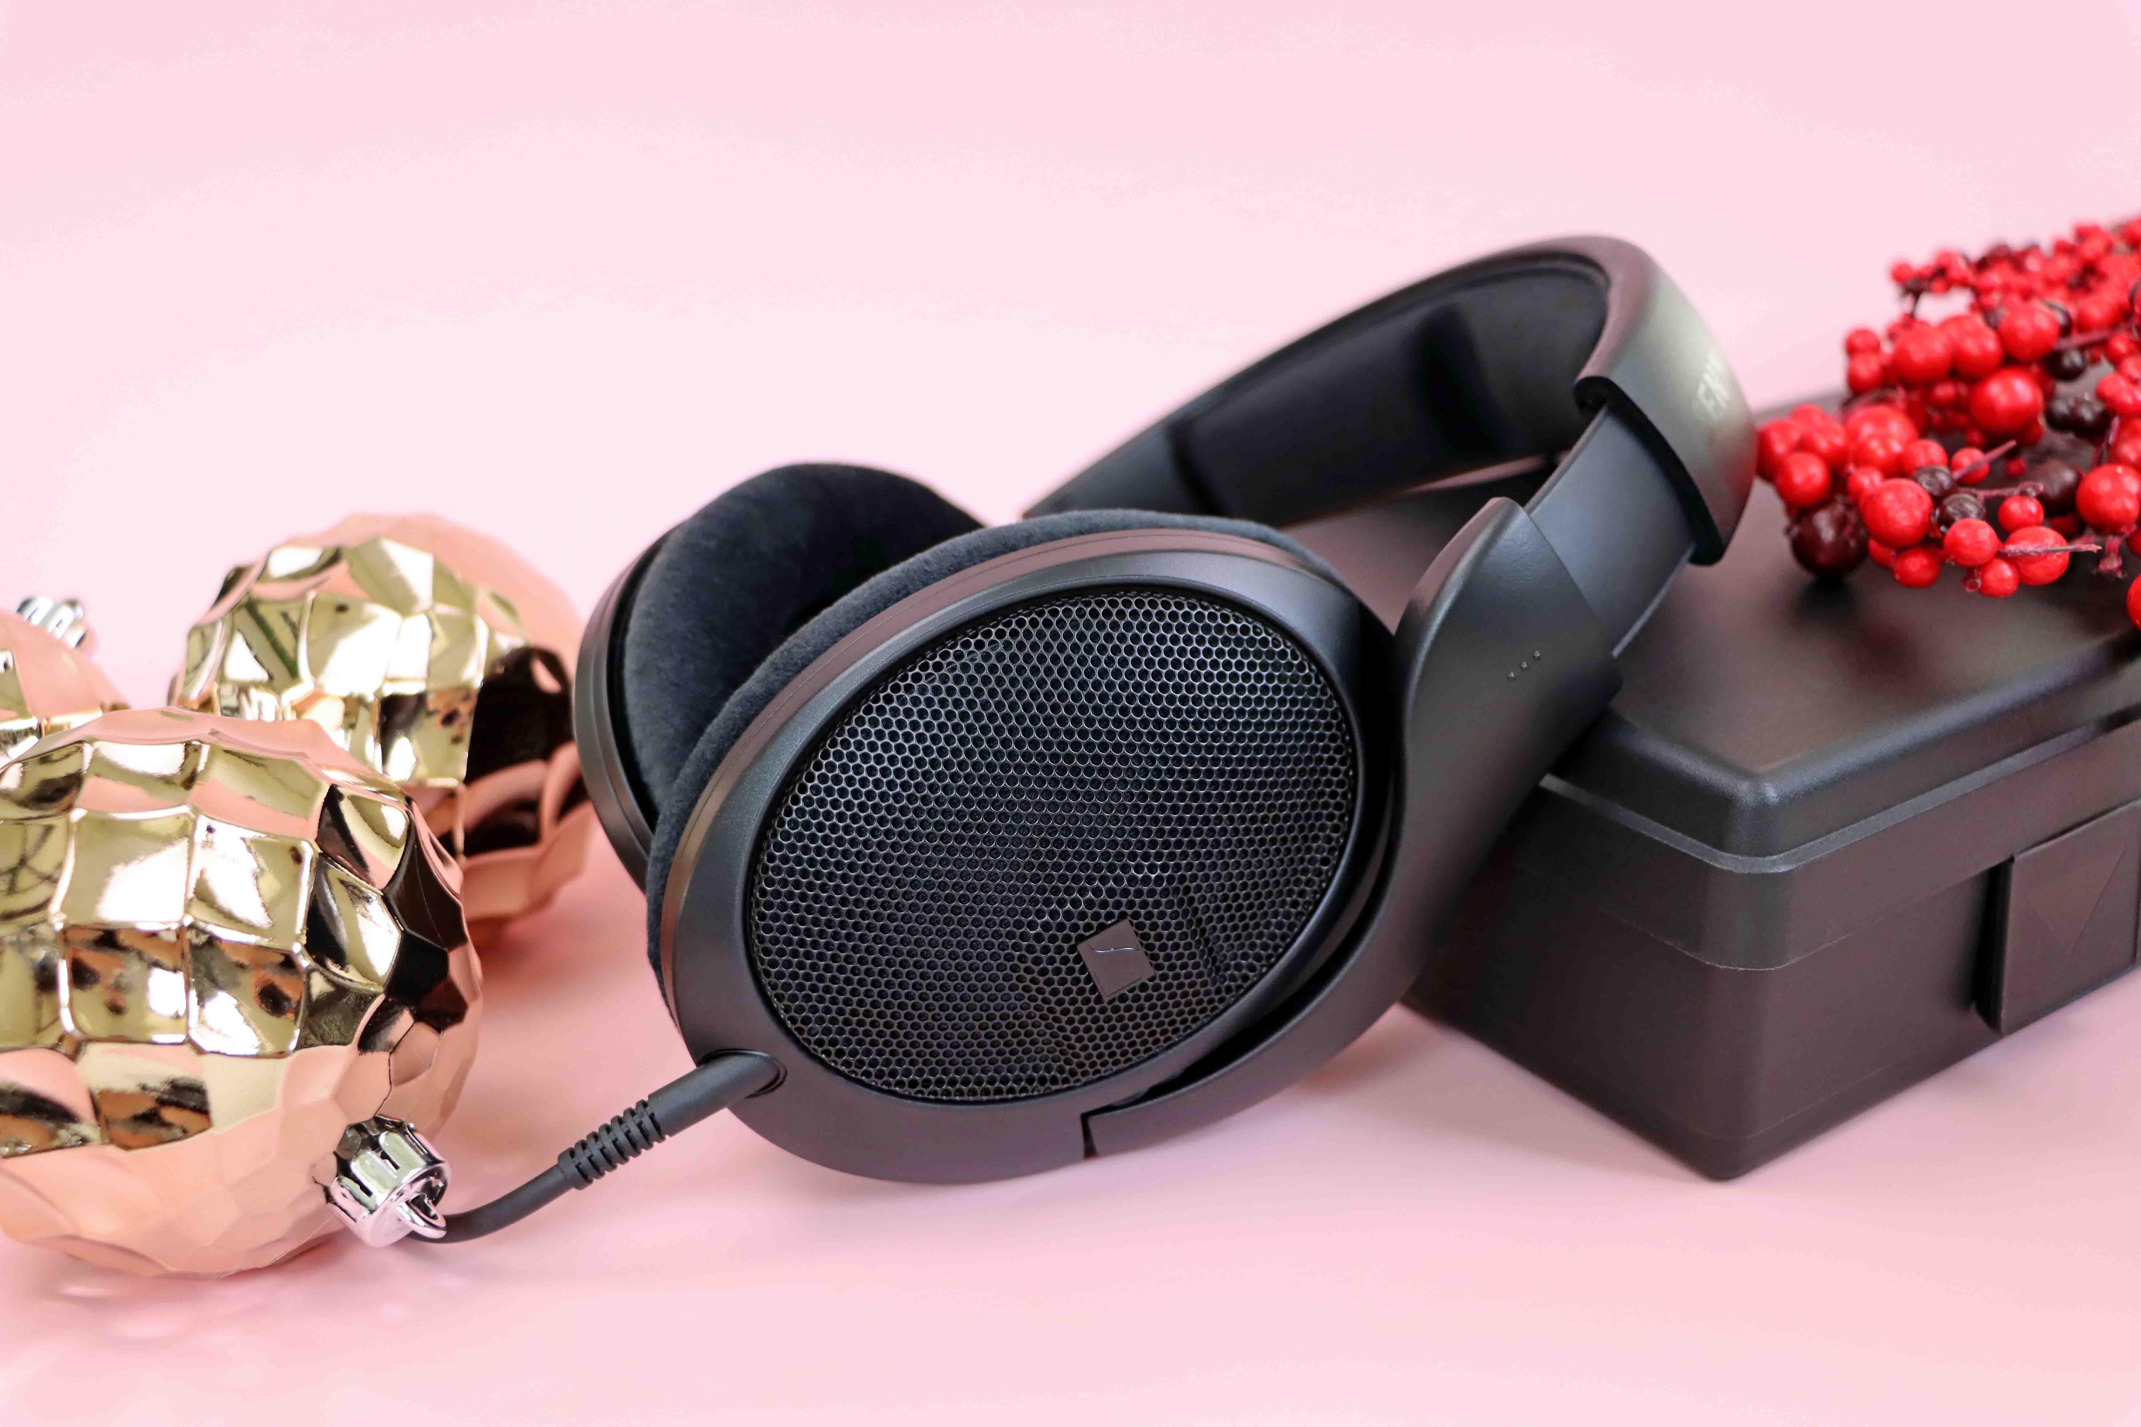

(Ends)

Pricing
MK 4: EUR 299; MKS 4: EUR 99
MD 421-II: EUR 399
e 835: EUR 99
e 935: EUR 199
XSW-D Pedalboard Set: EUR 379
XSW IEM: EUR 599
HD 25: EUR 149
HD 200 PRO: EUR 69
HD 280 PRO: EUR 99
HD 300 PRO: EUR 199
HD 400 PRO: EUR 249
All prices are MSRP incl. VAT.

The high-resolution images accompanying this media release can be downloaded here.
Holiday photography by Jaclyn Slimm.

About the Sennheiser brand
We live and breathe audio. We are driven by the passion to create audio solutions that make a difference. Building the future of audio and bringing remarkable sound experiences to our customers – this is what the Sennheiser brand has represented for more than 75 years. While professional audio solutions such as microphones, meeting solutions, streaming technologies and monitoring systems are part of the business of Sennheiser electronic GmbH & Co. KG, the business with consumer devices such as headphones, soundbars and speech-enhanced hearables is operated by Sonova Holding AG under the license of Sennheiser.

www.sennheiser.com
www.sennheiser-hearing.com

Global Pro Audio Press Contact

Stephanie Schmidt
Stephanie.schmidt@sennheiser.com
+49 (5130) 600 – 1275

