Light, Lighter: adidas Sport eyewear Launches progressor splite

– The progressor splite by adidas Sport eyewear features an ultra lightweight design weighing less than 80 grams, perfectly catering to ski mountaineering –

– Very small pack size, thanks to premium materials and highly flexible structure –

– New climacool® ventilation system with integrated rib structure for clear vision –
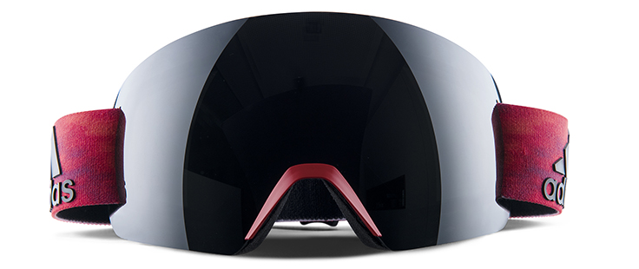
Linz, January 31st 2017: There is lightweight, and then there's the new progressor splite by adidas Sport eyewear.

Tipping the scales at less than 80 grams, it is one of the lightest goggles in the world and the first choice on your quest for higher speed up and down the mountain. Less weight means less unnecessary bulk on your face, allowing for unprecedented freedom of movement and all-day wearing comfort.

The reduced frameless design and extensive list of features, like the newly developed climacool® ventilation system or very small pack size, cater to ski mountaineers looking to gain an edge in any given situation, from training to competition and anything beyond.

Its antifog spherical twin filterTM offers an extraordinarily large field of vision, allowing you to capture the finest details of your surrounding winter landscape. Combined with the redesigned climacool® ventilation system, which now utilizes an integrated rib structure for optimum air circulation inside the goggles, fogging up of the lens is reduced to a minimum, even when the going gets tough on your way to the peak.

Flawless stability is key to focus on the way ahead. The 2-layered climacool® facefoam with auto-fit nose part provides a superior fit and great breathability, while a molded nose guard offers protection. No matter if wearing a beanie or helmet, or switching between the two, the ergonomically shaped buckles of the anti-slip siliconized goggles strap allow for quick and easy adjustment to virtually any surface or head size.

Only by combining premium materials with a highly reduced design, was it possible to minimize the weight of the progressor splite – a standalone model in the progressor lineup – to less than 80 grams, without sacrificing performance.

"In our sport, striking a good balance between weight savings and high functionality is not always easy. The progressor splite has exceeded my expectations," says ski mountaineering World Cup professional Anton Palzer.
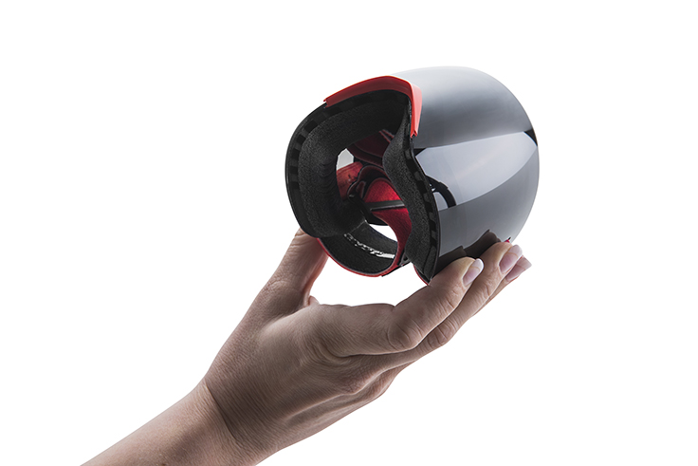
The spherical decentered 6-base Vision AdvantageTM PC lenses of the progressor splite are available in various LST® options, harmonizing light fluctuations and delivering high-contrast vision, even in low-light conditions – as well as a selection of multi-layered flash mirror lenses for uncompromising style.

Certain colorways can be matched with corresponding sunglasses from the sport essentials line. Check out the adidas Sport eyewear sunglasses models wildcharge, whipstart and 3matic and pick your best match.
The new progressor splite by adidas Sport eyewear is available in Fall 2017 in ten different color and filter combinations, starting at € 79,–.

For further information please visit adidassporteyewear.com or go to our facebook or Instagram pages to join the conversation.

– END –

