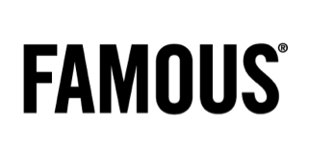 COMMUNIQUÉ DE PRESSE

Highlander: Just Married?

Credits
Client: Dirk Wouters – Erwin VanderWeerden – Sarah Van Loo
Agency: Famous
CD: Joeri Van Den Broeck , Tim Driesen & Christophe Ghewy
Account team: Mieke Van de Gehuchte – Marieke Michils - Naike Van Hulle
Creative Team: Paul Popelier, Iwein Vandevyver, Tom Jacobs, Gregory Verheyleweghen
Strategy: Luc Libens
Public Relations: Anne Cécile Collignon - Liesbeth Pyck
RTV Producer: Lander Engels – Charlotte Mathias
Photography: Renzo de Ceuster
Production: Czar
Director: Koen Mortier
Producer: Eurydice Gysel
Postproducer: Birgit d'hondt
Editing: Manu Van Hove
Camera: Lieven Van Baelen
Online: Nozon
Studio son: Cobra

