Beating the winter blues
Practice the art of mindfulness this winter with the help of Sennheiser’s noise-cancelling headphones

Wedemark, January 30, 2020 – It’s this time of the year: With the magic of Christmas behind us and the warm promise of spring still a few cold and grey months away, a lot of us can’t help but feel a little sluggish and out of sorts. But there is plenty you can do to beat the winter blues: Practicing the art of mindfulness and creating little pockets of happiness in your day can help you get through these dreary winter months. Mindfulness is about being present in the moment and taking in all the sensations raining down on you: the feeling of the winter sun on your face, the smell of a cup of freshly brewed coffee, the sound of snow crunching under your feet or the first beats of your favorite song. These four tips show you how to get started on your journey to mindfulness– and how a good pair of noise-cancelling headphones can help you be truly present in the moment.

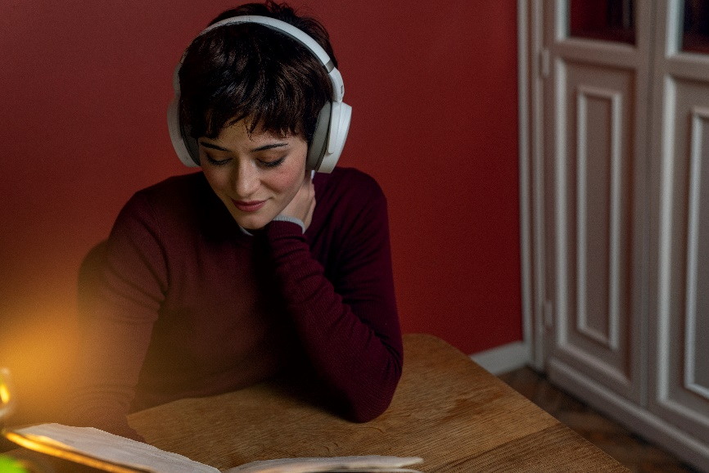

A good pair of noise-cancelling headphones like Sennheiser’s new HD 450BT (pictured here) can help you be truly present in the moment.

- Take it slow
Taking a pause and a deep breath when the phone rings instead of rushing to answer it will calm you down before the call. Switching it to silent mode altogether every once in a while helps to really be present in the moment and lets you enjoy reading, hanging out with friends or just your first cup of coffee in the morning in a whole new way. Small exercises like these can be powerful steps on your mindful journey.

- Listen to music
Nobody can deny the effect music has on us: we all have that one song that never fails to make us happy, music can help us focus and especially slow, classical music has a relaxing effect on body and mind. Great-sounding noise-cancelling headphones like the MOMENTUM Wireless or the new HD 450BT headphones from Sennheiser are perfect companions to create an oasis of relaxation in the everyday hustle.
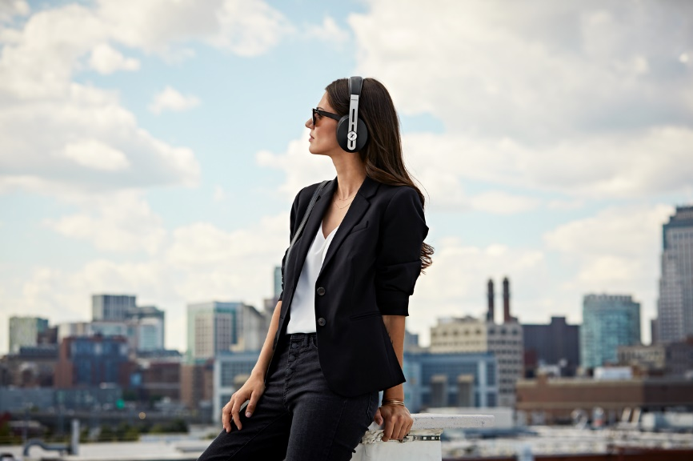

Create an oasis of relaxation in the everyday hustle with a pair of great-sounding noise-cancelling headphones like Sennheiser’s MOMENTUM Wireless (pictured here).

The headphones’ active noise cancellation lets you forget the outside world and really enjoy your favorite song. With the MOMENTUM Wireless, interaction is particularly intuitive thanks to a unique combination of features that offer fast access to your music. Just unfold it when you feel the need to escape it all and it switches on automatically. Designed to anticipate your needs, it offers a Smart Pause feature that immediately pauses playback when the headphones are taken off and smoothly resumes when put back on – so you can relax and stay in the zone.

- Meditate
Meditation offers the perfect space for mindfulness: sitting down comfortably, focusing on your breath, exploring the workings of the mind, letting thoughts, feelings and sensations come and go. Whether you choose to meditate in total silence to avoid any distractions, with music that helps you focus or by listening to a guided meditation app, noise-cancelling headphones like Sennheiser’s MOMENTUM Wireless or HD 450BT can help lift your meditations to a higher level.

- Keep it regular
To unfold the positive impacts of mindfulness, it must be practiced regularly. It often helps to pick a fixed time for your mindful exercise. The walk you take during your lunch break or the commute home after a long day at the office may be the perfect time to do so.

Sennheiser’s MOMENTUM Wireless are available in black for 399 EUR (MSRP). A sandy white color variant will be available later this year. The audio specialist’s new HD 450BT headphones will be available in black and white from early February for 179 EUR (MSRP).

About Sennheiser
Shaping the future of audio and creating unique sound experiences for customers – this aim unites Sennheiser employees and partners worldwide. Founded in 1945, Sennheiser is one of the world’s leading manufacturers of headphones, loudspeakers, microphones and wireless transmission systems. Since 2013, Sennheiser has been managed by Daniel Sennheiser and Dr. Andreas Sennheiser, the third generation of the family to run the company. In 2018, the Sennheiser Group generated turnover totaling €710.7 million. www.sennheiser.com

Global Press Contact
Sennheiser electronic GmbH & Co. KG
Jacqueline Gusmag
Communications Manager Consumer
T +49 (0)5130 600-1540
jacqueline.gusmag@sennheiser.com

