Sennheiser makes its mark at 2021 Afterpay Australian Fashion Week
Sennheiser partners with designer Karla Špetić to debut new collection at flagship Sydney store

Sydney, 8 June, 2021 – Sennheiser made an appearance at Afterpay Australian Fashion Week 2021 (AAFW) last week, collaborating with designer Karla Špetić as she debuted her new collection CEREMONY, SS22. As part of the show, models showcased the Sennheiser CX 400BT True Wireless earbuds as they took to the catwalk.

Afterpay Australian Fashion Week. #AAFW | Photo credit: Vladimir Kravchenko
Karla Špetić has taken inspiration from the deep DNA of her own brand’s 12-year history, and the award-winning work of film-maker Emir Kusturica, to create her latest collection, entitled CEREMONY, SS22.
The collection’s curated wedding looks of veils and mirror organza were complemented by the latest True Wireless earbuds from Sennheiser, the CX 400BT, worn by all models who graced the runway.
With their stylish and understated fit, Sennheiser’s CX 400BTs were the sleek accessory that polished off each look. Models marched to the beat of beautiful backdrop sounds from the divine Alix Higgins and Joan Banoit of Patamon, benefiting from the creation of their own sound experience as they tuned out of the real world and into exceptional audio quality.

Afterpay Australian Fashion Week. #AAFW | Photo credit: Vladimir Kravchenko
Speaking of the collaboration, Karla said, “I love technology and I love how sound creates a world of beauty and isolation we can lose ourselves in. So, it’s perfect that we launch (the new season collection) at the Sennheiser store.”

Karla said that “CEREMONY is a celebration of being however we want to be, celebrating however we want to celebrate.” That sentiment is echoed by the CX 400BT which let you enjoy amazing sound quality tailored to you, whether you’re in the mood for calming tunes or crave some thrilling beats. The bespoke drivers of the new CX 400BT True Wireless deliver high-fidelity sound with deep bass, natural mids and a clear, detailed treble. Plus, you can personalise your listening experience with built-in equalisers and the Sennheiser Smart Control App for iOS and Android to enjoy amazing sound quality for whatever mood you’re in.
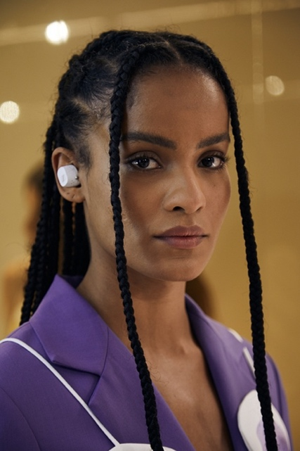

Afterpay Australian Fashion Week. #AAFW | Photo credit: Vladimir Kravchenko
Powered by Sennheiser’s leading audio technology, the CX 400BT True Wireless gives you total control over an exceptional sound experience. With passive noise cancellation, intuitive customisable controls, long-lasting battery life and a design made for all-day comfort, they are the ideal, uncompromised choice for people that are passionate about great sound.

To watch the full show, see here: https://app.nyfw.com/video/228554/karla-spetic-at-aafw-2021

The CX 400BT True Wireless are available in the Sennheiser Sydney store or online for the current sale price of $149.95 AUD (RRP $299.95 AUD). Visit the Sydney Store to discover Sennheiser’s full product range and experience the future of audio at 120 Pitt Street, Sydney.

About Sennheiser
Shaping the future of audio and creating unique sound experiences for customers – this aim unites Sennheiser employees and partners worldwide. Founded in 1945, Sennheiser is one of the world’s leading manufacturers of headphones, loudspeakers, microphones and wireless transmission systems. Since 2013, Sennheiser has been managed by Daniel Sennheiser and Dr. Andreas Sennheiser, the third generation of the family to run the company. In 2019, the Sennheiser Group generated turnover totaling €756.7 million. www.sennheiser.com

