

Biuro prasowe better. gaming agency
bettergamingagency.prowly.com

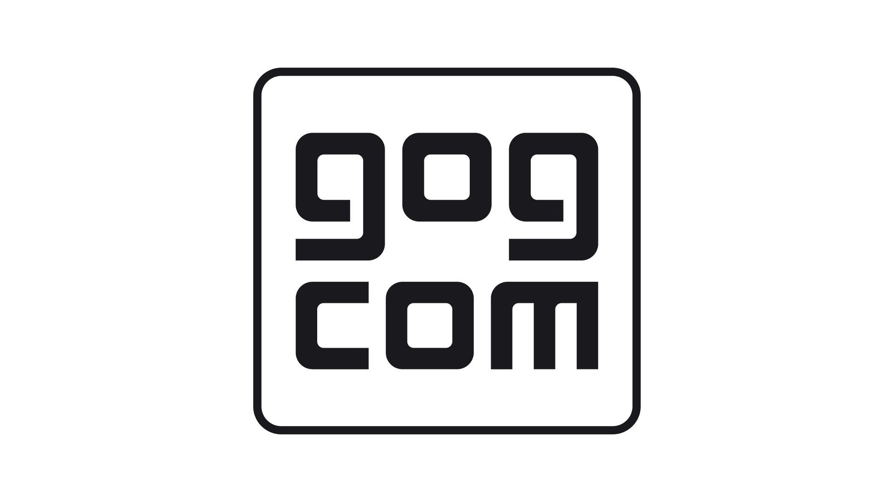

It is our duty to prevent games from being forgotten

Recently, an eye-opening report has surfaced, offering valuable insights into a saddening phenomenon that old gamers should hear about. According to the report prepared by Video Game History Foundation, 87% of classic games released before 2010 in the United States are currently unavailable through legal and convenient distribution channels.

One of the notable companies putting in a lot of effort to reverse the trend is GOG. As a global distributor, their mission goes hand in hand with the game preservation concept. Additionally, they are well-known for their commitment to promoting a DRM-free policy, which plays a crucial role in the overall process.

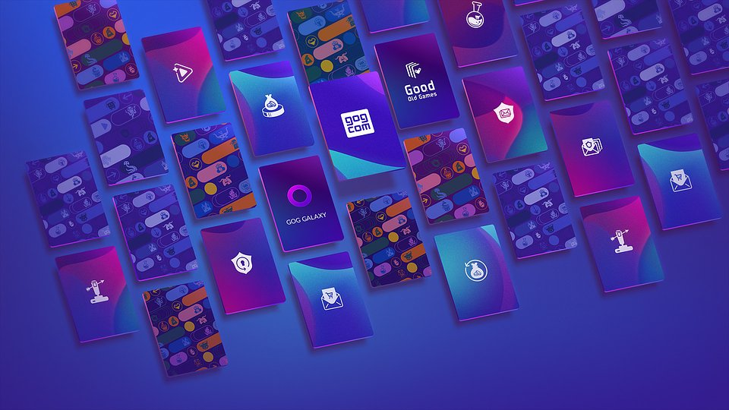

If you have an interest in game preservation and DRM-free initiatives, we invite you to get in touch with us. GOG representatives are eager to share their experiences and thoughts on these topics in interviews. As we have already witnessed more than once, games often vanish silently, which is why it is crucial to make a concerted effort to prevent our favorite titles from being forgotten.

For us, classic games mean more than just warm memories. They embody the rich history of video games, and our goal is to make them easily accessible to players through our platform, offering titles that are otherwise hard to find. That is why we go above and beyond to bring back iconic classics, ensuring they will never be forgotten or lost to time.Our DRM-free policy also plays an important role in preserving the legacy of video games, and it brings us great joy to stand alongside classic gaming enthusiasts in our joint mission of making games last forever.

- Maciej Gołębiewski, Vice President, Publishing &amp; Monetization

GOG is a treasure trove of classics that are worth checking after years. Below, we present you a list of 10 titles that you will not find in any other digital store. Friendly warning: the wave of nostalgia is strong!

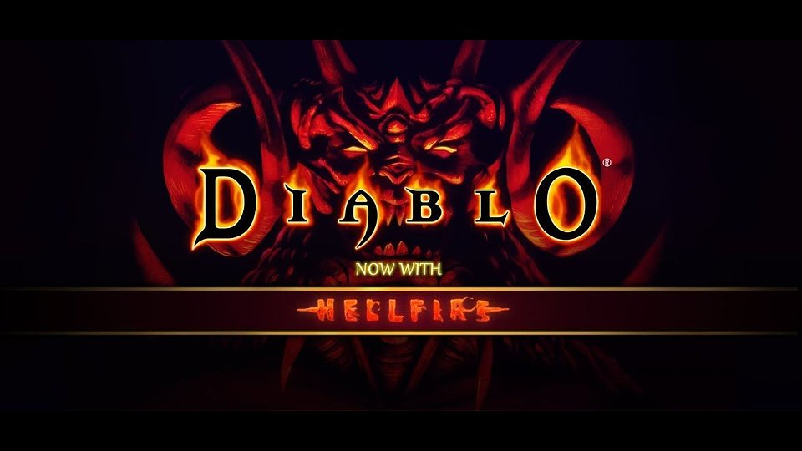

🕹️ Diablo + Hellfire – currently, everyone is busy leveling their characters in Diablo IV. However, it is worth looking back and seeing the circumstances in which one of the greatest game series was born, shaping an entirely new genre and captivating generations of gamers.

🕹️ The Settlers 2: 10th Anniversary Edition – The Settlers is a franchise that may have passed its prime, but it still holds a special place in the hearts of gamers as the epitome of perfect strategy games. It was easy to spend countless hours developing your kingdom and its virtual territories.

🕹️ Blood Omen: Legacy of Kain – an action-adventure game that introduced the acclaimed Legacy of Kain series. With its captivating storyline, players are immersed in a vast world, where they can indulge in over 100 hours of intense gameplay filled with blood-sucking and spell-casting.

🕹️ World in Conflict: Complete Edition – an RTS game that evokes a deep nostalgia for a genre that once dominated but now has taken a backseat. Immerse yourself in an alternate vision of the world in 1989, where World War III breaks out, and three powerful superpowers clash for domination. Experience the intense battles and strategic decisions as you navigate through this gripping conflict.

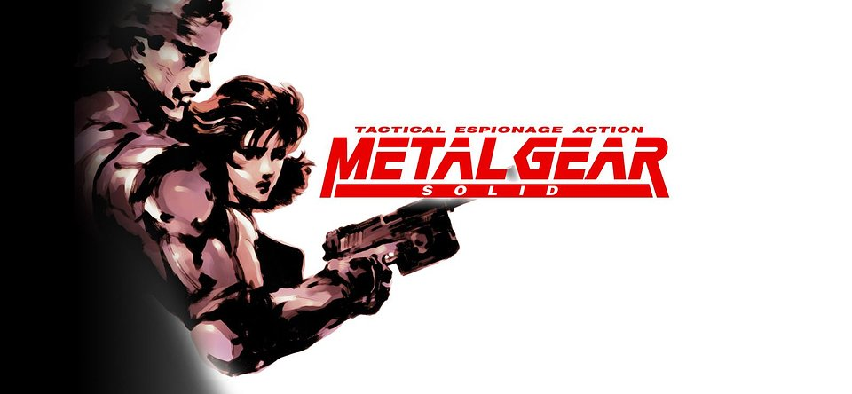

🕹️ Metal Gear Solid – a brand that is known by everyone, but have you ever had the chance to play the installment that celebrated its 25th anniversary this year? The internationally acclaimed PlayStation game made its way to PCs with improved graphics, additional features, and new gameplay modes.

🕹️ Might and Magic 6-pack Limited Edition – in this edition, you will find the first six beloved games from the series. However, the standout, and possibly the best installment is Might and Magic VI: The Mandate of Heaven. With its challenging combat system, engaging character development, and memorable storyline, it leaves a lasting impression. It is one of those titles that gains charm with each passing hour of gameplay.

🕹️ SWAT 4 Gold Edition – the last installment of the series that has captivated the hearts of tactical shooter enthusiasts. It is a goldmine of brilliant ideas and mechanics that could outshine many modern games.

🕹️ Warcraft I and II Bundle – strategies that you must know. It is precisely this style of gameplay that defined the RTS genre in the eyes of many players. These games, with their mechanics and even graphics, withstand the test of time. Just think about it, Warcraft II is already 28 years old!

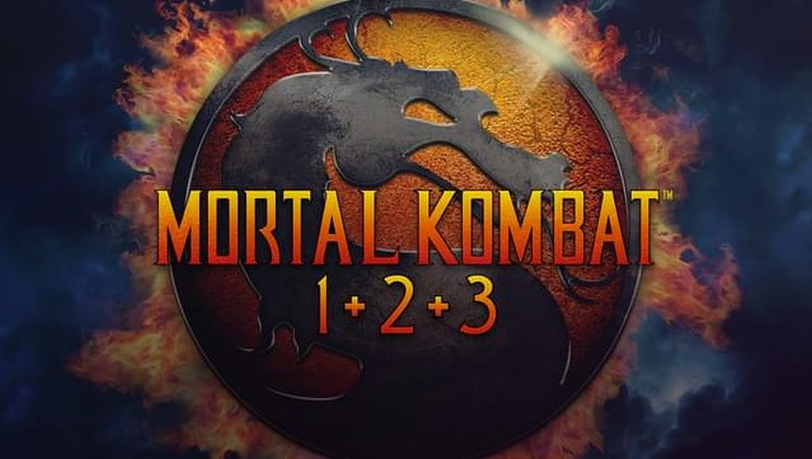

🕹️ Mortal Kombat 1+2+3 – a series that rose controversy and made the hair of older generations turn gray. The Mortal Kombat series introduced a new level of brutality to the world of video games that was previously unheard of. The series remains popular to this day, so it is worth taking a moment to see how the idea of the famous fatality was born.

🕹️ Neverwinter Nights 2 Complete – a must-have for all RPG games fans. This title comes from Obsidian Entertainment, which continues to deliver great games to this day. It offers an epic adventure set in the fantasy world of the Forgotten Realms, one of the most popular campaign settings of Dungeons &amp; Dragons. Dive into the game and unleash a plethora of wicked spells, feats, and prestige classes from the D&amp;D 3.5 ruleset.

These ten titles are just a fraction of what GOG has to offer. On the platform, you will find a wide selection of classics available in DRM-free versions. It is also worth checking the ongoing sale where mentioned games are available at discounted prices.

About GOG:We make games last forever – that is our motto. GOG is a friendly home for building and playing your curated game collection. It is a digital distribution platform that puts gamers first and respects their need to own games. We offer a rich selection of great DRM-free games, from modern hits to all-time classics, that you really should not miss.



Jakub Smolak
PR Specialist at better. gaming agency
jakub.smolak@bettergaming.pro
Twitter

