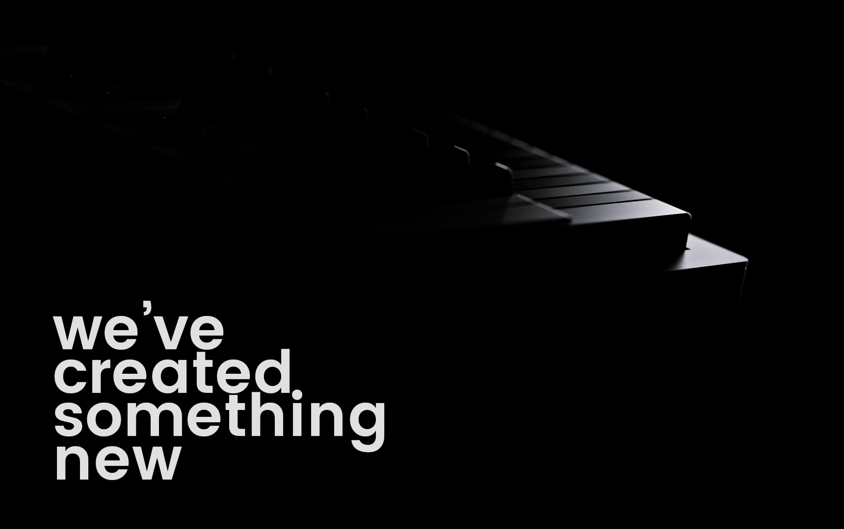
FOR IMMEDIATE RELEASE
Expressive E and Haken Audio Announce Their Collaboration on a New Electronic Music Instrument
This Groundbreaking New Expressive E Product Will Be Revealed Soon.

Paris, France, November 13, 2019 — Expressive E and Haken Audio, two leaders in researching the next generation of electronic instruments, announce their unique collaboration in creating a new product to be unveiled soon. This instrument will be available to pre-order on the Expressive E website for a limited-time, introductory price.

After several years of intense research and development, the Expressive E team visited some exceptional artists from around the world to give them hands-on test sessions with the instrument—in secret. Their expert feedback helped mold the finished product. Hear what some of these great talents had to say:

[VIDEO]

About the Collaborating Companies:

Haken Audio:
Haken Audio, maker of the Continuum Fingerboard and ContinuuMini electronic instruments with expressive control surfaces, has never before entered into a collaboration like this one.

The members of the Haken Audio team each have over 25 years of experience working on experimental sound design. Founder Dr. Lippold Haken began work on the Continuum in the early 1980s, and over the past decade has worked with Edmund Eagan on developing the EaganMatrix, a sound engine inspired by modular synthesizers that’s optimized for the three-dimensional finger movements of the Continuum Fingerboard.

Expressive E:
The French electronic instrument developer Expressive E has created the award-winning Touché controller, the award-winning Arché plug-in instruments, and the MPE Collection of sounds. Expressive E’s mission is to improve the way musicians interact with sounds by creating a much more intuitive and powerful music-making experience.

The company debuted its first product, Touché, to bring the same emotive depth, playing sensation, and expression of acoustic instruments to the world of synthesizers and electronic music-making. As with an acoustic instrument, the users’ fingers tap, press, or trace across the wooden touch plate to create new sounds with astonishing dimensions.
Expressive E builds an open ecosystem of hardware and software products, letting musicians rediscover their hardware and software synths simply by using Expressive E’s presets or creating their own presets in the Lié software.
With the Arché plugin suite of physically modeled violin, viola, and cello are expertly designed for use with a Touché or Touché SE, but also open up the company philosophy to any computer musician or composer who needs realistic string sounds.

https://www.expressivee.com/coming-soon
US and Canada
Jeff Touzeau
Hummingbird Media, Inc.
jeff@hummingbirdmedia.com
+1 (914) 602-2913
Markkus Rovito
Hummingbird Media, Inc.
markkus@hummingbirdmedia.com
+1 (575) 208-4782

