New initiatives help eneloop continue its positive impact
Zellik, 17 February 2019 – Panasonic’s sustainable battery brand, eneloop, and its green messaging is gaining momentum, with a number of recently announced initiatives taking place.

The Panasonic eneloop range offers ready-to-use rechargeable batteries that have gained popularity due to their greener footprint, and level of quality and reliability. The trusted batteries, which are manufactured in Japan, are pre-charged with solar energy and can be used up to 2,100 times (depending on battery type). They are used worldwide in both personal and professional settings and are a more cost-effective and environmentally friendly alternative to disposable batteries.

A satisfied customer

As an official partner for Cirque Du Soleil®, eneloop has made a positive impression as part of the Cirque Du Soleil® TOTEM tour. Sound Technician, Stephen Mendi comments, “We’re more than satisfied using the eneloop batteries as they have a fantastic capacity to be charged and discharged. Compared with other brands, they retain their charge very well, even over time without use. We’re going to continue using eneloop for a long time.”

Latest developments

Panasonic has made some recent announcements in relation to additional offerings as part of the eneloop range. Further, the company will be launching a campaign to raise money for non-governmental organisations (NGOs) and to spread eneloop’s brand messaging, “A Better Life, a Better World”. The underlying messages highlight preservation of the Earth’s beauty by rethinking how the world consumes products, using rechargeable batteries that are better for the environment and reconnecting with Mother Nature.

Reducing landfill

Panasonic has introduced new durable, reusable packaging for the eneloop range, which is currently only available online. The new packaging, made from recycled PET, is an alternative to the original single-use packaging. This will help to reduce the amount of waste going into landfill. The sturdy new packaging acts as a storage case, useful in the home and office.

Convenient recharging
A new pocket-sized USB charger for eneloop batteries was launched last week. The portable CC80 battery charger features two slots for charging two batteries at the same time. Compact and lightweight, the charger is convenient for travellers and those who are constantly on the go.

Giving back to the community

Panasonic is also announcing its [RE]CHARGE Activation campaign, which aims to immortalise the beauty of the planet, and making sure it stays that way. The 4-week photography campaign consisting of three teams will take a road trip through Europe. The campaign aims to raise money for three NGOs while increasing awareness around eneloop’s sustainability approach.

The teams will take photos according to eight different themes that have been selected to showcase the vast beauty of the planet. The best theme shot will be posted online by each team, where members of the public can ‘like’ them. The more ‘likes’ generated, the more funds can be raised for the dedicated NGO. Additionally, the road trip will be taken using electric cars.

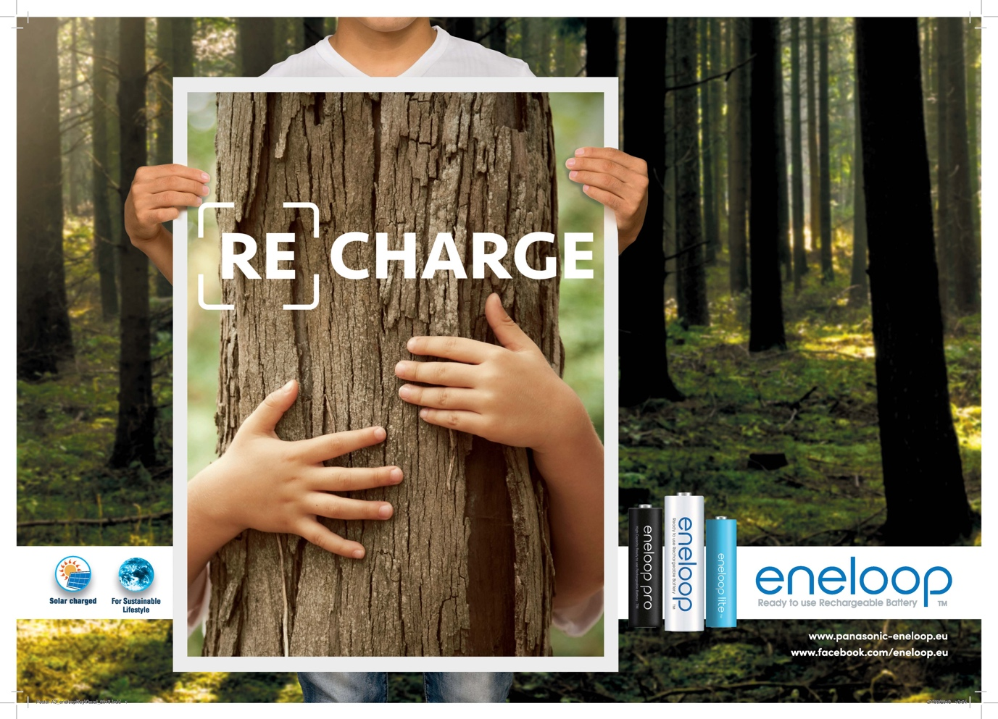

About Panasonic Energy Europe

Panasonic Energy Europe, with its headquarters in Zellik, near Brussels (Belgium), is a part of Panasonic Corporation, a leading provider of electrical and electronic devices. Thanks to Panasonic’s extensive experience in consumer electronics built up over many years, Panasonic has grown into the largest battery manufacturer in Europe. There are production units in Tessenderlo (Belgium) and Gniezo (Poland). Panasonic Energy Europe supplies ‘mobile’ energy in over 30 European countries. There is an extensive product range consisting of rechargeable batteries, chargers, carbon-zinc batteries, alkaline batteries, and specialised batteries (such as batteries for hearing aids, photo lithium, lithium button cells, micro-alkaline, and silver oxide). You can find more information on www.panasonic-batteries.com.

About Panasonic
Panasonic Corporation is one of the world’s major developers and manufacturers of electronic products for private, business, and industrial use. The company is located in Osaka (Japan) and on 31 March 2015 had achieved a net turnover of €57.28 billion. Panasonic is committed to creating a better life and a better world, continuously contributing to the evolution of society and to the happiness of people around the globe.
For more information about Panasonic and its brands, please visit www.panasonic.com.

PRESS CONTACT
ARK BBN
Ann-Sophie Cardoen
Project Manager
T +32 3 780 96 96
ann-sophie@arkbbn.be
www.arkbbn.be

Panasonic Energy Europe NV
Vicky Raman
Brand Marketing Manager
T +32 2 467 84 35
vicky.raman@eu.panasonic.com
www.panasonic-eneloop.eu

