Perfect audio surprises for our own personal heroes
Sennheiser gift guide for Father’s Day

Marlow, UK, 10 May, 2021 – Fathers are often our most important teachers, role models, no.1 fans and personal heroes. Following a year like none other, delighting our fathers with the gift of quality audio is a perfect way to say thank you. With Sennheiser’s line-up of audio gear, there are plenty of ways to show gratitude to the fathers in our lives, so that they can hear our appreciation all year round.

For the trendsetting Dad, wow him with the MOMENTUM 3 Wireless headphones (£349 / €399)
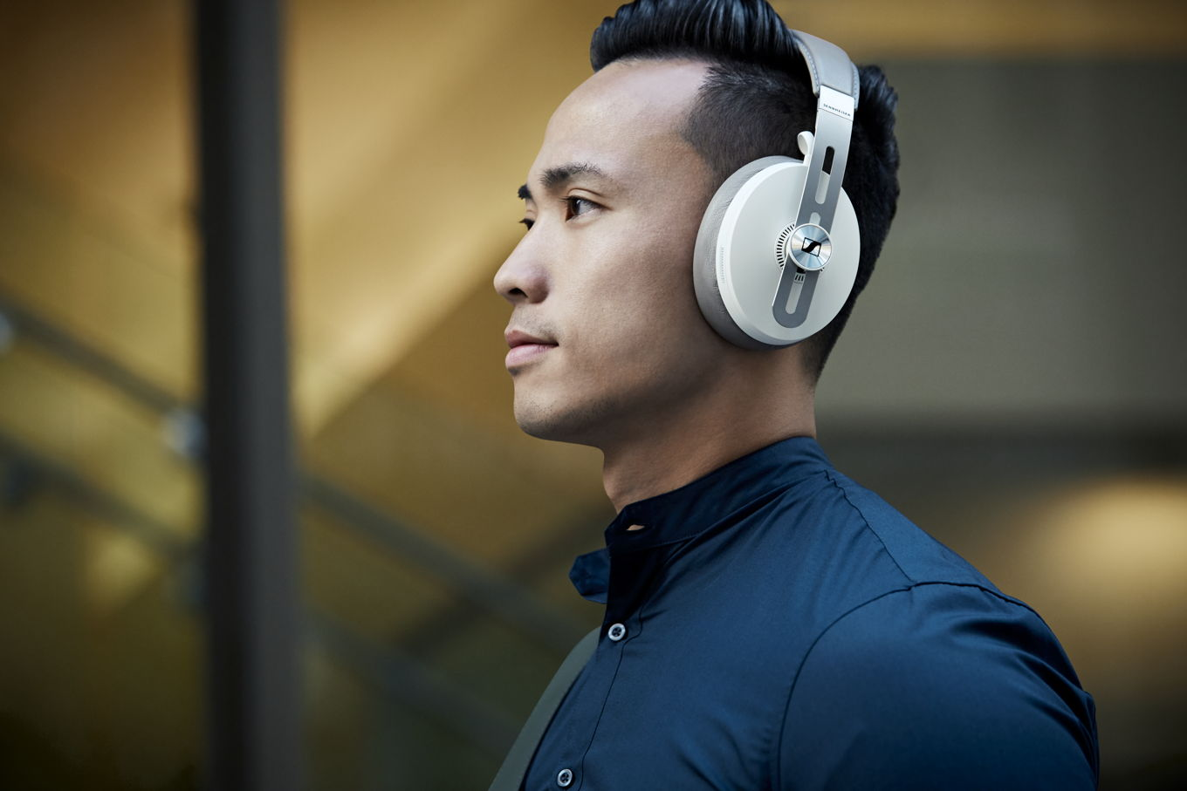
- Outstanding sound performance
- 17-hour battery life
- Three ANC modes and Transparent Hearing function
- Auto On/Off and Smart Pause
- Luxurious design with soft leather on the earpads and headband
- Tile Bluetooth tracker makes them almost impossible to misplace
- Available in black or sandy white from Sennheiser, John Lewis, Currys, Amazon, Richer Sounds, Harvey Norman and Arnotts

For the Dad on-the-go - ﻿MOMENTUM True Wireless 2 (£279 / €299)
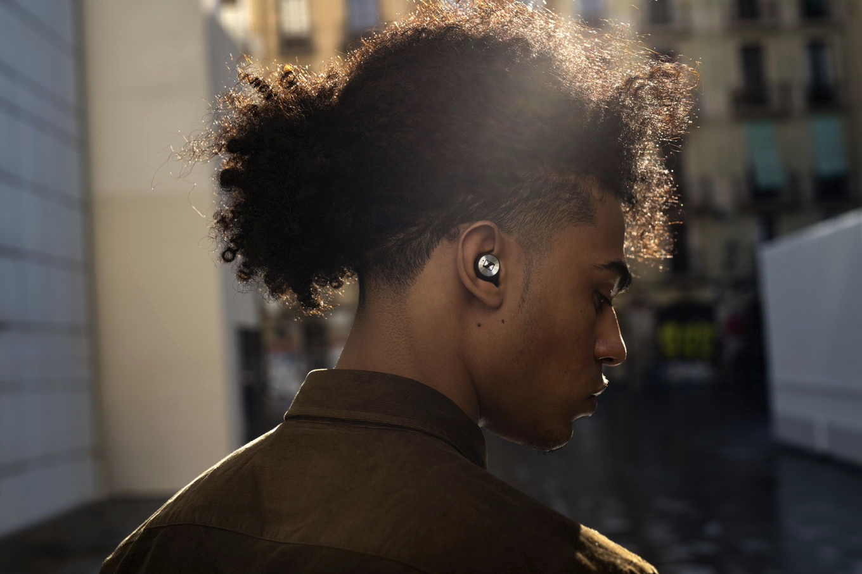
- Exceptional sound featuring Sennheiser’s 7mm dynamic drivers
- Active Noise Cancellation
- Transparent Hearing feature that blends in ambient noise at a touch
- Customisable touch controls and Smart Pause feature
- 7-hour battery life (+21 via the case)
- Available in black or white from Sennheiser, John Lewis, Currys, Amazon, Harvey Norman, Richer Sounds and Littlewoods

Give the gift of detailed sound to the audiophile in your life - IE 300 (£259 / €299)
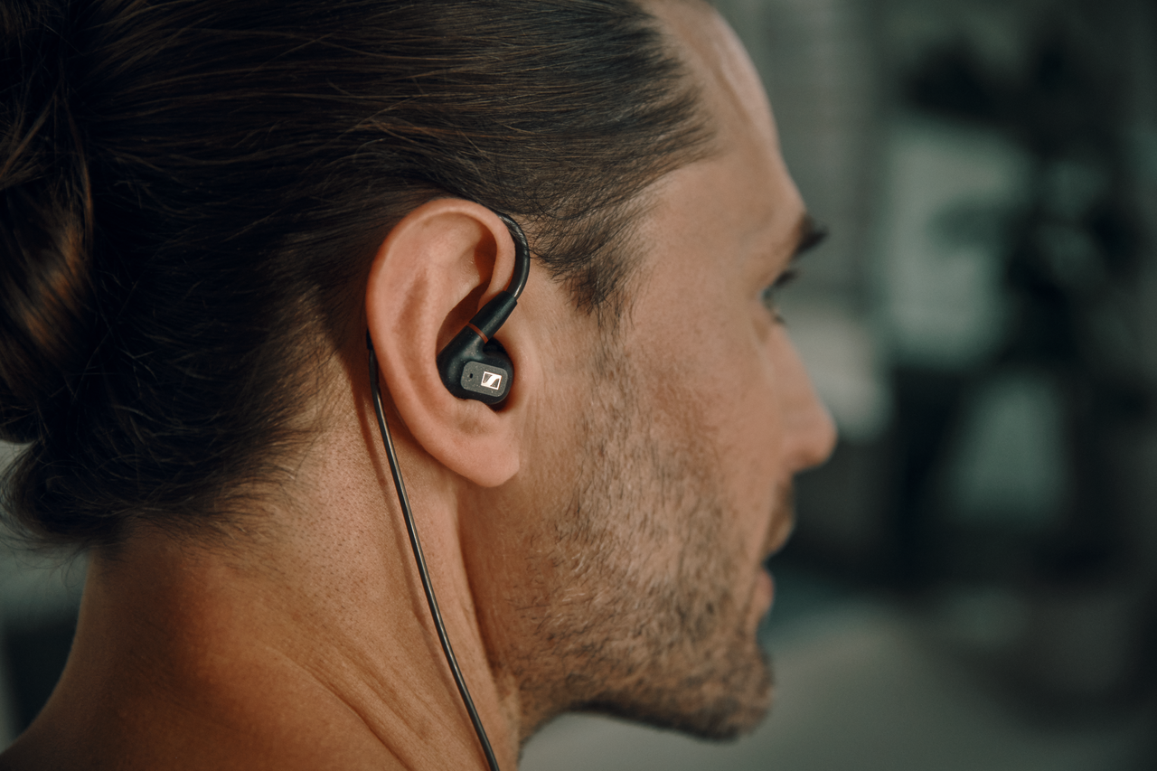
- Audiophile listening experience, wherever you are
- Premium, professional audio-inspired design with exceptional comfort
- Well-balanced sound and excellent sonic accuracy
- Optimum noise isolation to guarantee undisturbed listening
- Available to purchase in black from Sennheiser and Amazon

For the aspiring DJ Dad - HD 250BT (£59.99 / €69)
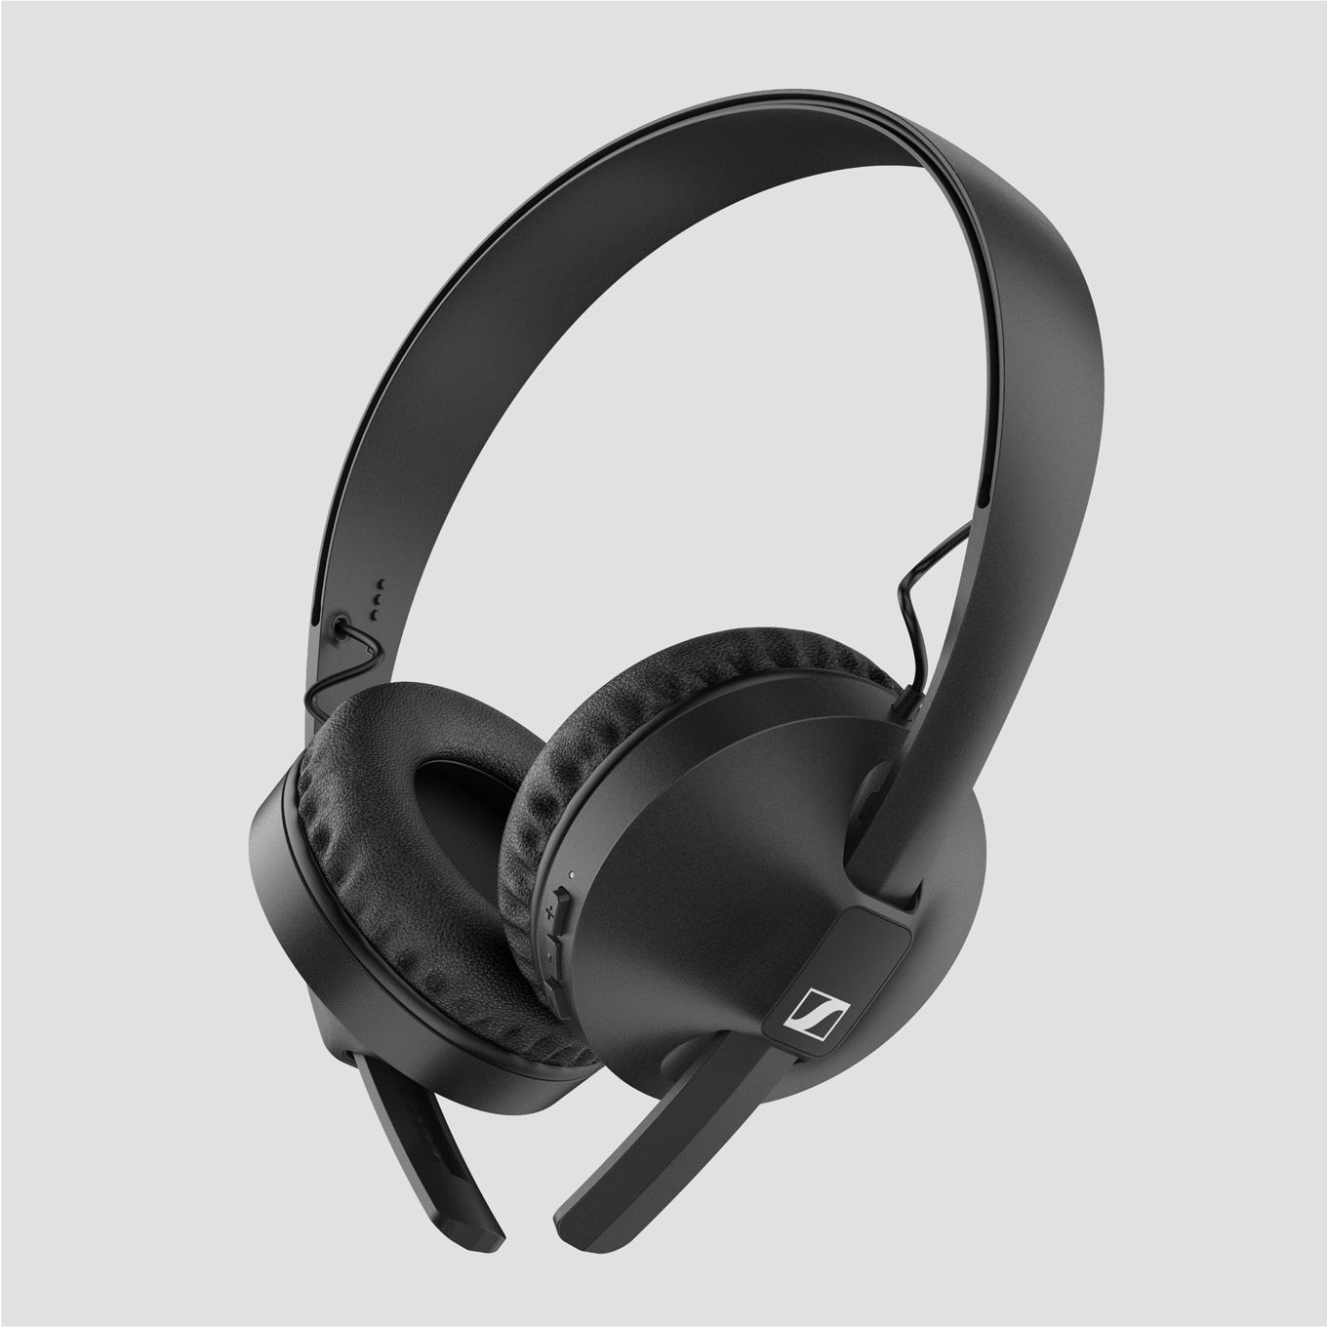
- A thrilling DJ-inspired audio experience, ensuring high quality audio with dynamic bass
- 25-hour battery life for a remarkable listening experience anytime, anywhere
- Advanced wireless technology and rugged design to keep up-to-speed with the busiest lifestyles
- Available in black from Sennheiser, Amazon and Harvey Norman

Press Contacts

Maik Robbe
maik.robbe@sennheiser.com
+44 (0) 7393 462484

Emily Ackland
sennheiser@harvard.co.uk
+44 7393 758442

