For more information, please contact Marta de Paco
On +34 670 780 664 or email press@comunicahair.com

Important:
These images are only available for editorial content.
Credits must be included.
Notification of their publication is expected.

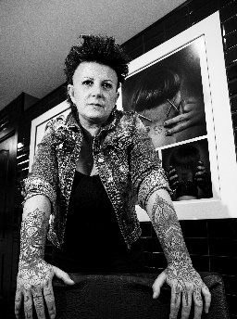
ANNA BARROCA
INTENSITY Collection

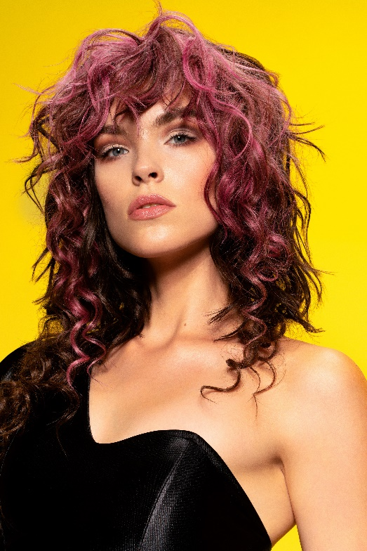
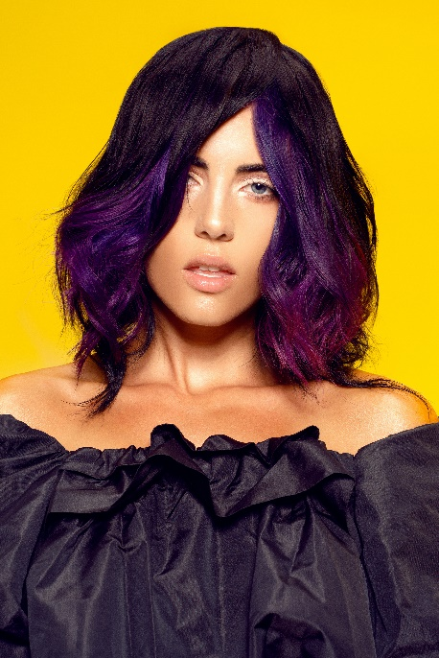

Hair: Anna Barroca
Hair Instagram @annabarroca
Photography: David Arnal
Photography Instagram @davidarnalteam
Make up: Anna González
Make up Instagram @iamlaflaca
Styling: IKKA’S & YONS
Styling Instagram: @ikkasshop @trendandsweet

ANNA BARROCA
INTENSITY Collection

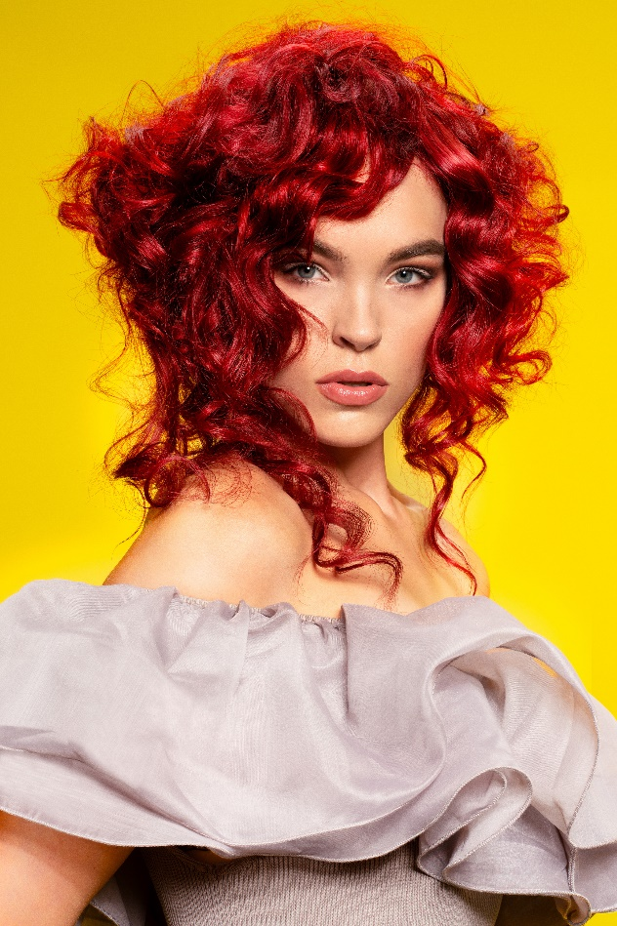

This collection is an exercise in strength and fluidity, an energy that catches you and is transmitted, projecting you into the future. The vibrant colors are mixed with smooth and wavy textures, showing that different forms exist for the same message, full of value and hope. Leather, satin and ruffles for a femininity that draws on the festive and powerful aesthetics of the 80s to launch itself into the conquest of the most current present. Life is a celebration that is explored at every moment no matter how dark it may seem.

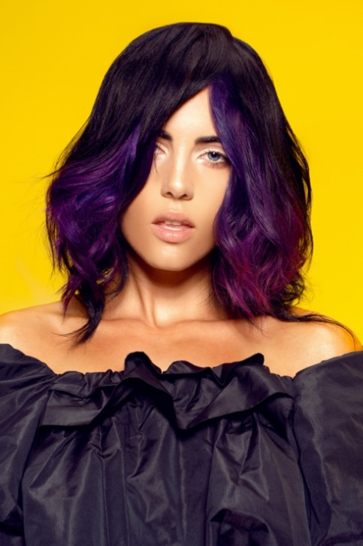

Hair glides in layers with a flowing force that is intensified by violet with burgundy undertones. The layered haircuts provide volume in a harmony created through different lengths. Details matter, they are the reflection of a unique essence.

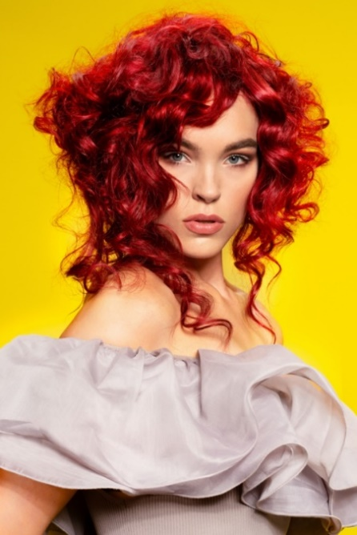

Hair can be a burning flame, a set of volumes that move to the beat of an inner cadence, indomitable, almost incomprehensible to strange eyes.
Curls create a unique architecture that faces forward to dismantle known geometries. It is time to create new forms, those dictated by the heart.

In the wind there is hardness, and in the rock there is comfort. By transforming old thoughts into codes of a new language, we prepare ourselves for transformation, one capable of understanding what seemed illogical.
Hair is full of movement, expression reinforced by the energy of orange, in a look that represents the dawn of being.
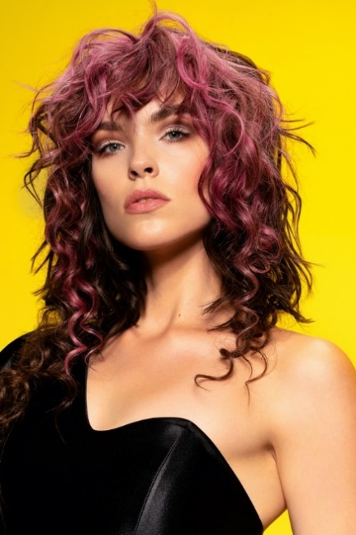

When I break an old scheme, I am creating a new one at the same time. That is the cycle of life, that of energy that transforms to become new again.
Nothing is like before and, although we look at our origin, every day we die to be born again. Curls are presented with different textures and color is like a score of shades and intensities. The result is an amazing and powerful look.

