Producer Jason Deift Selects RME’s Fireface UFX+ Interface for its Transparency When Mastering Pop Hits
Working on several Abigail Barlow tracks, Deift found the interface a perfect match for high-fidelity pop recording

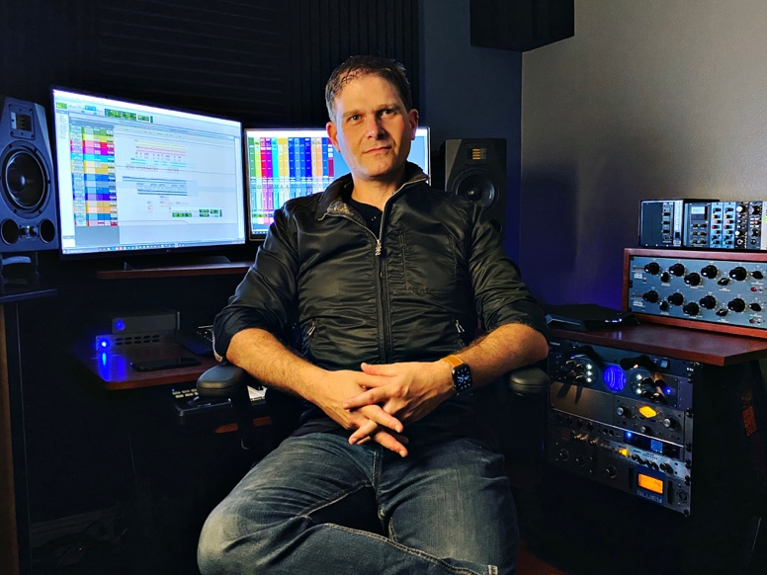
Alsio Veijo, California, October 19, 2020 — Producer Jason Deift has worked on a wide variety of projects out of his Orange County, California-based home studio over the last 25 years. With a focus on mastering, Deift recently got pinged by Adam Gubman of Moonwalk Audio to work with 21-year-old songstress Abigail Barlow on a few songs off her debut EP “Abigail.” Because of the pop nature of the tracks, Deift selected the fully transparent RME Fireface UFX+ audio interface.
“I selected the Fireface UFX+ because it is completely transparent and the converters are top notch,” Deift explained. “It’s pop material and pop is high-fidelity so it make sense to use a modern medium. You don’t want a lot of color on these recordings — what goes in you want to come back out.”
A Stable Solution
Deift mastered several of Barlow’s hits off her EP “Abigail” which rose on the iTunes charts in August, including “Jet Black Hearts” and “Heartbreak Hotel.”
“I was excited to start on this project because I could tell from the start that she was the real deal,” said Deift, who also builds his own PCs for his mastering work. “One of the reasons I chose RME is because I knew it was rock-solid, and its stability on PCs is fantastic. I run the interface as a thunderbolt setup, and the reliability with RME is unmatched.”
In addition to its pristine, transparent sound, the UFX+ provided Deift with just the right amount of stereo width he was looking for.
“The stereo is very wide and ultra clean,” he explained. “The UFX+ provides tons of gain and tons of headroom.”
Workflow Master
In addition to the Fireface UFX+, Deift also integrates RME’s TotalMix FX routing and mixing software — which comes with every RME interface — into his workflow.
“I use TotalMix every day,” Deift said. “It’s like a full blown DAW in and of itself. It’s very detailed, so every day I’m working, I’m also routing things into TotalMix. I absolutely love it.”
Deift explained his workflow as “a hybrid of plugins and hardware.”
“When I do mastering, I get the track — left and right channel, a 2-track — and I come out of the UFX+ and use a summing box. Out of the D box, I go into a bus compressor and then into a stereo limiter compressor,” he explained. “I then go back into ProTools and print. I use various other tools to sculpt and shape the track, but the D box is a great compliment because the UFX+ has 8 outputs, and it’s going into the D box and those 8 outputs are critical because if I didn’t have those, I couldn’t sum.”
An avid user of RME for the last 10 years, Deift said he can’t imagine using any other interface for his mastering work.
“RME’s interfaces just work,” he said. “With other interfaces I spend so much time fixing things. RME’s reliability is unsurpassed.”
For more on RME, visit rme-usa.com

About Synthax, Incorporated
Synthax Inc. is the exclusive USA distributor for RME digital audio solutions, Digigram broadcast audio systems, Appsys digital audio tools, Ferrofish advanced audio applications, myMix personal monitoring systems and ALVA cableware. We supply a nationwide network of dealers with these products for professional audio, broadcast, music industry, commercial audio, theater, military and government applications. For additional information, visit the company online at http://www.synthax.com.

Media Contacts:
Katie Kailus
Public Relations
Hummingbird Media
+1 (630) 319-5226
katie@hummingbirdmedia.com

Jeff Touzeau
Public Relations
Hummingbird Media
+1 (914) 602 2913
jeff@hummingbirdmedia.com

