For more information, please contact Marta de Paco
On +34 670 780 664 or email press@comunicahair.com

Important:
These images are only available for editorial content.
Credits must be included.
Notification of their publication is expected.

KUMENHAIR
JOSÉ GARCÍA BENÍTEZ
UMA Collection

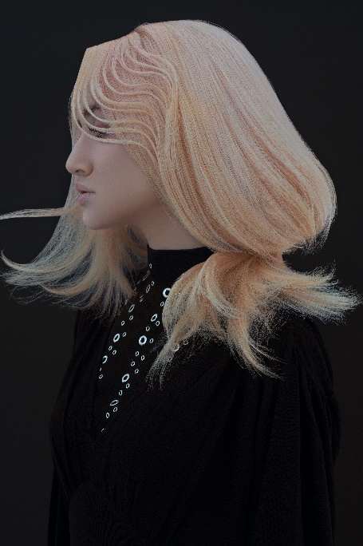
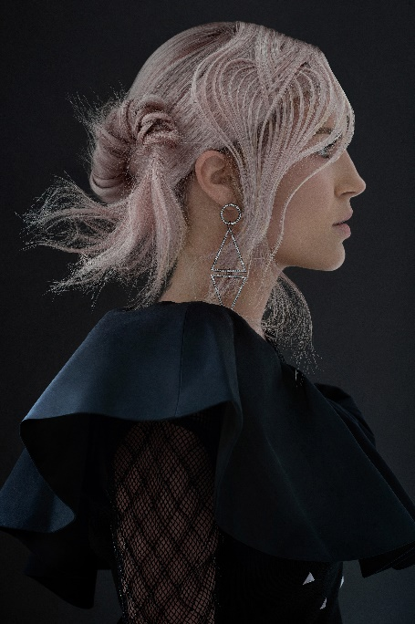
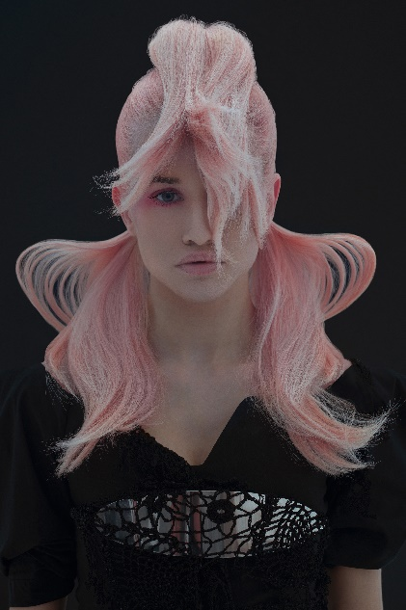

Hair: Kumenhair | @kumenhair
Hair Assistant: Yuleymi Sukeyna Boucif García | @yuleymi01
Photography: David Arnal | @davidarnalteam
MUA: Raúl Castaño | @raulcastam
Styling: Eunnis Mesa | @eunnismesa
Products: Revlon Professional @revlonprofessional_es

KUMENHAIR
JOSÉ GARCÍA BENÍTEZ
UMA Collection

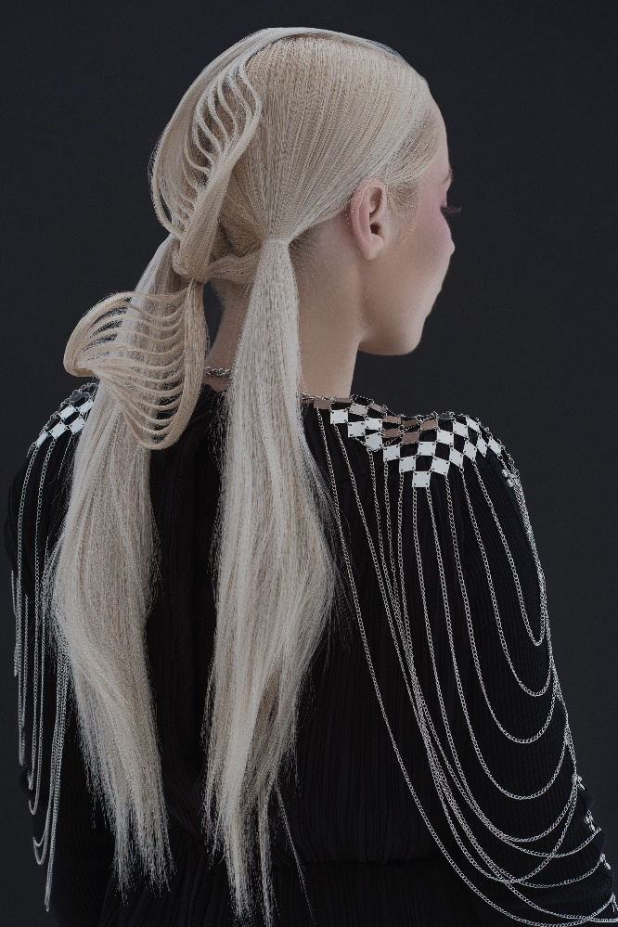

This innovative technique turns hair into a new geometric body. It remains rigid, creating the sensation of movement through sinuous shapes and unusual volumes. At the same time, these new contours convey an idea of lightness and fragile delicacy. The result is transformative and pure beauty.

