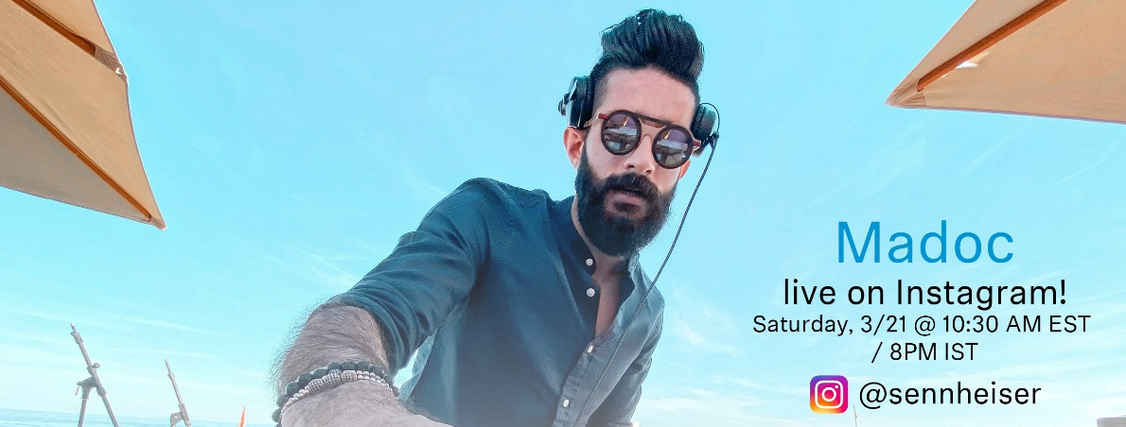#DontStopTheMusic with Madoc
Sennheiser’s #DontStopTheMusic series continues: Exclusive streaming concert with Madoc on March 21 at 10:30 a.m. (EST) / 8 p.m. (IST)

Wedemark/Germany, March 20, 2020 – After concerts with Mousse T., Love Fame Tragedy and Logan D., Sennheiser’s exclusive streaming concert series #DontStopTheMusic continues with the DJ Madoc from India. Now more than ever, when many artists had to cancel or postpone their live tours and public life as we know it no longer takes place, the music must not stop! Therefore, Sennheiser has initiated the series of exclusive streaming concerts on the company’s Instagram account, which will be broadcasted via IGTV (Instagram TV).

Further dates will be announced soon on http://www.sennheiser.com/anniversary. Beyond announcements of dates, the website contains numerous music videos with immersive recordings from jazz clubs, electro sets in a living room atmosphere as well as live recordings from recording studios. Just put on your headphones or turn up the speakers and dive into the music.

For your social media channels:
Exclusive concert with Madoc (madocofficial) on March 21 at 10:30 a.m. (EST) / 8 p.m. (IST) as part of the new streaming concert series on IGTV by Sennheiser (@Sennheiser). #DontStopTheMusic #TogetherAtHome
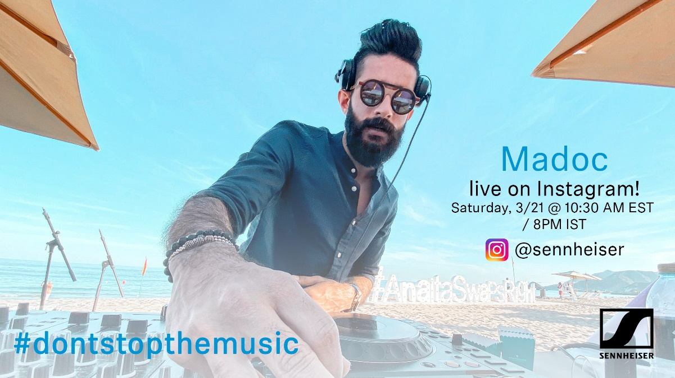

about Sennheiser
Founded in 1945, Sennheiser is celebrating its 75th anniversary this year. Shaping the future of audio and creating unique sound experiences for customers – this aim unites Sennheiser employees and partners worldwide. The independent family company, which is managed in the third generation by Dr. Andreas Sennheiser and Daniel Sennheiser, is today one of the world’s leading manufacturers of headphones, loudspeakers, microphones and wireless transmission systems. In 2018, the Sennheiser Group generated turnover totaling €710.7 million. www.sennheiser.com

Press Contact

Mareike Oer Stephanie Schmidt
mareike.oer@sennheiser.com stephanie.schmidt@sennheiser.com
T +49 0(5130) 600 – 1719 T +49 0(5130) 600 – 1275

