Sennheiser and Audinate present webinar on DANTE and TeamConnect Ceiling 2
Webinar on September 18 features presentations from Sennheiser and Audinate product specialists

Wedemark, September 11, 2019 – On Wednesday, September 18, 2019, at 11 a.m. EDT (5 p.m. CEST), Sound & Video Contractor will bring together experts from both Sennheiser and Audinate to host a webinar titled “The Advantages of Ceiling Microphones with Dynamic Beamforming Technology and Dante.” The webinar will focus on Sennheiser’s innovative TeamConnect Ceiling 2 – which is Dante Domain Manager ready — and will address how Dante brings IT’s best practices to the AV world by making audio networking more secure, scalable and controllable than ever before. The webinar is open to all who register on the event registration website.

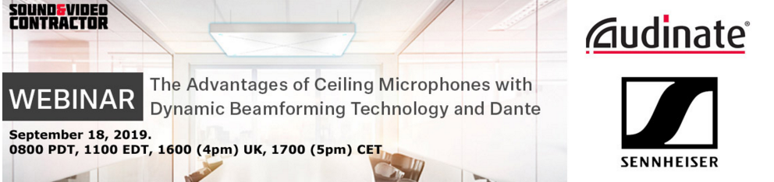

Rather than using many static beam zones and multiple DSP channels, Sennheiser's TeamConnect Ceiling 2 microphone needs only a single dynamic microphone beam and a Dante network to pick up superior audio in any conference room.

Optimizing speech intelligibility with 28 individual, omni-directional microphone capsules, TeamConnect Ceiling 2 automatically focuses on the voice of the speaker in a meeting, regardless of positioning. Simple to integrate and compatible with existing audio and video conferencing systems, the microphone array automatically adapts to any room layout without reconfiguration.

Once installed, the TeamConnect Ceiling 2 microphone does not require any ongoing maintenance. It can be seamlessly integrated into both analogue and digital environments, featuring the necessary connectors and Power over Ethernet capability. For integration into Dante networks, the microphone features two Dante ports for redundant operation and supports Dante Domain Manager.

Speakers include:
Christoph Eppert: Training Supervisor & Field Support Engineer, Sennheiser
Christoph has over 23 years of experience as radio TV technician, technical supervisor and project manager and has held various roles in sales and marketing. As the training supervisor and field support engineer for Sennheiser, Christoph is leading business communication product trainings for sales teams as well as system integrators and end users worldwide.

John McGregor: Product Trainer, Sennheiser Sound Academy
John has been an audio engineer for 20 years with experience covering studio engineering and video post-production before moving into full-time lecturing of audio engineering in 2005. In 2010, John moved into a sales role representing Avid and Blackmagic Design in the Middle East. Since 2014, John has been with Sennheiser, starting off based in Dubai and moving over to the Sennheiser headquarters in Wedemark, Germany in August 2017 to take up a role in the Sennheiser Sound Academy, where he is responsible for training and training development for the Sennheiser Pro Audio division.

Jens Werner: Product Manager – Meeting & Conferencing Solutions, Sennheiser
As the product manager of Sennheiser’s meeting and conferencing solutions, Jens is leading the product innovation for its beamforming technology, especially the TeamConnect Ceiling 2 microphone among other meeting and conferencing solutions like the popular ADN conference system. He has over 21 years of experience as IT developer, project engineer and solutions expert for conference and infra-red solutions.

Kathryn Taub: Technical Sales Engineer, Audinate Inc.
Kathryn works for Audinate as a Technical Sales Engineer providing pre-sales support and training for AV integrators and end users on Dante. She received her Bachelor’s degree from Berklee College of Music, where she first fell in love with audio technology. Prior to working at Audinate, Kathryn spent many years working at Berklee in a variety of technical roles designing, supporting and training on audio technology.

To register for “The Advantages of Ceiling Microphones with Dynamic Beamforming Technology and Dante,” please visit the event registration website.

About Audinate
Audinate Group Ltd (ASX:AD8) has a vision to pioneer the future of AV. Audinate’s award winning Dante AV over IP networking solution is the worldwide leader and used extensively in the professional live sound, commercial installation, broadcast, public address, and recording industries. Dante replaces traditional analogue cables by transmitting perfectly synchronized AV signals across large distances, to multiple locations at once, using nothing more than an Ethernet cable. Audinate is headquartered in Australia and has regional offices in the United States, United Kingdom and Hong Kong. Dante technology powers products available from hundreds of leading audio partners around the world. The company’s ordinary shares are traded on the Australian Securities Exchange (ASX) under the ticker code AD8.
Dante and Audinate are registered trademarks of Audinate Group Ltd.

About Sennheiser
Shaping the future of audio and creating unique sound experiences for customers – this aim unites Sennheiser employees and partners worldwide. Founded in 1945, Sennheiser is one of the world’s leading manufacturers of headphones, loudspeakers, microphones and wireless transmission systems. Since 2013, Sennheiser has been managed by Daniel Sennheiser and Dr. Andreas Sennheiser, the third generation of the family to run the company. In 2018, the Sennheiser Group generated turnover totaling €710.7 million. www.sennheiser.com

Local press contact Global press contact

Jeff Touzeau Stephanie Schmidt
jeff@hummingbirdmedia.com stephanie.schmidt@sennheiser.com
+1 (914) 602-2913 +49 (5130) 600 – 1275

