(Photo by Ben Foster / @gnarlybravo)

UK pop star Anne-Marie relies on Sennheiser Digital 6000 for unparalleled audio
Digital 6000 provides unparalleled sound quality, an exceptionally wide dynamic range, and bullet-proof reliability even in the most challenging RF scenarios

Wedemark, September 26, 2023. Over the past decade, Anne-Marie has emerged as one of Britain’s most brilliant female artists. In the ten years since she released her earliest demo, which was shared by Ed Sheeran on Twitter, and secured a position as a touring vocalist for drum n’ bass giants Rudimental in 2014, her distinctive brand of personality-infused pop has garnered billions of streams. As a testament to her remarkable achievements, she recently received a prestigious BRIT Billion Award, and has successfully collaborated with artists, including on her first UK number one hit ‘Rockabye’, a collaboration with Clean Bandit and Sean Paul. Currently on tour promoting her third album Unhealthy, the singer relies on Sennheiser’s Digital 6000 microphone system, which provides unparalleled sound quality, an exceptionally wide dynamic range, and bullet-proof reliability even in the most challenging RF scenarios.

Having cultivated a successful working relationship with the Relationship Management team at Sennheiser, Edd Sedgwick, Anne-Marie’s Tour & Production Manager, has become a passionate advocate of the Digital 6000 series. He has actively collaborated with Peter Craig, the UK Relations Manager, and the entire Sennheiser crew to bring several artists on board with their Digital 6000 wireless microphone system, which Anne-Marie has also been using for several years.

“The D6000 boasts a modern and premium appearance while also demonstrating remarkable robustness,” begins Sedgwick. “Even amidst unexpected mishaps, such as an accidental mic drop, this resilient workhorse ensures the show must, and will, go on without missing a beat.

“It gives artists confidence; they know it’s going to be a good show with the D6000. Performers can run down into the crowd and interact with the audience without worrying about the range, and Anne-Marie usually does that with her fans. The interchangeability of capsules is a really big factor, too.”

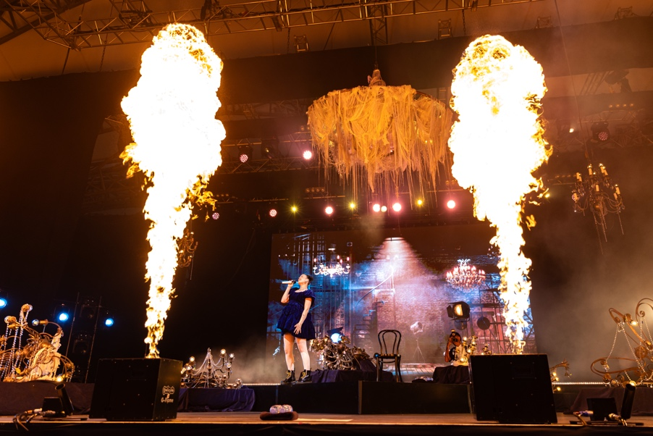 | Singer Anne-Marie relies on Sennheiser's Digital 6000 microphone system  (Photo by Ben Foster / @gnarlybravo)

A range of capsules are used depending on the size of the show, which can range from mammoth-capacity stadium gigs to small-scale acoustic performances for Anne-Marie. A more sensitive capsule is used if the stage is large, empty, and more prone to room reflections and noise, but equally it can be quickly changed to adapt to a more intimate show that needs a much tighter super-cardioid capsule. This minimises any issues with the artist being in front of the PA.

“The interchangeability of capsules is a great selling point for someone who does shows ranging from stadiums and festivals to large indoor corporate events, knowing we can always get the best and cleanest sound for Anne-Marie’s vocal,” says Monitor Engineer, Joe Standen. “For us, having the option of analogue and AES outputs is a great advantage, too, we can also process each output separately and have full control of her vocal. We personally don’t use the Dante option but it’s great to know it’s there if we ever needed it.”

The Digital 6000 series is popular with artists embarking on large-scale tours, as its reliability guarantees unrivalled sound quality for any size of stage or production. It delivers a wider dynamic range even in the most challenging RF scenarios and, working with Sennheiser’s proprietary Digital Audio Codec (SeDAC), it also ensures the highest quality. Anne-Marie chose the Sennheiser Digital 6000 series as it aesthetically works for her, too, especially in the custom white. “Anne-Marie loves using the D6000 series, she owns her own system. It’s her choice of transmitter and we’ve never had a problem with it. She’s been using D6000 for as long as I can remember,” explains Sedgwick.

Edd Sedgwick: “It gives artists confidence; they know it’s going to be a good show with the D6000. Performers can run down into the crowd and interact with the audience without worrying about the range, and Anne-Marie usually does that with her fans.”

(Photo by Ben Foster / @gnarlybravo)

Front of House Engineer Chris Whybrow adds, “Where the vocal sound has to be precise, transparent and rock-solid with no compromises, the 6000 series provides the confidence that it will be delivered to the channel crystal-clear for FOH, monitors and broadcast. Anne-Marie’s vocal is the most important thing to put across so trusting we have the tools to do that is a great reassurance, and we can choose a capsule that captures her vocal exactly as it needs to.”

One of the most notable shows for Anne-Marie and Digital 6000 was her appearance at Capital’s Summertime Ball at Wembley Stadium back in June. It was headlined by a star-studded line-up of huge acts including Niall Horan, The Jonas Brothers, RAYE and Calvin Harris, and Digital 6000 ensured that Anne-Marie’s performance sounded neat, streamlined and as powerful as possible.

“We love the Sennheiser 6000 series on Anne-Marie. It’s a very sleek and attractive design, whilst being robust, especially now it’s white – nicknamed the stormtrooper,” says Standen. “The unit gives our artist confidence that she can venture off into the crowd or a large B-stage and we never have to worry about dropouts due to its resistance to interference and efficient use of bandwidth and LR mode.”

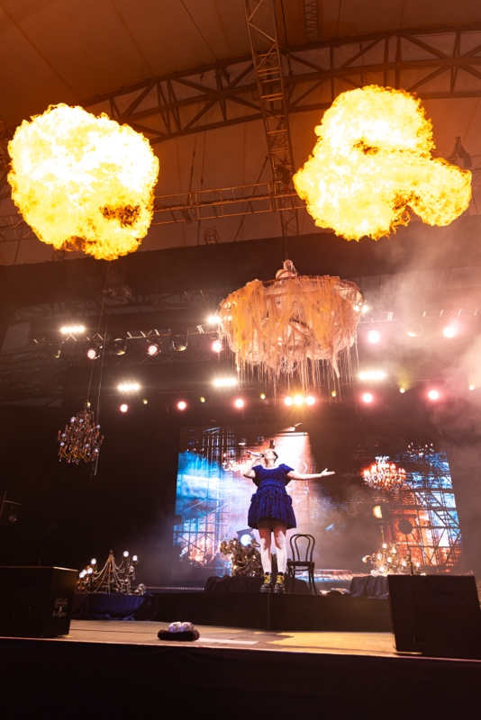 | The Digital 6000 series is popular with artists embarking on large-scale tours, as its reliability guarantees unrivalled sound quality for any size of stage or production  (Photo by Ben Foster / @gnarlybravo)

“I was looking after several artists at this year’s Summertime Ball, including Jax Jones and Sigala, as well as Anne-Marie,” Sedgwick continues. “All of them were using the D6000 series. Sennheiser has always been a brand that I’ve turned to. We know that they will deliver what we need at the shows, especially the larger-scale stadium events. The flexibility really is key with performers like Anne-Marie.”

In addition to his role as Tour & Production Manager with Anne-Marie, Sedgwick also operates his own business, The Fly Pack Company. The company specialises in providing customised fly pack solutions featuring Sennheiser IEMs and Digital 6000, along with evolution wireless G4 microphone systems. These pre-configured systems present a compact and flyable solution that conveniently fits within a PelicanTM case, serving as a portable luggage case for artists while on the move. “This represents yet another avenue through which we extend support to all our artists, ensuring they have these systems readily available no matter where their journey takes them,” he elaborates.

Anne-Marie’s loyalty to Sennheiser is one that is shared by many of the biggest popstars on the current circuit. “With unmatched sound quality at its core, the D6000 series gives artists the confidence they need to perform in any size of venue, to any size of audience, ensuring that the vocal delivery is always crystal clear,” Sedgwick concludes.

(Ends)

The high-resolution images accompanying this media release can be downloaded here.

About the Sennheiser Group

Building the future of audio and creating unique sound experiences for our customers - this is the aspiration that unites the employees of the Sennheiser Group worldwide. The independent family-owned company Sennheiser was founded in 1945. Today, it is managed in the third generation by Dr. Andreas Sennheiser and Daniel Sennheiser and is one of the leading manufacturers in the field of professional audio technology.

sennheiser.com | neumann.com | dear-reality.com | merging.com

Local Press Contact
Maik Robbe
Maik.Robbe@sennheiser.com
+49 (5130) 600 – 1028

