
FOR MORE INFORMATION:
Sarah Wynn Benton
BRAVE Public Relations
404.233.3993
sbenton@emailbrave.com

FOR IMMEDIATE RELEASE

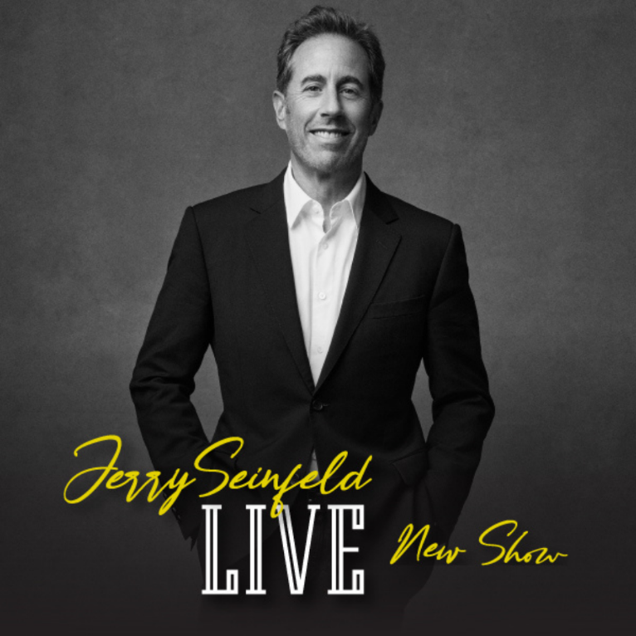
JS Touring Presents Jerry Seinfeld at Fox Theatre on Oct. 26

ATLANTA – (June 10, 2024) – Fox Theatre, and JS Touring, announced today that America’s premier comedian, Jerry Seinfeld, will perform on the Fox Theatre stage on Saturday, Oct. 26 at 8 p.m.! Tickets are on sale now.

America’s premier comedian, Jerry Seinfeld, comes to the Fox Theatre stage in Atlanta to perform his newest stand-up routine on Saturday, Oct. 26 at 8 p.m. Seinfeld has been hailed for his uncanny ability to joke about the little things in life that relate to audiences everywhere.

Jerry Seinfeld’s comedy career took off after his first appearance on “The Tonight Show with Johnny Carson” in 1981. Eight years later, he teamed up with fellow comedian Larry David to create what was to become the most successful comedy series in the history of television, “Seinfeld.” The show ran on NBC for nine seasons, winning numerous Emmy, Golden Globe and People’s Choice awards, and was named the greatest television show of all time in 2009 by TV Guide, and in 2012 was identified as the best sitcom ever in a 60 Minutes/Vanity Fair poll.

His latest Emmy-nominated Netflix projects include “Jerry Before Seinfeld” and “23 Hours to Kill” along with the highly-acclaimed web series “Comedians in Cars Getting Coffee.” Seinfeld has also starred in, written, and produced movies (“Comedian” and “Bee Movie”), directed and produced a Broadway hit (“Colin Quinn Long Story Short”), and wrote three best-selling books (“Is this Anything?,” “Seinlanguage,” and “The Comedians in Cars Getting Coffee Book”) and a children’s book (“Halloween”). He stars in the comedy film, “Unfrosted,” which he directed, co-wrote, and produced. Seinfeld continues to perform both nationally and internationally.

Tickets are on sale now.

WHAT: Jerry Seinfeld

WHEN: Saturday, Oct. 26, 2024 at 8 p.m.

WHERE: Fox Theatre

TICKETS ON SALE: Now

TICKETS: Tickets start at $57.50

Ticket info: Tickets are available for purchase at foxtheatre.org

###
About the Fox Theatre
The Fox Theatre is one of Atlanta's premier venues for live entertainment, welcoming more than 200 performances a year in its 4,665-seat theatre. From concerts to ballets, comedy, and movies, the historic venue attracts more than 500,000 visitors annually. The theatre hosts over 100 annual private events like wedding receptions, trade shows, corporate meetings, and association functions in two fabulous ballrooms. The Fox’s premium Marquee Club, presented by Lexus, is a 10,000 sq. ft, three-story luxury bar accessible to all Club Level ticket holders or annual members of the Fox Theatre. As a 501(c)(3) nonprofit arts organization, the Fox Theatre is a fiercely protected landmark and nationally acclaimed theatre today. The Fox Theatre proudly acknowledges its partners' generous support: Coca-Cola, Georgia Natural Gas, Georgian Terrace Hotel & Livingston Restaurant, Humana, Lexus, Northside Hospital, and Regions Bank. Tickets for all events are available at FoxTheatre.org, or toll-free at 855-285-8499. Stay connected by following the Fox Theatre on social via @theFoxTheatre on Instagram, Twitter, and Facebook.
Notable accolades include 2023 Billboard Magazine #2 Highest Grossing Theatre Worldwide (5,000 seats or less); 2023 VenuesNow Magazine #2 Year-End Top Stops (2,001-5,000 seats); 2022 IEBA Theatre of the Year; 2021 Billboard Magazine #1 Highest Grossing Theatre Worldwide (5,000 seats or less); 2021 Pollstar Magazine #2 Theatre Worldwide in Ticket Sales and 2021 VenuesNow Magazine #2 Year-End Top Stops (2,001-5,000 seats). Additionally, in 2019, the Fox Theatre was honored with the VenuesNow #1 Top Stop of the Decade Award for Tickets Sold, further cementing its reputation as a premier entertainment venue.

