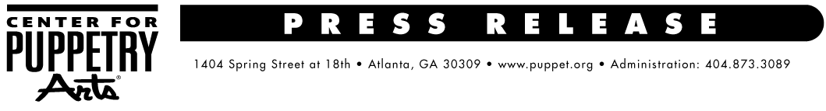
For more information, contact:
Becca Meyer / Jennifer Walker
BRAVE Public Relations, 404.233.3993
bmeyer@bravepublicrelations.com /
jwalker@bravepublicrelations.com

Billy Goats Gruff & Other Stuff crosses the bridge to the Center for Puppetry Arts,
August 10 – 13
Local production company presents one-man show featuring family-friendly tales

ATLANTA (July X, 2017) – The Center for Puppetry Arts is pleased to present Billy Goats Gruff & Other Stuff performed by All Hands Productions of Atlanta, August 10 – 13. Families are invited to meet a cantankerous troll, persnickety chickens, a wolf that’s allergic to blueberries and a host of other kooky characters in this mixture of traditional folk tales, witty original stories and silly songs! The show is sure to have guests tapping their toes and laughing out loud. Billy Goat’s Gruff & Other Stuff will be performed by David Stephens, founder of All Hands Productions. Stephens, a multi-talented solo puppeteer and banjo player, will puppeteer and voice all of the various characters as well as perform music for four separate stories including the tale of Little Red Riding Hood.

For more than a decade, All Hands Productions has been dedicated to bringing quality puppet productions to children and their parents. Billy Goats Gruff & Other Stuff is the winner of a 2005 UNIMA-USA Citation of Excellence (American puppetry’s highest honor). This performance is recommended for children ages 4 and older.

WHAT: Billy Goats Gruff & Other Stuff presented by All Hands Productions

WHEN: Regular show times are as follows:
August 10 – 13
Thursday and Friday: 10 a.m. and 11:30 a.m.
Saturday: 11 a.m. and 1 p.m.
Sunday: 1 p.m. and 3 p.m.

WHERE: Center for Puppetry Arts
1404 Sprint Street NW
Atlanta, GA 30309
Billy Goats Gruff & Other Stuff is presented in the Mainstage Theater

HOW: Tickets are $9.75 (Members) and $19.50 (nonmembers) – plus sales tax. Tickets include admission to the performance, the Worlds of Puppetry Museum (with the largest collection of Jim Henson puppets and artifacts in the world as well as a Global Gallery), and entrance to the Create-A-Puppet Workshop™, where guests can make and decorate their own special Cheerful Chicken Rod Puppet and perform with it on our classroom stage. Tickets are available online at www.puppet.org or by calling 404.873.3391.

###
The Center for Puppetry Arts is supported in part by: Fulton County Arts Council • City of Atlanta Mayor’s Office of Cultural Affairs • Georgia Council for the Arts • The Zeist Foundation • The Jim Henson Company
For a complete list of the Center’s major supporters visit www.puppet.org/about/sponsors.
Center for Puppetry Arts® is a unique cultural treasure – a magical place where children and adults are educated, enlightened, and entertained. Since 1978, the Center has introduced millions of visitors to the wonder and art of puppetry and has touched the lives of many through enchanting performances, curriculum-based workshops, and the hands-on Museum as well as Distance Learning and Outreach programs. Center for Puppetry Arts is a non-profit, 501(c)(3) organization and is supported in part by contributions from corporations, foundations, government agencies, and individuals. Major funding is provided by the Fulton County Board of Commissioners and the City of Atlanta Mayor’s Office of Cultural Affairs. These programs are also supported in part by the Georgia Council for the Arts through the appropriations of the Georgia General Assembly. GCA is a partner agency of the National Endowment for the Arts. The Center is a member of Theatre for Young Audiences (TYA/USA/ASSITEJ).The Center also serves as headquarters of UNIMA-USA, the American branch of Union Internationale de la Marionnette, the international puppetry organization.

