**RELEASED: Thursday 12th October, 2017**

**Stars come out for new ABC comedy *Squinters***

ABC and Screen Australia in association with Create NSW are pleased to announce that filming is underway in Sydney this week on Jungle’s new six-part comedy series ***Squinters****,* a series that celebrates the great Aussie ritual that is the everyday work commute.

An extraordinary ensemble cast includes beloved performer/composer Tim Minchin, Academy-Award nominee Jacki Weaver, Miranda Tapsell, Mandy McElhinney, Damon Herriman, Sam Simmons, Andrea Demetriades, Wayne Blair, Christiaan Van Vuuren, Justin Rosniak and Jenna Owen, along with young comic talents Susie Youssef (*Rosehaven*), Rose Matafeo (NZ’s *Funny Girls*), Steen Raskopoulos (BBC’s *Top Coppers*), *YouTube* sensation John Luc (aka ‘MyChonny’) as well as the UK’s Nyasha Hatendi (Hulu’s *Casual*).

Created by Trent O’Donnell (*The Moodys, No Activity*) and Adam Zwar (*Wilfred, Lowdown*), *Squinters* tracks the trials and tribulations of five carloads of travelers in peak hour morning transit and again on their drive home to find out how the workday turned out.

Our commuters include: a dispatch driver hoping to win the woman of his dreams by carpooling her to work; a single mum keen to avoid her teen daughter making the same mistakes in love, while juggling a new romance of her own; a clueless ex-school bully hitching a ride with the guy he tormented; best girlfriends whose friendship is tested when one becomes the other’s unlikely boss; and a newly ‘out’, middle-aged man grappling with both possible redundancy and a recalcitrant dog.

*Squinters*’ behind the scenes creative team is also compelling. Head director Trent O’Donnell leads an ensemble directing team including Kate McCartney (*Get Krack!n*, *The Katering Show*), Amanda Brotchie (*Girl Boss* (US), *Picnic at Hanging Rock*), Van Vuuren Bros. (*Bondi Hipsters*, *Soul Mates*) and alumnus of Jungle‘s gender equity initiative Operation Sheena, Cate Stewart (ABC Fresh Blood pilot *The Record*). Adam Zwar leads a diverse writing team including playwright Lally Katz, Sarah Scheller (*The Letdown*), Adele Vuko (*Skitbox*), Leon Ford and newcomer Ben Crisp.

*Squinters* will shoot in October in Sydney and Los Angeles, and air on ABC in 2018.

**Production Credits: A Jungle Production for the ABC. Principal production investment from Screen Australia, in association with Create NSW. Created by Trent O’Donnell and Adam Zwar. Producer Chloe Rickard. Executive Producer Jason Burrows. ABC Executive Producers Andrew Gregory and Rick Kalowski.**



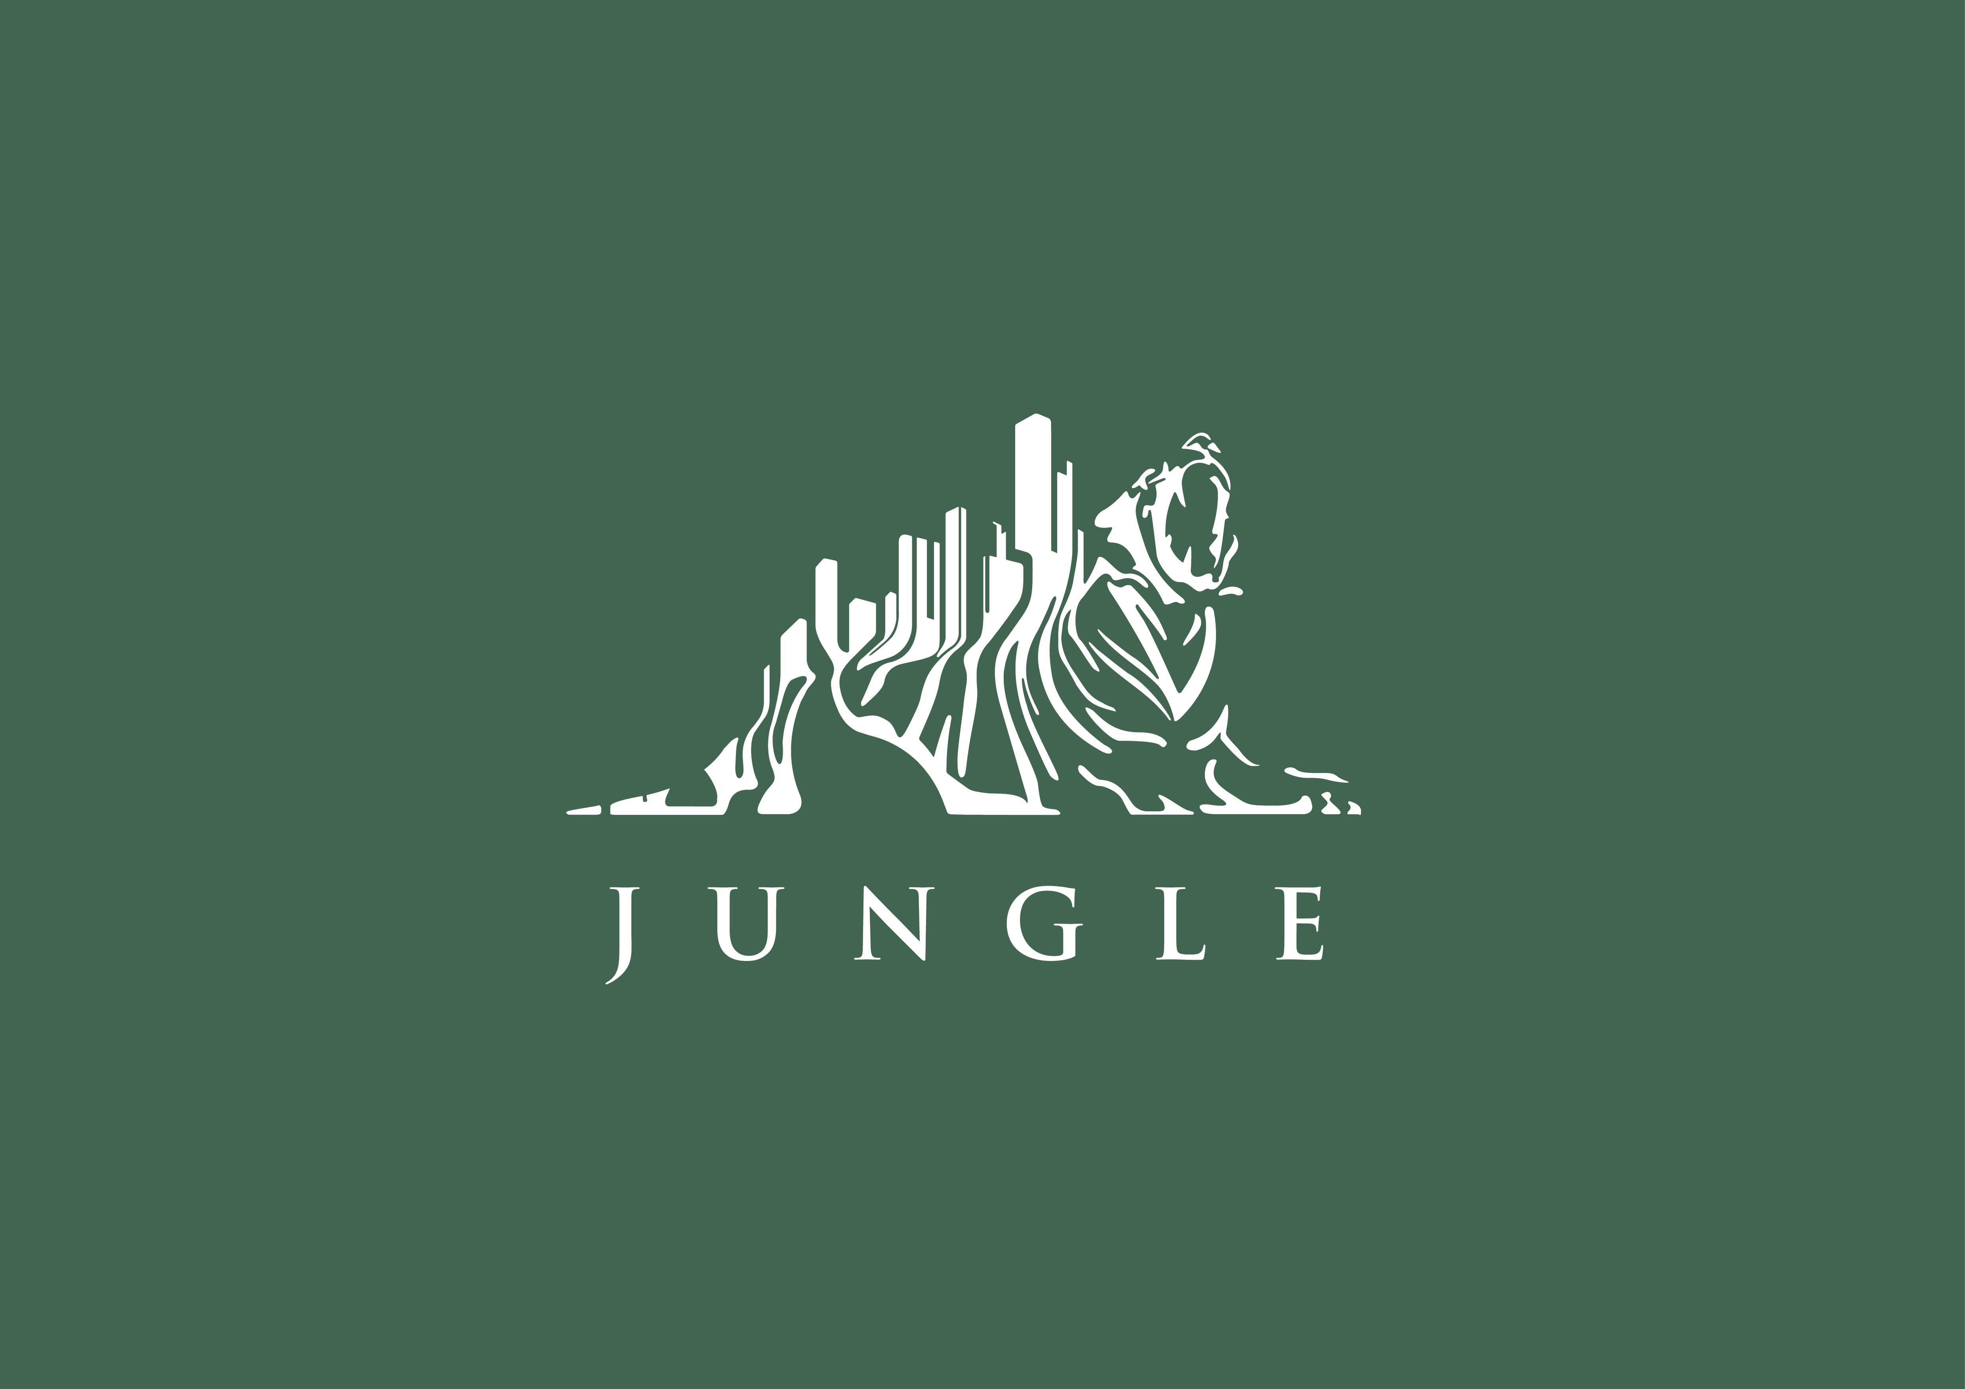





___________________________________________________________________

**For further information and interviews contact:**

**Yasmin Kentera (03) 9524 2629, 0418 813 071, e:** [kentera.yasmin@abc.net.au](mailto:kentera.yasmin@abc.net.au)