Alexa, this sounds incredible
Sennheiser’s HD 450SE Bluetooth headphones offer superior sound and effortless Alexa interaction

Marlow, UK, June 1, 2021 – Sennheiser is introducing the new HD 450SE, a special edition of the audio specialist’s HD 450BT. The noise-cancelling headphones deliver exceptional wireless sound and seamless Amazon Alexa interaction. Offering superior sound quality with deep dynamic bass, the HD 450SE also features advanced Bluetooth technology and a 30-hour battery life.
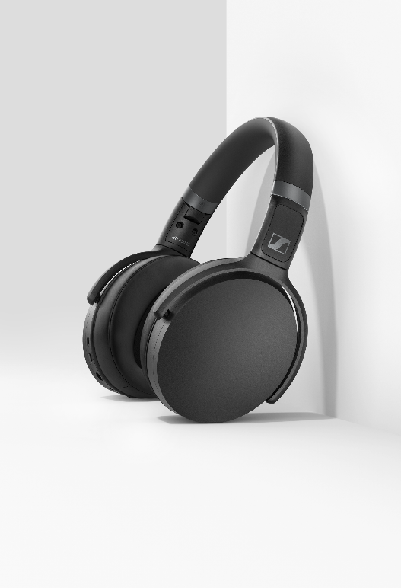

Sennheiser's HD 450SE offers exceptional wireless sound and seamless Amazon Alexa interaction

Music lovers can enjoy distraction-free, superior sound anywhere with the HD 450SE thanks to the headphones’ closed back design and active noise cancellation. The HD 450SE perfectly synchronises audio and on-screen visuals using aptX™ Low Latency, while high-quality wireless codec support, including AAC and aptX™, ensures excellent wireless sound.

Bluetooth 5.0 support and a dedicated Voice Assistant button on the HD 450SE guarantee effortless connectivity. Audio enthusiasts can interact with Alexa, Siri, or Google Assistant at the touch of a button, while intuitively controlling music and calls via dedicated buttons on the earcups.

A personalised audio experience
Listeners can tailor the HD 450SE sound to their liking with the Sennheiser Smart Control App and the intuitive in-app equaliser. The Smart Control App also offers access to the headphones’ battery status and a Quick Guide for user tips and enables firmware updates, while podcast mode enhances the clarity of speech when enjoying podcasts, audio books and other speech content.
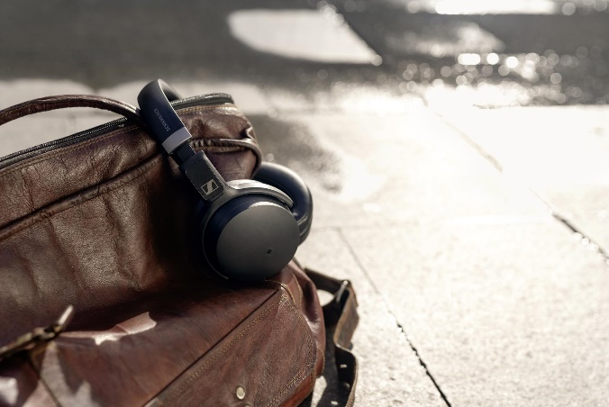

Listeners can tailor their HD 450SE experience using Sennheiser’s Smart Control App

Minimalist design combined with durability
Perfect for life on the road, the HD 450SE boast an impressive 30-hour battery life, fast USB-C charging, and a compact folding design. Crafted from top-quality materials and sporting a sleek black finish, the HD 450SE offer minimalist style, ergonomic comfort and durability. The headphones come with an extra audio cable for wired audio enjoyment as well as a convenient carry case for storage and transport.

The HD 450SE is available from sennheiser.com and Amazon for £179.99 (RRP).

About Sennheiser
Shaping the future of audio and creating unique sound experiences for customers – this aim
unites Sennheiser employees and partners worldwide. Founded in 1945, Sennheiser is one of
the world’s leading manufacturers of headphones, loudspeakers, microphones and wireless
transmission systems. Since 2013, Sennheiser has been managed by Daniel Sennheiser and
Dr. Andreas Sennheiser, the third generation of the family to run the company. In 2019, the
Sennheiser Group generated turnover totalling €756.7 million.
www.sennheiser.com

Local Press Contacts

Maik Robbe
Communications Manager UK, Ireland & Nordics
maik.robbe@sennheiser.com
T +44 (0) 7393 462484
Emily Ackland
Harvard
sennheiser@harvard.co.uk
T +44 (0) 7393 758442

