DIEGO GUERRERO

LA BARBERÍA DE DIEGO

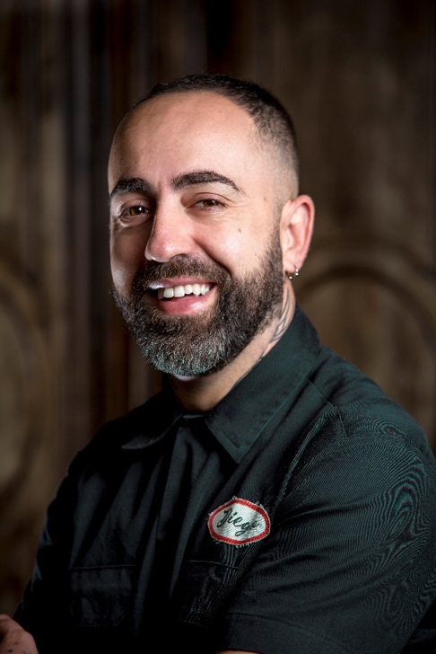
He began in the profession exploring his artistic side, personal and in hairdressing, cutting the hair to his friends with a sheep shearing machine that came to his hands by chance when he was a teenager. He grew up in a creative and entrepreneurial family that has transmitted to him the importance of values such as commitment, perseverance and respect for the world around them. He started drawing on the heads of his friends with easy designs that became more and more complicated. At that time he was attracted to drawing, tattoos, graffiti or music while he was studying at the conservatory.

Shortly after, he decided to enroll in a hairdressing school and even though it was not his intention, he could only learn hairdressing for women. Barbers had been obsolete for years, so he developed his method on his own, since there was no internet. However, he was lucky enough to be an apprentice to a barber from whom he received advice that even today remains latent in his daily work. Many years later and thanks to the resurgence of barbershops, he has had the opportunity to train with countless colleagues such as Josh Lamonaca, Blesson, New York BarberShop, Fran Aranda or Ismael de Mora, among others.

"La Barbería de Diego" is located in Guadalupe de Maciascoque, Murcia, and though it is a small town, it receives clients from all over the region and even from neighboring regions. Currently, the team consists of six professionals and a tattoo parlor in the waiting room. With the idea of merging the two arts, they offer a very careful service based on old-school barbershops, yet fully adapted to current trends.

DIEGO GUERRERO

LA BARBERÍA DE DIEGO

They prioritize conversation and unforgettable moments, making the customer's visit an experience, since their promotion has always been based on emotions. For this reason, they organize live music concerts or any type of sociocultural creative event. Another innovative contribution is the pioneering fusion of a barbershop and a tattoo parlor in the region.
Camaraderie, sharing ideas and a problem-solving attitude define the team, led by Diego, who has always bet on hiring people and not hairdressers.

He is an ambassador for the brand Skull Men, influencing the creation and testing of its cosmetic products for hair and beard, as well as the creation of audiovisual content for it. He is the creator of the shared training sessions for hairdressers. He is a professor at the Nefer Center School of Hairdressing.

As recognitions, he received the "Best Spanish Barber Shop" award from Barberías con Encanto (2016). In addition, his barbershop has been classified as one of the 10 best in Spain according to a ranking carried out by the newspaper "ABC". He has also appeared in other media as a recognized and influential barber in the country with numerous appearances and infomercials in the sector's media.

He has shared pages and collections in the leading magazines in the sector with professionals from around the world. He has also been a promoter of the Movember Foundation in the region, raising vital funds for patients with testicular or prostate cancer each year.

He is the father of two children, Ricardo and Vega, and is married to Verónica.

