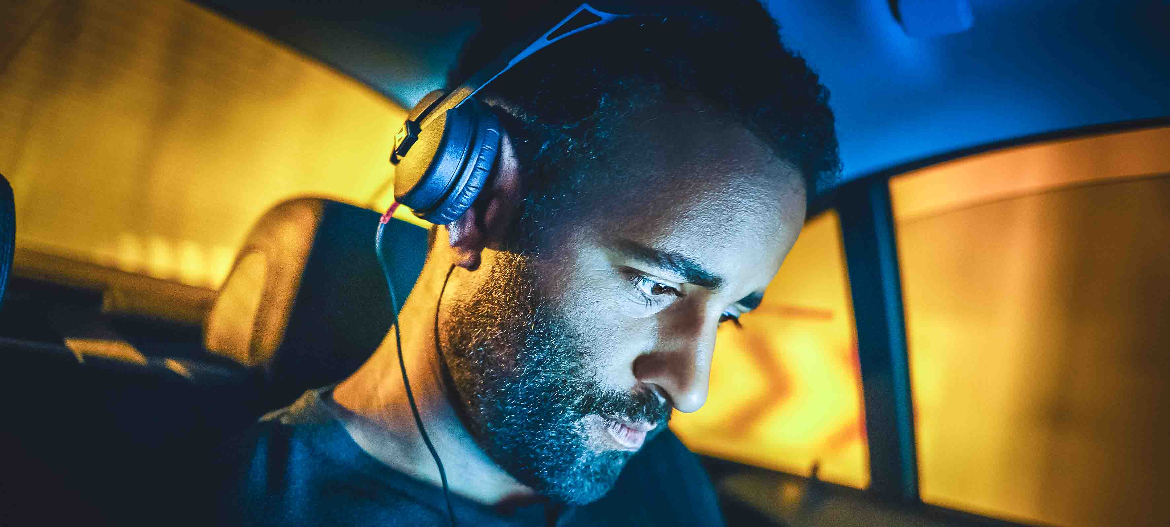

The legend redesigned
New HD 25 LIGHT combines the sound of the iconic HD 25 with a minimalist headband design

Anaheim, January 16, 2020 – For more than 30 years, the Sennheiser HD 25 headphones have been the professionals’ choice for monitoring, field recording and DJing. Now the audio specialist is launching an all-new HD 25 LIGHT, which for the first time combines the sound signature of the original with a simpler headband design. By offering the same sought-after sound performance as the iconic classic, the new model provides an attractive entry into the HD 25 world.

The HD 25 has been part of the Sennheiser portfolio for more than 30 years – the new HD 25 LIGHT now features the sound signature of the original but with a simpler headband design | 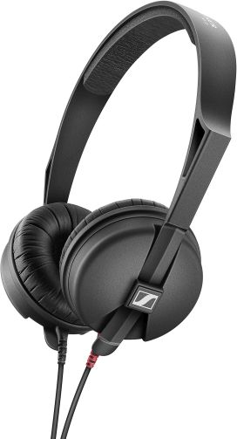

“The HD 25s are found in DJ booths the world over. Also, they are the industry standard for field recording engineers and for film and video productions,” said Jannik Schentek, Product Manager at Sennheiser. “Unlike the previous model to bear the name, the new HD 25 LIGHT headphones feature the original HD 25 capsules. The minimalist headband design makes them a great, lower-cost alternative to the standard HD 25 with its split headband and swivel earpiece.”

Capable of handling high sound pressure levels, the closed, supra-aural HD 25 LIGHT are ideal for use in high-noise environments. They feature a dual-sided, 1.5 m long, detachable cable. Delivery includes a screw-on jack adapter (1/8” to 1/4”, 3.5 mm to 6.3 mm). The HD 25 LIGHT retail at EUR 99 (MSRP)/USD 99.95 (MAP).

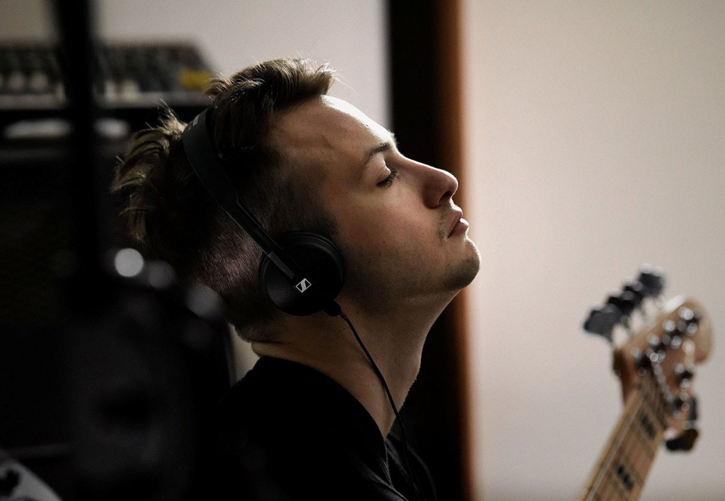 | The HD 25 LIGHT is an ideal choice for precision audio monitoring and DJing

Technical Data
Headphone principle: dynamic, closed-back, supra-aural
Frequency response: 16 – 22,000 Hz
Max. sound pressure level: 120 dB
Impedance: 70 ohms
Cable length: 1.5 m
Connector: 3.5 mm jack
Color: black
Weight: approx. 120 g

Visit Sennheiser at NAMM, Anaheim Convention Center North, Level 1, Booth No. 14108.

The images accompanying this press release plus additional photos can be accessed here: https://sennheiser-brandzone.com/c/181/K4CHPDCC

The history of the HD 25: https://www.youtube.com/watch?v=wB7Nhq5HQFA

About Sennheiser
Shaping the future of audio and creating unique sound experiences for customers – this aim unites Sennheiser employees and partners worldwide. Founded in 1945, Sennheiser is one of the world’s leading manufacturers of headphones, loudspeakers, microphones and wireless transmission systems. Since 2013, Sennheiser has been managed by Daniel Sennheiser and Dr. Andreas Sennheiser, the third generation of the family to run the company. In 2018, the Sennheiser Group generated turnover totaling €710.7 million. www.sennheiser.com

Local press contact Global press contact

Daniella Kohan Stephanie Schmidt
daniella.kohan@sennheiser.com stephanie.schmidt@sennheiser.com
+1 (860) 222 – 4226 +49 (5130) 600 – 1275

