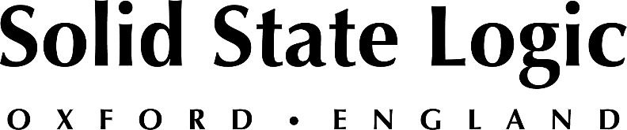

2022 NAB Show New York: Solid State Logic to Present Latest Workflow Advancements for On-Premise and Remote Audio Production

As demand for distributed and decentralized collaborative workflows increases,
SSL’s System T production platform delivers agility and scalability to broadcasters

New York, October 5, 2022 — Solid State Logic [Booth 119 in the AES hall] will demonstrate the very latest workflow advancements for on-premise and remote audio production for news, sports and live-to-air broadcast at the 2022 NAB Show New York on Wednesday, October 19th and Thursday, October 20th.

Distributed And Decentralized Workflows
As demand for distributed and decentralized content workflows increases, Solid State Logic have successfully completed a proof-of-concept initiative for running Tempest Engine DSP in virtualized and public cloud environments. The virtual engine can be used with any System T surface or software control instance. Find out how cloud-based processing can enhance your production workflow at NAB NY 22.

Control Solutions
System T offers a range of versatile control solutions, from large-format modular control surfaces, fixed format mid-sized consoles, rack mount controllers to software running on COTS computer hardware or virtual machines. System T technology can facilitate working from home using off-the-shelf components over the internet. Physical console surfaces, or software instances running on your own computing hardware can remotely control the console at your facility via a VPN. Software instances can be used with optional physical fader hardware, even at home. Two remote locations can simultaneously connect, with a third position within your facility. Each position has independent fader layouts and GUI displays for true collaborative operation when required.

Scalable DSP
Featuring pay-as-you-go licensing, new TE1 and TE2 Tempest Engines enable broadcasters to flexibly scale processing capabilities according to production requirements. For example expanding audio processing capacity for an immersive NGA broadcast event utilizing Dolby Atmos or MPEG-H. Software licenses for five different processing packs, defined by the total number of mono All-Paths equivalent channels supported, from 85 to 800, are available to users as perpetual or short-term, time-based rental upgrades. Channel, bus and monitor paths structures up to 7.1.4 are fully supported, with elegant 3D panning and automatic downmixing.

SSL will be showcasing the large-format, configurable S500 control surface at NAB NY 22. With its modular design, the S500 can be configured with a range of touchscreen and hardware tiles that can be combined with an optional meter bridge — offering exactly the right configuration for a broad range of applications. With connectivity and routing via Dante, AES67 & ST 2110, System T provides a truly plug and play AoIP experience with audio routing directly on the network using SSL’s Network IO – on show at Nab NY - or 3rd party audio devices for full interoperability.
To book a personalized demonstration or consultation with one of SSL's broadcast experts, please visit https://www.solidstatelogic.com/events/nab-new-york. Meanwhile, to register for a free guest pass, visit the AES portal and use code 22SSL153.

Solid State Logic is the world’s leading manufacturer of analogue and digital audio consoles and provider of creative tools for music, broadcast, live and post production professionals. For more information about our award-winning products, please visit: www.solidstatelogic.com.

###
For further information contact:
Jeff Touzeau
+1 (914) 602-2913
jeff@hummingbirdmedia.com

Ross Gilbert
+44 (0) 1865 842300
rossg@solidstatelogic.com

