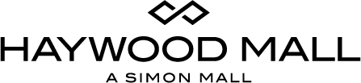

For More Information:
Jennifer Walker / Katie Clark
BRAVE Public Relations
404.233.3993
jwalker@bravepublicrelations.com /
kclark@bravepublicrelations.com

*MEDIA ADVISORY*

Haywood Mall to host Susan G. Komen Race for the Cure packet pick up on September 9
Local shoppers are invited to pick up their race packets and receive giveaways

GREENVILLE, S.C. (September 8, 2017) –Haywood Mall will have a pickup location for registration packets for Susan G. Komen’s Race for the Cure from 10 a.m. to 5 p.m. on Saturday, September 9. Shoppers will have the opportunity to register for the race, make donations to the cause, receive giveaways and more!

WHAT: Susan G. Komen Packet Pick Up
Shoppers are invited to pick up their race packets, receive giveaways and more!

WHERE: Haywood Mall
700 Haywood Rd.
Greenville, S.C. 29607

WHEN: Saturday, September 9 from 10 a.m. – 5 p.m.

Visit Haywood Mall on Facebook, Twitter and Instagram.
For more information, visit simon.com/haywoodmall

# # #

