AN ENHANCED HOME AUDIO EXPERIENCE
Sennheiser announces AMBEO|OS and a major software update to its Smart Control app

Wedemark, March 8, 2022 – Sennheiser has released the all-new AMBEO|OS to provide AMBEO Soundbar users with an even more immersive 3D home audio experience. Additionally, Sennheiser has completely updated its Smart Control app with an intuitive and new user experience to give Soundbar and headphone users effortless sound control and personalization.
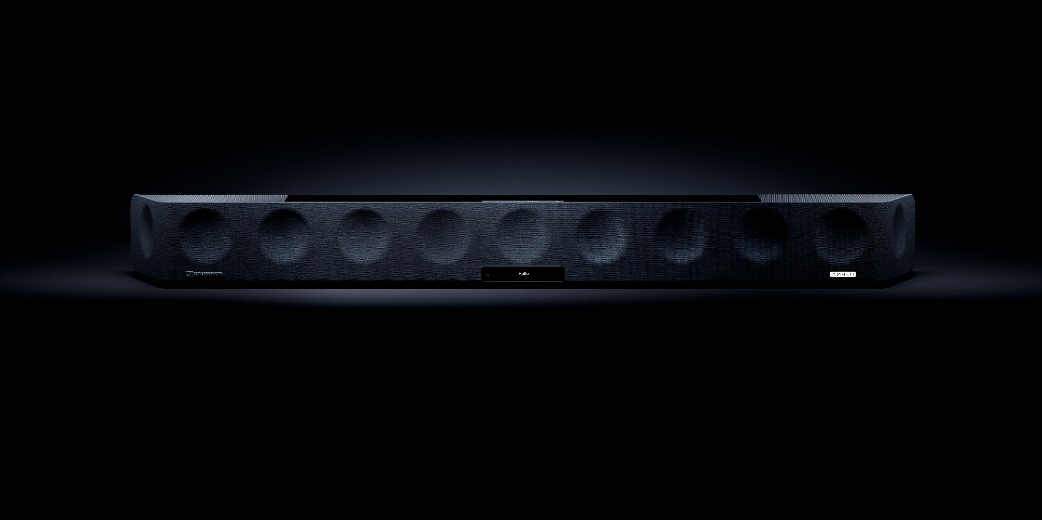
With the launch of AMBEO|OS, the AMBEO Soundbar receives a major update. The operating system expands the Soundbar ecosystem, introduces new functionalities, and elevates the user experience to greater heights.

With AMBEO|OS, which is available for all AMBEO Soundbars, listeners now have even more ways to enjoy incredibly immersive sound. The update supports Apple AirPlay 2, Spotify Connect, and Tidal Connect, providing even more options for high-quality listening.

Every aspect of AMBEO|OS has been meticulously optimized to ensure a smooth and enjoyable experience. By utilizing Wi-Fi rather than Bluetooth Low Energy to connect to the Sennheiser Smart Control app, the user experience is faster and more responsive. The operating system also guarantees greater security and stability.

“The all-new AMBEO|OS is a gamechanger for our AMBEO Soundbar, and we are certain our customers are going to love it,” says Maximilian Voigt, Product Manager AMBEO Soundbar at Sennheiser. “By offering even more audio streaming providers and an improved user experience, Sennheiser customers will enjoy personalized high-resolution audio streaming with enhanced features.”

An app update with all-new functionalities
AMBEO|OS can be accessed through the completely rebuilt Smart Control app. The all-new app elegantly merges modern aesthetics with a more personal, relevant, and rewarding intuitive user experience.
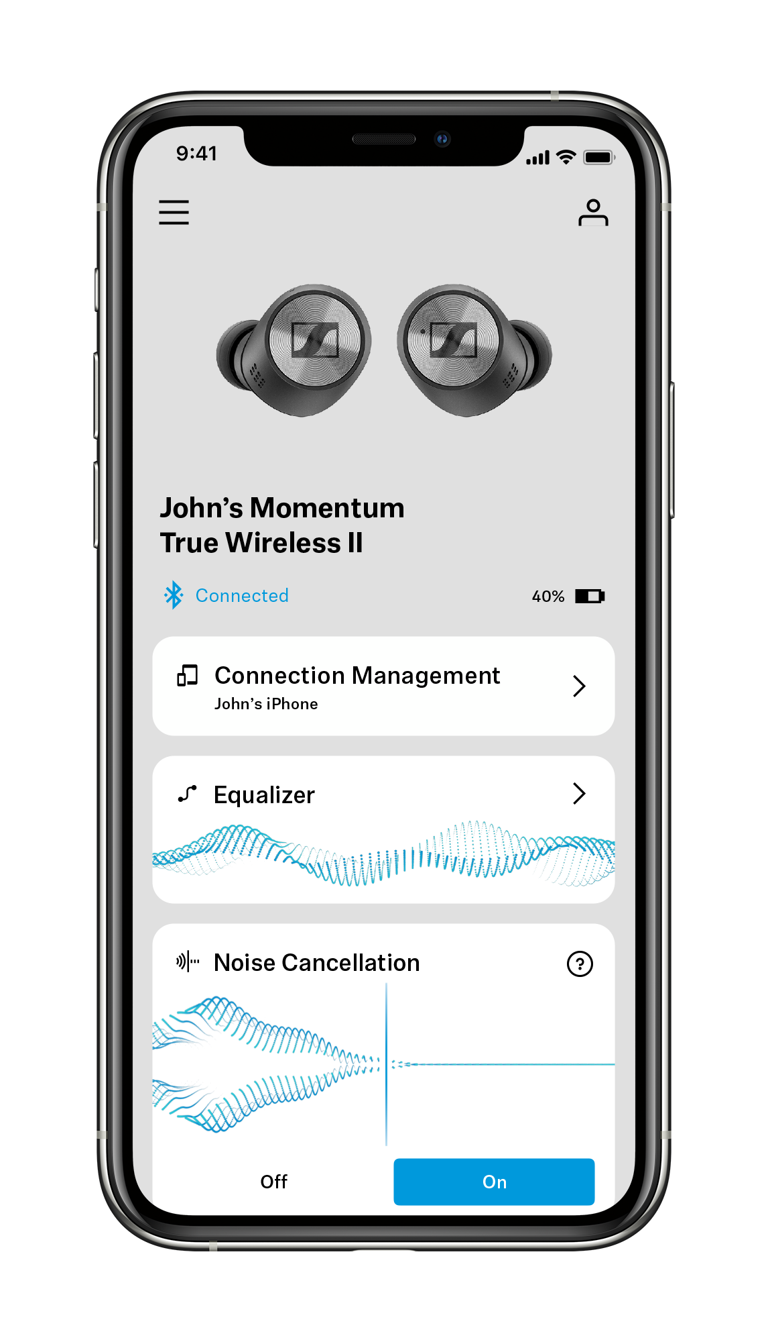
On top of that, Smart Control offers users exciting new features to improve the functionality of their Sennheiser headphones, including Sound Check and Sound Zones. Sound Check guides users through three easy steps to find the perfect EQ preset according to their tastes. Sound Zones let True Wireless users tailor EQ settings, Noise Cancellation, and Transparent Hearing to defined places – whether home, the office, or on the go – and dynamically adjust audio settings according to the user's location.

Smart Control also offers users a higher level of personalization. User accounts make it even easier to transfer settings and customizations between Sennheiser devices. The in-app Discovery area provides relevant product news and updates from the Sennheiser world.

“The next update to our Sennheiser Smart Control app will offer our customers a level of personalization that they have never experienced before,” says Polina Gartenfluss, Product Owner Mobile Applications. “On top of individualized EQ presets and tailored sound setting for different locations, we are giving our customers access to personalized content to better meet their needs.”

The Smart Control app also includes an intuitive equalizer, pulls up digital user manuals, and provides the latest software and firmware for Sennheiser products.

Control beyond the app
To offer as much flexibility as possible, users can also opt to control their AMBEO Soundbar via the dedicated web interface. They will have access to the same precise control and effortless ease of use along with a range of future-proof options to integrate their Soundbar into their digital environment.

The free software and firmware update will go live to all Smart Control and AMBEO Soundbar users on March 8.

ABOUT SENNHEISER
Shaping the future of audio and creating unique sound experiences for customers – this aim
unites Sennheiser employees and partners worldwide. The independent family company,
which is managed in the third generation by Dr. Andreas Sennheiser and Daniel Sennheiser, is
today one of the world’s leading manufacturers of headphones, loudspeakers, microphones
and wireless transmission systems. In 2020, the Sennheiser Group generated turnover totaling
€573.5 million. www.sennheiser.com

Global Press Contact
Sennheiser Consumer Audio GmbH
Paul Hughes
Head of PR and Influencers
Consumer Marketing
T +49 (0)162 2921 861
paul.hughes@sennheiser-de.com

