RELEASED: Monday November 5, 2018

Wheels in motion on ABC drama series Diary of an Uber Driver.

300 billion stars in the sky. Ben just needs five.

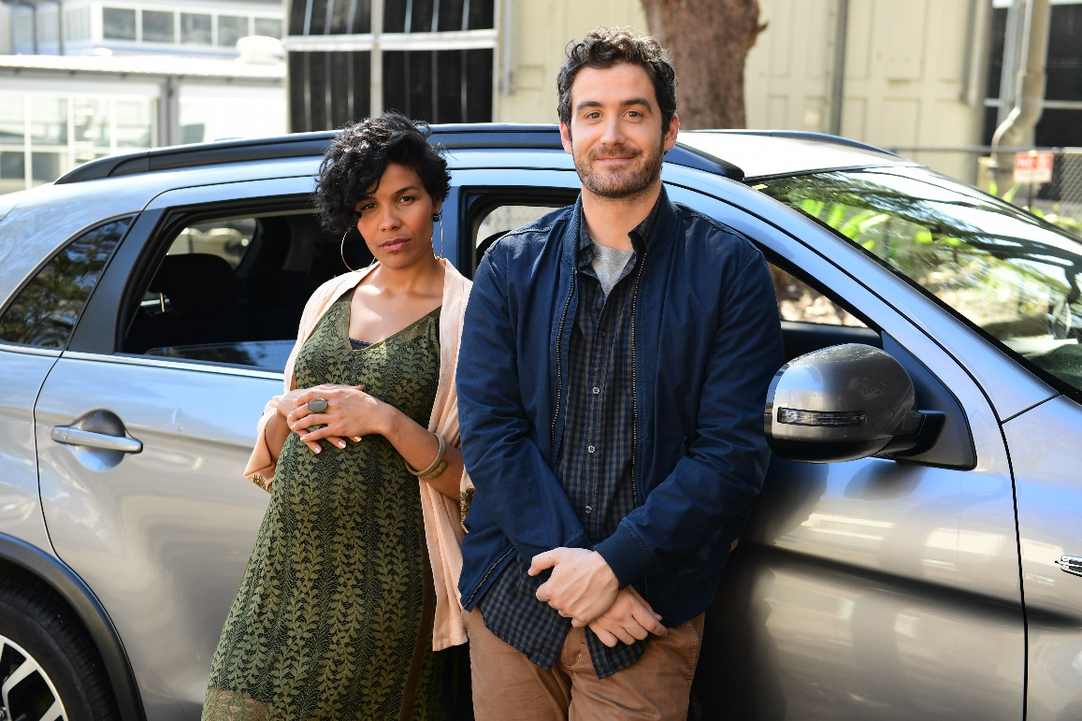
Zahra Newman as “Beck” and Sam Cotton as “Ben” in Diary of an Uber Driver. Photo Credit: Tony Mott

ABC, RevLover Films, all3media international and Create NSW are pleased to announce that filming is underway in Sydney on the six-part drama series Diary of an Uber Driver.

Written by Thomas Ward (Please Like Me) and based on the popular blog and bestselling e-book by Ben Phillips, the show is a series of love letters to the hearts and minds of those who make a city pulse.

The half-hour narrative drama follows Uber driver Ben as he tries to figure out what he should be doing while helping others get where they’re going. Against the ticking clock of impending fatherhood Ben must decipher what being ‘relevant’ looks like in a relationship that seems to think he's surplus to requirements. Lucky for him, Ben has a revolving car door of human behaviour to trawl through for clues.
Directed by two-time Berlinale Crystal Bear winning director Matthew Moore (Offspring), the cast includes Sam Cotton (Rosehaven) as Ben and Zahra Newman (Wentworth, Sisters) as Beck, the mother of his unborn child. The series will see performances from an exciting array of guest stars including Bell Shakespeare’s John Bell, Caroline Brazier (Rake), Ed Oxenbould (Paper Planes, Puberty Blues), Julian Maroun (Romper Stomper) and Emily Barclay (Please Like Me, Sisters, Glitch).

The series will be shot by Fast and the Furious franchise DOP Stephen F. Windon and produced by Martha Coleman and Lauren Edwards for RevLover Films.
ABC’s Head of Drama, Comedy and Indigenous, Sally Riley, says, “We’re delighted to commission such a distinctive and inclusive half hour drama series from breakout producer RevLover. Where else but on the ABC can audiences find such a loving portrait of urban Australia that is both deeply funny and full of heart?”

“We started RevLover to make the kinds of shows we want to watch, and we’re thrilled that Diary of an Uber Driver is our first production” said producer and partner at RevLover Films, Martha Coleman. “Audiences will fall in love with the honest, funny, nuanced writing of Tom Ward, inspired by the warm, observational blog by Ben Phillips and brought to life by a sensational cast and crew helmed by Matthew Moore. Thanks to all3media international, ABC and Create NSW who have been fantastically supportive in bringing this special show to life.”

Said Maartje Horchner, EVP Content at all3media international: “We are delighted to be working for the first time with RevLover – we started the conversation with them a few years ago when Diary of an Uber Driver was an idea, inspired by the Ben Phillips’ blog, presented to us by Martha and her team. It’s been a joy working with them to bring this show to production. The series offers a smart, humorous, contemporary view of life – and to have Matthew Moore and Stephen F. Windon aboard as director and DOP endorses RevLover’s credentials in the drama arena.”

Create NSW Acting Director Screen Investment, Engagement and Attraction Sally Regan said, “We’re very excited to support RevLover Films on their first scripted production. Diary of an Uber Driver is a timely, well-crafted contemporary drama series with a great deal of humour and warmth, and a wonderful opportunity to generate opportunities for production in NSW.”

Filming will take place in and around Sydney over the next five weeks. Diary of an Uber Driver will screen on ABC in 2019.

Production Credits: The Australian Broadcasting Corporation presents, in association with all3media international Limited and Create NSW, A RevLover Films production. Produced by Martha Coleman and Lauren Edwards. Executive Producers Michael Ritchie, Steve Rogers, Will Vicars, Nina Stevenson and Greg Sitch. Directed by Matthew Moore. Written by Thomas Ward. ABC Executive Producer Que Minh Luu. ABC Head of Drama, Comedy and Indigenous Sally Riley.

For further information contact:

Safia van der Zwan, ABC TV Publicity
02 8333 3846 | vanderzwan.safia@abc.net.au

