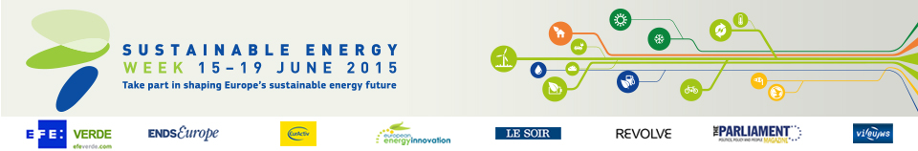

Switch to the Sun – Live in Comfort! (Building Local Capacity for Domestic Solar Heating, Hot Water and Insulation for Rural and Remote Areas of the Eastern Europe, Caucus Region)

Category

Renewable energy

Location

Munich, Germany

Switching on the sun can benefit local communities

A cross-border training project has shown how isolated rural communities can embrace sustainable energy and boost their local economies at the same time.

Living conditions for 22 rural communities in the Eastern Europe and Caucasus (EEC) region have been improved thanks to a capacity-building sustainable energy project. Training sessions across Armenia, Azerbaijan, Georgia, Moldova, Russia and Ukraine – often involving 50 % women – taught local people how to build and maintain solar collectors. Over 500 of these have since been constructed, 45 houses insulated and nine solar home-heating systems installed. As a result, families have saved an average of EUR 157 a year on energy costs.

The project has shown that with proper guidance and support, remote and cash-poor communities have the ability to take control of their energy needs. Solar collectors were built with materials easily available on the local market, and are capable of operating in winter as well as summer. Some of the insulation materials were produced by villagers, helping to open up new economic possibilities.

Organisation

WECF
Germany
www.wecf.eu
Project website: www.wecf-energy.eu

