Powersoft T Series Nominated for NAMM TEC Award for Outstanding Technical Achievement
Powersoft captured the nomination for Outstanding Technical Achievement in “Amplification Hardware/Studio & Sound Reinforcement”

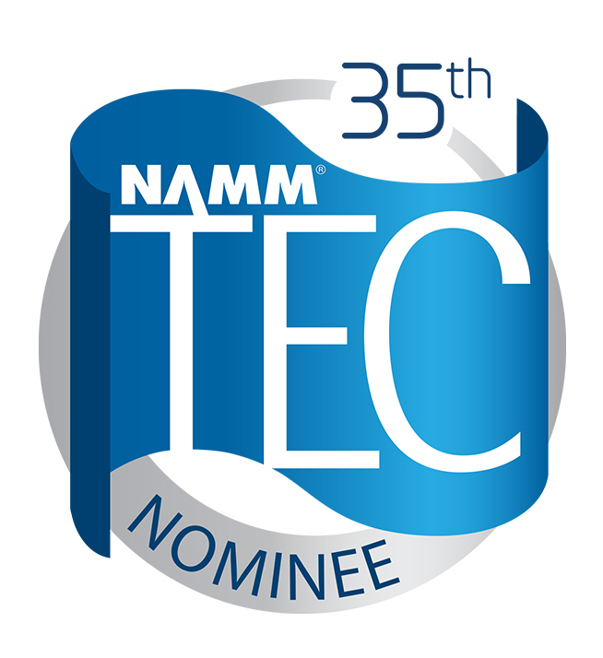
Anaheim, California
22 July 2019
Powersoft, a world-leading manufacturer of professional power amplifiers, has been announced as a nominee for the 35th Annual NAMM Technical Excellence & Creativity (TEC) Awards in the category of Outstanding Technical Achievement in Amplification Hardware/Studio & Sound Reinforcement. Presented by The NAMM Foundation, The NAMM TEC Awards are bestowed annually in celebration of the pro audio community by recognizing the individuals, companies, and technical innovations behind today's sound recordings, live performances, films, television, video games and other media.

Designed with the rental market in mind, the Powersoft T Series is an ultra-reliable and efficient amplifier platform available in 3,000 W and 6,000 W versions supporting channel powers from 750 W to 3,000 W in a single rack unit. All models can deliver the same high peak voltage and can drive single 8/16 ohm cabinets at full SPL, making the T Series a cost-effective solution for small systems without boxes in parallel. The high voltage can also be used for power sharing between channels for applications such as bi-amped loudspeakers or subwoofers with passive tops.
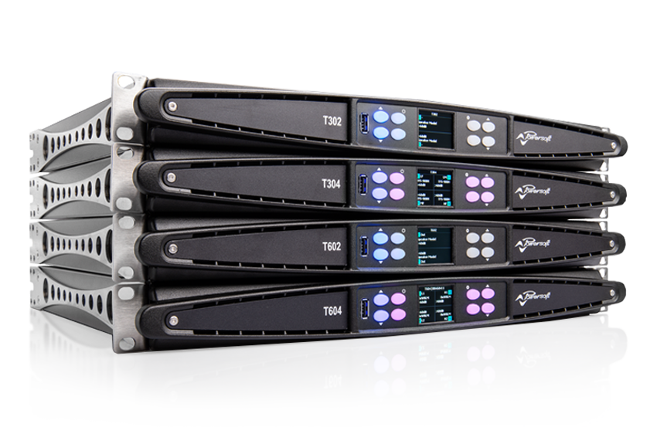
The nomination announcement follows a two-month call for entries of standout technical and creative products and projects that have a made a significant impact on modern sound and music. A panel of respected industry voters from pro audio publications, as well as members of professional music, technical and creative organizations, along with select NAMM members, carefully evaluated each entry before selecting the Powersoft T Series for nomination.

In addition to analog inputs, the T Series also includes AES3 and Dante™ by Audinate® inputs, which are optimized for daisy-chained distribution of 2-channel audio to multiple amplifiers with no need for external switches or splitters. Each model features group controllable advanced EQ to let users equalize the multiple amplifiers in a chain, as well as a robust present library with FIR processing. Each amplifier platform in the T Series is fully operable from the front panel display, ensuring ease of set up and control. The display includes features like preset recall, gain, delay and mute, plus it also shows available headroom, as well as other status monitoring.

For further information

Francesco Fanicchi  POWERSOFT FIRENZE  francesco.fanicchi@powersoft.com  +39 346 9719798 | Jeff Touzeau  Hummingbird Media  jeff@hummingbirdmedia.com  +1 (914) 602-2913

ABOUT POWERSOFT:
Powersoft is the world leader in lightweight, high power, single rack space, energy efficient amplifiers for the professional audio market. Founded in Italy in 1995, headquartered in Florence, Italy, with offices in New Jersey, Powersoft couples the experience and precision of its production department with exceptional components to deliver products with perfect audio response and high-performance reliability. Its state-of-the-art amplifiers can be found in an array of markets, ranging from stadiums, sporting arenas, theme parks, performance venues and airports to convention centers, churches, and clubs, and are used by the world's leading tour sound companies. For more information, visit the Powersoft website: www.powersoft.com

About the TEC Awards
Presented annually by the NAMM Foundation during The NAMM Show, The NAMM TEC Awards recognize the individuals, companies and technical innovations behind the sound of recordings, live performances, films, television, video games and other media in 31 Technical and Creative Achievement Categories. The Les Paul Award is given at the event in tribute to musical artists and others whose work has exemplified the creative application of audio technology. Through its Hall of Fame, The TEC Awards also honors the pioneers of audio technology and the music industry’s most accomplished producers and audio technicians. The NAMM Foundation’s TECnology Hall of Fame celebrates innovations and ground breaking technical achievements of the past. For more information, visit www.tecawards.org

About NAMM
The National Association of Music Merchants (NAMM) is the not-for-profit association with a mission to strengthen the $17 billion music products industry. NAMM is comprised of approximately 10,400 members located in 104 countries and regions. NAMM events and members fund The NAMM Foundation's efforts to promote the pleasures and benefits of music, and advance active participation in music making across the lifespan. For more information about NAMM, please visit www.namm.org, call 800.767.NAMM (6266) or follow the organization on Facebook, Instagram and Twitter.

