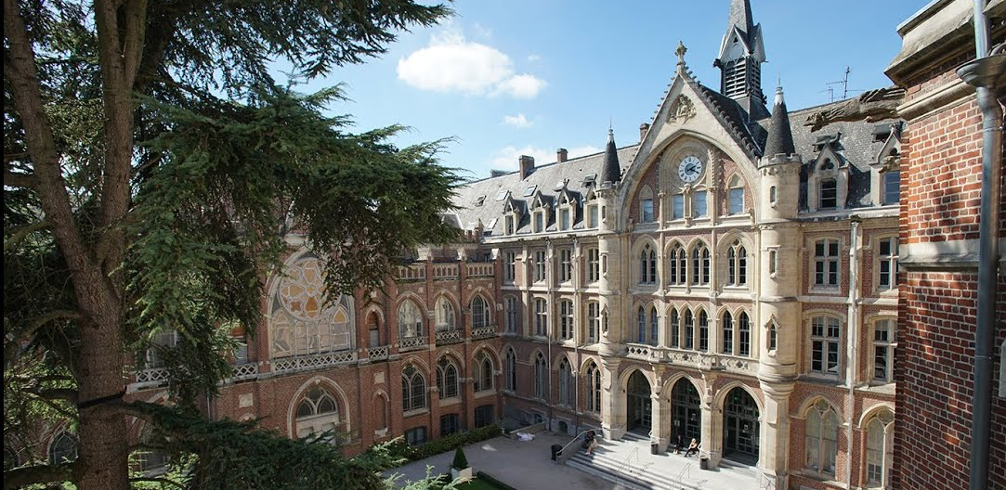

The Faculties of the Catholic University of Lille Adopt Sennheiser’s Innovative Audio Technology
MobileConnect has been deployed to help students with hearing loss

Paris, 21 September 2022 – Sennheiser, the first choice for advanced audio technology that makes collaboration and learning easier, is pleased to have its MobileConnect assisted listening technology selected for inclusion in all amphitheaters and classrooms intended to accommodate more than 50 people at the faculties of the catholic university of Lille, France. The decisive criteria for the choice of MobileConnect included ease of use, the high audio quality, as well as the exceptional ergonomics of its dedicated application. MobileConnect was a perfect match for a university project called "Taking Care", led by President and Rector Patrick Scauflaire. Too often, a hearing disorder can lead to a form of exclusion from life in society, which begins at school. With its values of openness, the faculties of the catholic university of Lille is committed to welcoming all those who wish to pursue higher education.

An optimal solution to meet a major challenge
The "Programmed Accessibility Agenda" project of the Faculties at the Catholic University of Lille required a contemporary approach to assisted listening. The specifications, therefore, required a solution that was user-friendly, hygienic and easily scalable for a centralized hardware solution. The solution proposed by Sennheiser was obvious thanks to the "Bring-Your-Own-Device" concept. The audio stream is sent directly to the students' personal smartphones, making it easily accessible and intuitive to use. People with hearing loss do not have to ask for a specific receiver device and can settle anywhere the faculty's WiFi is available.

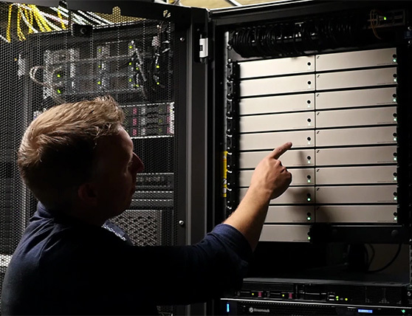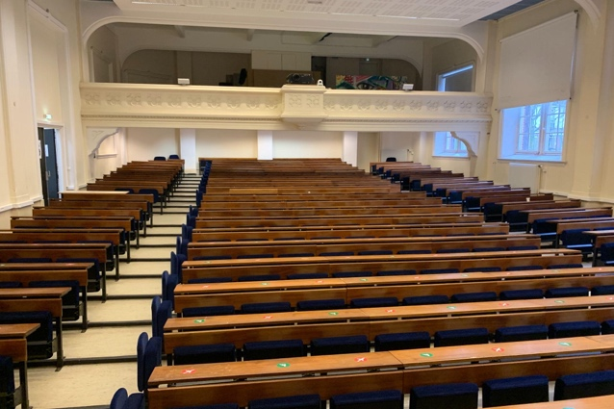
MobileConnect uses the existing Wi-Fi network so no special services need to be installed.
Students have access to the service throughout the campus: simply select the channel number in the app on their smartphone or scan a QR code

A solution for personal listening and future-proof assistance
As a centralized solution for assisted listening, the 20 MobileConnect stations are located in the server room and span several buildings. This streaming system with hearing assistance delivers high-definition sound to the student's smartphone, thus transforming it into an audio receiver. MobileConnect converts a speaker's microphone signals into audio streams that can be easily accessed via the campus Wi-Fi system. Therefore, students wearing hearing aids, cochlear implants or headphones can comfortably follow the lectures, with barely noticeable latency.

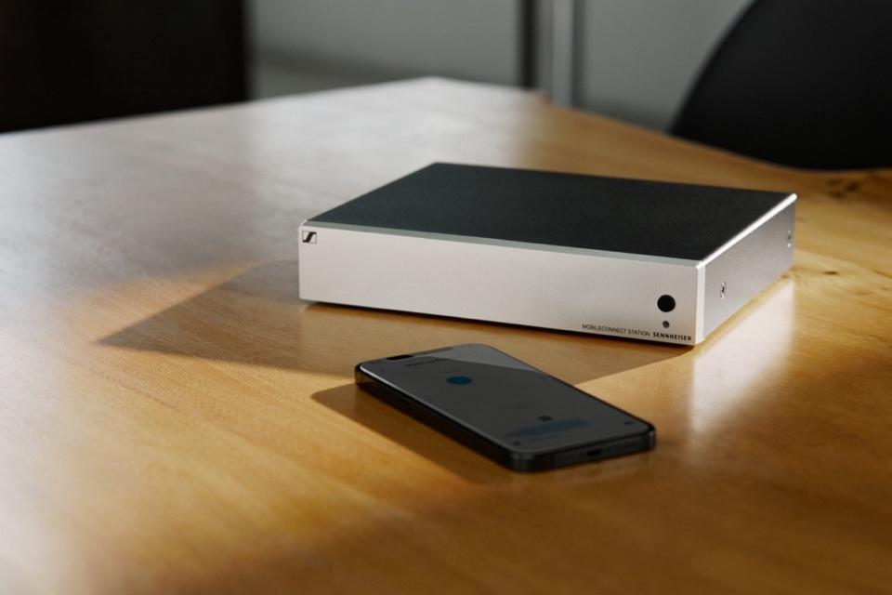
The MobileConnect app provides easy access to all audio streams provided by the MobileConnect station.

"MobileConnect offers us great flexibility because it not only enables assisted listening, but also allows for live translation and audio retransmission in other rooms with Dante. This flexibility is important for us as an educational institution," says Aurélien Trancart, multimedia project manager for the Faculties of the Catholic University of Lille.

Vianney Delory, multimedia manager for the Faculties of the Catholic University of Lille, adds: "The users of the solution are fully autonomous. Students who have a hearing implant or have any disability they don't want to show can scan the QR code at the entrance. This is an undeniable advantage over assisted listening via induction loops where users must sit in the front rows. With MobileConnect, they can place themselves wherever they want in the room.”

Another major asset of MobileConnect for the Faculties of the Catholic University of Lille lies in the hygienic dimension. Students can use their own smartphones to access the audio stream. There is no need to distribute and clean rental devices for assisted listening, which minimizes health risks.

The team of Faculties of the Catholic University of Lille is very satisfied with this assisted listening equipment and its collaboration with Sennheiser. "The new configuration met exactly our expectations. The cooperation with the Sennheiser team is excellent. We have very good support and we get quick and efficient answers in case of problems or questions," says Aurélien Trancart.

More information about the Faculties of the Catholic University of Lille here.

ABOUT THE SENNHEISER BRAND
We live and breathe audio. We are driven by a passion to create audio solutions that make a difference. Shaping the future of audio, delivering remarkable sound experiences to our customers – that's what the Sennheiser brand has stood for for more than 75 years. Professional audio solutions such as microphones, conference systems, streaming technologies and monitoring systems are part of the business of Sennheiser electronic GmbH & Co. KG. While consumer equipment, such as headphones, soundbars, headphones and hearing aids, are developed and distributed by Sonova Holding AG under license from Sennheiser. www.sennheiser.com

Press contacts  Sennheiser electronic GmbH & Co. KG  Jeff Horan  Global PR/Media Manager Business Communication  Phone: +1 860-598-7539  jeffrey.horan@sennheiser.com | Sennheiser electronic GmbH & Co. KG  Ann Vermont  Communications Manager Europe  Phone : +33 1 49 87 44 20  ann.vermont@sennheiser.com

