Sennheiser offers NAB visitors a unique opportunity to witness world-class foley artists in action
Emmy-nominated foley artist Sanaa Kelley and head mixer Arno Stephanian will demonstrate the art of creating sounds, captured by Sennheiser and Neumann microphones

Wedemark, 14 April 2023 – From using bags filled with cornstarch and coarse sand to emulate snow sounds to utilizing concrete tiles for recreating footsteps, this year’s NAB visitors are invited to a truly special ‘sound’ treat. Recorded by Sennheiser and Neumann microphones, California-based foley artist and founder of Reel Foley Sound (RFS), Sanaa Kelley, will be joined by RFS’s head mixer, Arno Stephanian, to create a truly unforgettable sound spectacular for NAB visitors. At the Sennheiser Group’s booth C5217, they will be demonstrating how some of the most popular film sounds are created.

Kelley will create live sound effects using a variety of materials such as wood, grass, starch, concrete tiles, and carpet in a designated foley area. Sennheiser MKH 416, MKH 8060 and Neumann KMR 81 i shotgun microphones will pick up the ‘action’, as will a Neumann TLM 170 R. Arno will operate a mixing desk positioned below a flatscreen TV mounted on the wall, which will display the foley feed.

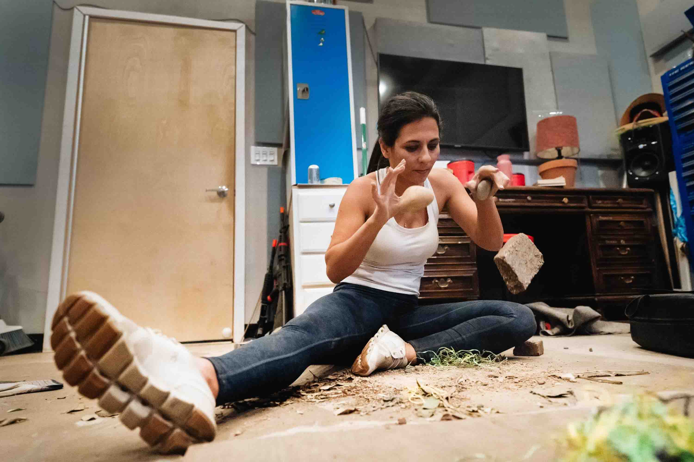 | Emmy-nominated foley artist Sanaa Kelley will demonstrate the art of creating sounds to this year’s NAB Show visitors

With over 28 years of industry experience, Kelley is a highly regarded foley artist with an impressive list of credentials. Her work has earned her four Emmy nominations and 25 MSPE Golden Reel nominations for projects such as Apple TV+’s sports comedy Ted Lasso (currently airing with Season 3), AMC’s Emmy-winning series The Walking Dead and Disney+’s The Right Stuff. In 2016, Kelley was part of the sound editing team that earned a Golden Reel Award for their work on the live-action film All the Wilderness.

Focused on episodic television, Kelley’s expertise in foley artistry has more recently seen her work on projects such as HBO Max’s The Flight Attendant and AppleTV+’s Lisey’s Story starring Julianne Moore. Her TV credits also include Warner Bros.’ award-winning drama series Pretty Little Liars, Netflix’s The Midnight Club directed by Mike Flanagan, and Fox’s multi-generational musical drama Monarch starring Susan Sarandon.

Kelley’s foley skills have also been featured in films such as Cry Macho directed by Clint Eastwood; HBO’s Those Who Wish Me Dead starring Angelina Jolie; and Universal’s Ouija starring Olivia Cooke. In addition to TV and features, Kelley has worked on Nickelodeon’s popular animated series Avatar the Last Airbender and Rugrats.

Born and raised in Morocco, Kelley is a long-time resident of California and is one of TikTok’s fast-growing stars, garnering an impressive following of over two million in just one year.

With over 28 years of industry experience, Kelley is a highly regarded foley artist with an impressive list of credentials | 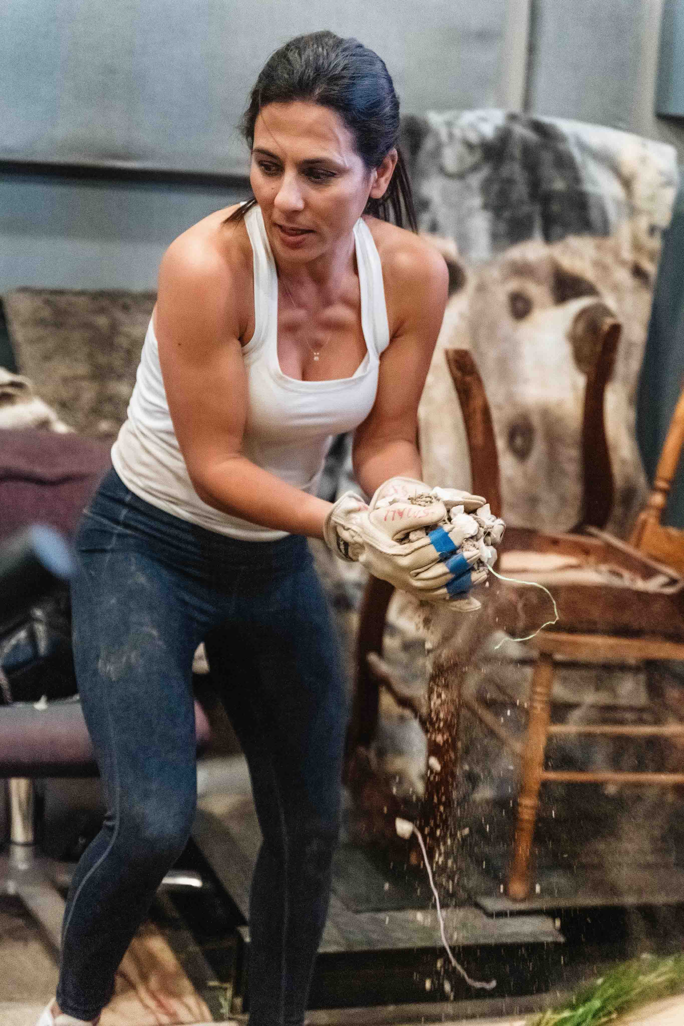

Kelley’s partner in crime, Arno Stephanian, was born in Tehran to an Armenian family that was renowned for their pioneering work in the music industry. In fact, his family opened the first music store in the area, Skenderian Music Center, in 1945. Growing up in an environment that was immersed in music and the arts, Stephanian developed an early interest in playing the piano. By the age of eight, he was already playing the piano by ear, learning from his father. As he continued to develop his skills, Stephanian began to play jazz and transcribe solos. However, due to the limitations on artistic freedom in the country, he found there was not much room for growth as an artist or musician.

At the age of 23, Stephanian fulfilled his long-standing dream of emigrating to the United States with his wife, embarking on an exciting new chapter in his life. He delved into the world of sound and successfully completed an Audio Engineering program, all while working and supporting his family. After completing his studies, he began an internship at a foley stage and quickly made a name for himself. Within two years, he was nominated for the Best Sound Editing award at the 2014 Golden Reel Awards, thanks to his exceptional work as a foley editor. With the guidance of his mentor, Kyle Billingsley, he further honed his skills as a foley mixer, developing techniques to streamline the process and increase efficiency.

After 12 years in the industry with 10 of those as a foley mixer and having worked at many different facilities in Los Angeles, Arno Stephanian is now the head mixer at Reel Foley Sound, founded by Kelley | 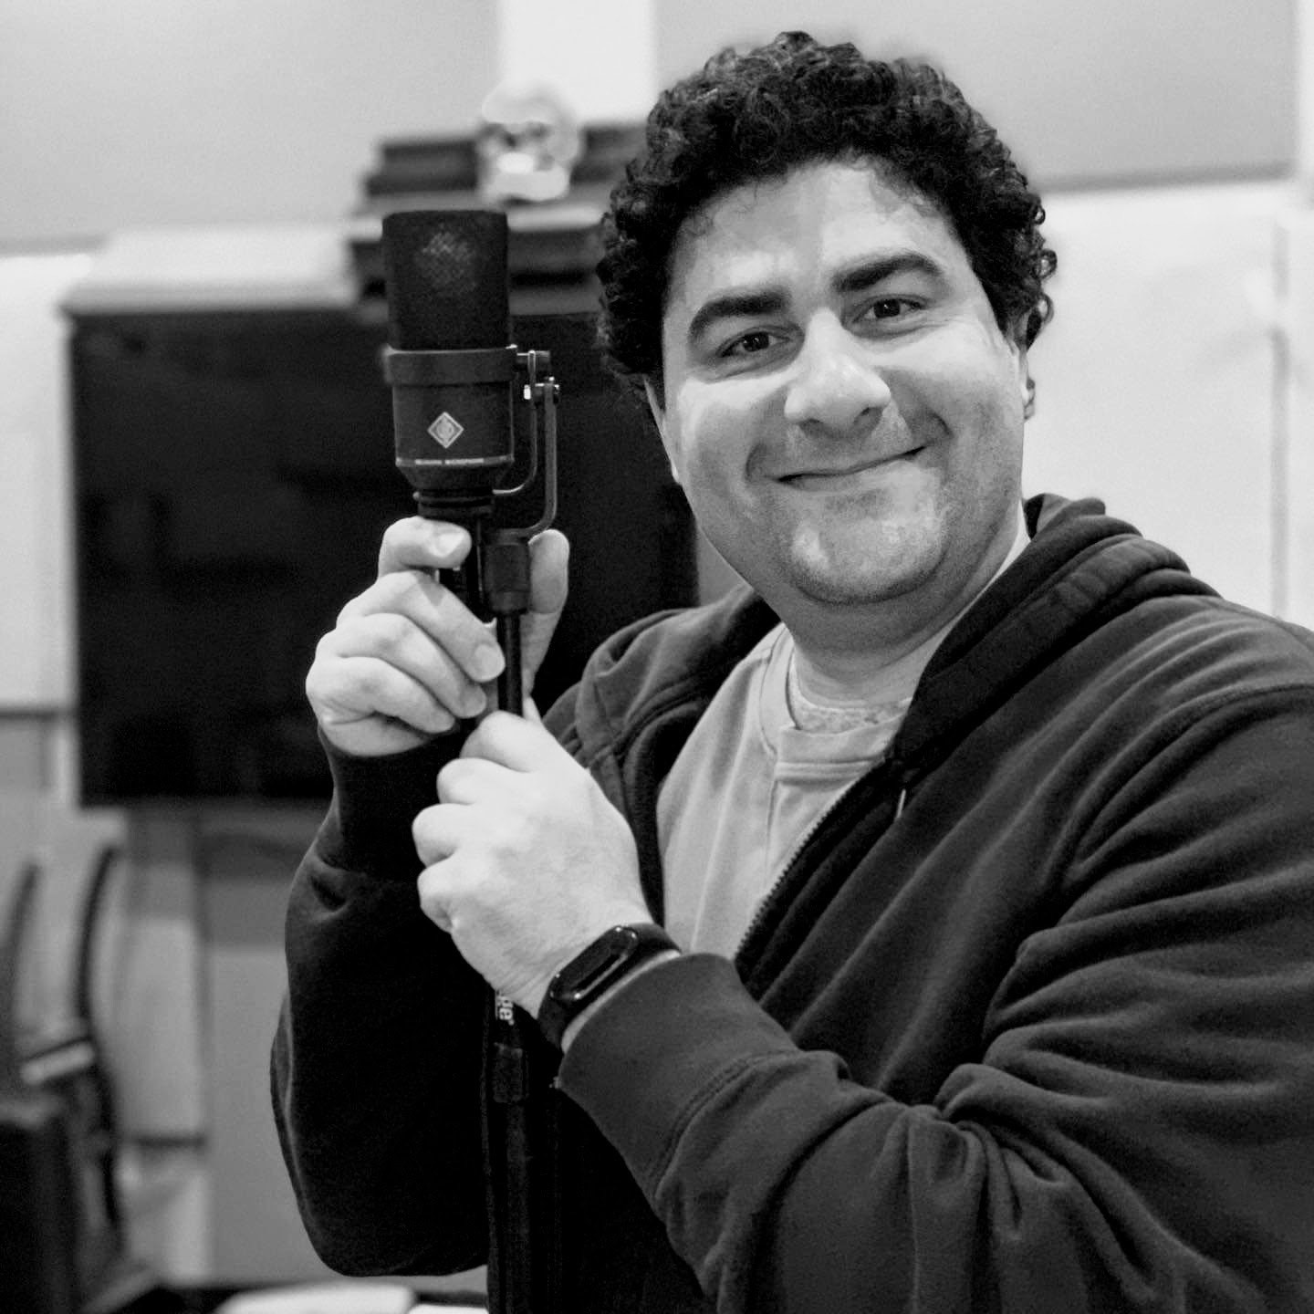

After 12 years in the industry, with ten of those as a foley mixer, and having worked at many different facilities in Los Angeles, Stephanian is now the head mixer at Reel Foley Sound, founded by Kelley. Throughout his career, Stephanian has achieved two Emmy nominations, two CAS Wins and eight Golden Reel Nominations. His portfolio includes working on many popular television shows including Ted Lasso, Lisey’s Story, Only Murders in the Building, The Cleaning Lady, Flight Attendant, Woman of the Movement, High School Musical, Once Upon a Time, Grey’s Anatomy, and American Horror Stories.

Stephanian had the privilege of supervising the foley for the recently released Zootopia+ animated series. The show features six different episodes inspired by the original Zootopia movie, which was recorded at Skywalker Sound. Arno has also been fortunate to work on several feature films, including Those Who Wish Me Dead directed by Angelina Jolie, Clint Eastwood’s Cry Macho, and Always Be My Maybe. He has also contributed to acclaimed films The Intern starring Robert De Niro, Trumbo featuring Bryan Cranston, and Danny Collins starring Al Pacino, amongst others.

Visit the Sennheiser Group at NAB, Central Hall, booth No. C5217 to experience the art of sound creation by these two world-renowned foley artists.
Sunday, April 16 at 11:30 a.m., 2:30 p.m. 4:30 p.m.
Monday, April 17 at 10:30 a.m., 2:00 p.m.
Tuesday, April 18 at 10:30 a.m., 2:00 p.m.

(Ends)

The images accompanying this media release can be downloaded here.

About the Sennheiser Group

Building the future of audio and creating unique sound experiences for our customers - this is the aspiration that unites the employees of the Sennheiser Group worldwide. The independent family-owned company Sennheiser was founded in 1945. Today, it is managed in the third generation by Dr. Andreas Sennheiser and Daniel Sennheiser, and is one of the leading manufacturers in the field of professional audio technology. Within the Sennheiser Group are Georg Neumann GmbH (Berlin, Germany), manufacturer of studio-grade audio equipment; Dear Reality GmbH (Düsseldorf, Germany), known for its binaural, Ambisonics, and multichannel encoders with realistic room virtualization; and Merging Technologies SA (Puidoux, Switzerland), specialist in high-resolution digital audio recording systems.
sennheiser.com | neumann.com | dear-reality.com | merging.com

