Sennheiser-konserni IBC 2026 -messuilla
Integroituja audioratkaisuja lähetystuotannon jokaiseen työvaiheeseen
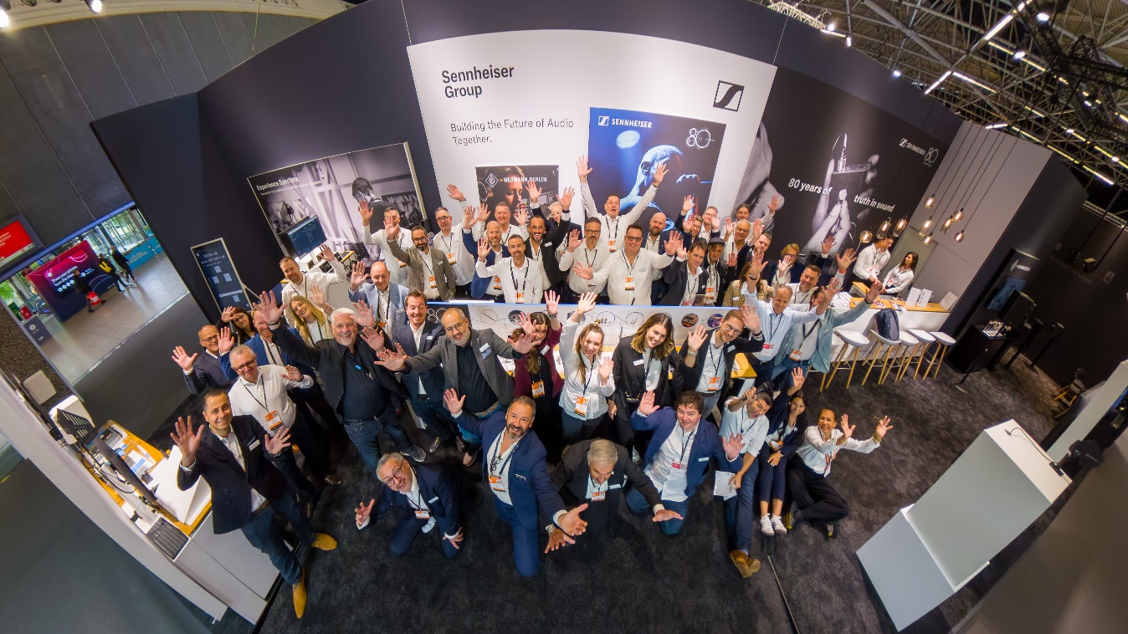

Sennheiser-konserni esittelee IBC 2026 -messuilla, kuinka sen johtavien audiobrändien ja -teknologioiden valikoima tukee yleisradioyhtiöitä ja tuotannon ammattilaisia lähetyssignaaliketjun jokaisessa vaiheessa – äänen taltioinnista ja vahvistamisesta aina monitorointiin ja jakeluun asti. Vaikuttava esittely hallissa 8, osastolla D50 nostaa esiin saumattoman yhteentoimivuuden, tulevaisuuden vaatimukset täyttävät audiotyönkulut sekä Sennheiserin, Neumannin ja SoundBasen kumppaniekosysteemin ratkaisujen yhdistetyn voiman. Kävijät pääsevät myös ainutlaatuisena ensiesittelynä tutustumaan Neumannin arvostetun studiomonitorivalikoiman uusimpiin tulokkaisiin.
Lisää alla englanniksi.

Wireless workflows built for the field and the studio
On the Sennheiser wireless area, visitors can explore how the company’s solutions enhance deployment, monitoring and management workflows for broadcast and production teams.
Front and centre is Spectera, Sennheiser’s bidirectional wideband wireless ecosystem, which will be shown together with the new Spectera SKM handheld microphone that will become available commercially mid-September, completing the core Spectera ecosystem. The Spectera SKM handheld offers premium wireless handheld microphone performance, combining Sennheiser’s renowned sound quality with the control options, flexibility and intelligence of the Spectera platform.

With the addition of the SKM handheld, all core elements of Spectera are now available, bringing microphones, in-ear monitors, full remote control and monitoring together in one integrated ecosystem for virtually any live performance or broadcast application.
The Spectera SKM handheld will start shipping from mid-September | 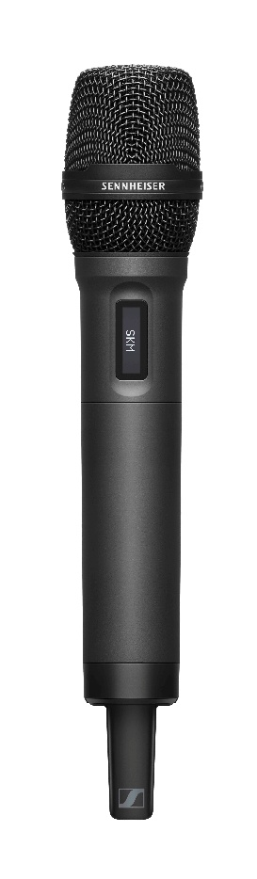

The Spectera Base Station ZMAN, which carries a Merging ZMAN audio network module for AES 67 ecosystems, will also be on show, and expected to be available from October 2026. With native ST 2110-30 audio integration via the Merging ZMAN module, the Base Station brings the benefits of the Spectera ecosystem directly into professional broadcast workflows, with the flexibility, interoperability and control broadcast engineers require.

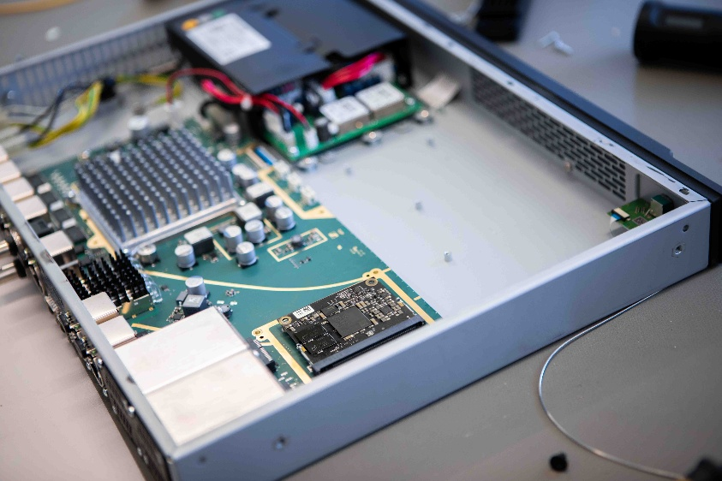 | Available from October: The Spectera Base Station ZMAN for integration into SMPTE 2110 workflows

Also being demonstrated is the Spectera Command functionality, which gives the artist or speaker direct control of the audio routing pre-configured in the wireless system. Available as a Command Button for connection between the SEK bodypack and the microphone, and as a Command Ring for the SKM handheld from October 2026, it enables end users to mute their audio or open a talkback channel. The Spectera system allows the button to be configured as a latched or a momentary switch to accommodate different workflows and preferences.
Spectera’s credentials in live broadcast were underlined earlier this year at the Eurovision Song Contest 2026 in Vienna. There, the ecosystem, including manufacturing samples of the Spectera SKM handheld, was deployed at its largest scale to date as part of the audio set-up, working across multiple Base Stations to deliver wireless mics, in-ear monitoring and control for the show. Sennheiser’s renowned EW-DX EM4 digital wireless system will round out the wireless showcase.
Also on show is SoundBase’s brand-neutral RF planning and management application. Developed and operated by the Sennheiser partner, the software has recently added full support for Spectera and the Command functionality. A highlight is SoundBase’s Remote View tool, which allows broadcast productions to share live monitoring data with multiple team members without increasing network traffic, ensuring that a control network stays efficient and the gear responsive.

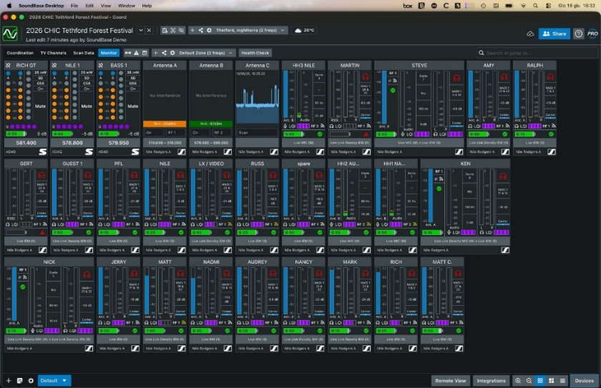 | SoundBase have fully integrated Spectera into their RF management app

Experience the next generation of Neumann studio monitors
Visitors will get an exclusive look at the latest additions to Neumann’s studio monitor portfolio. Designed to deliver exceptional accuracy, versatility, and performance for demanding broadcast, production, and immersive audio workflows, these new models further expand Neumann’s commitment to reference-quality monitoring. Visit the Neumann monitoring area for live demonstrations and listening sessions.

Neumann will also unveil two new capsule heads, the KK 104 A (cardioid) and KK 105 A (supercardioid) for Sennheiser’s state-of-the-art wireless systems, including Spectera. As successors to Neumann’s acclaimed KK 204 and KK 205 condenser capsule heads, they will continue to bring studio sound quality to the stage while featuring a more elegant form factor, as well as vastly improved suppression of handling noise.
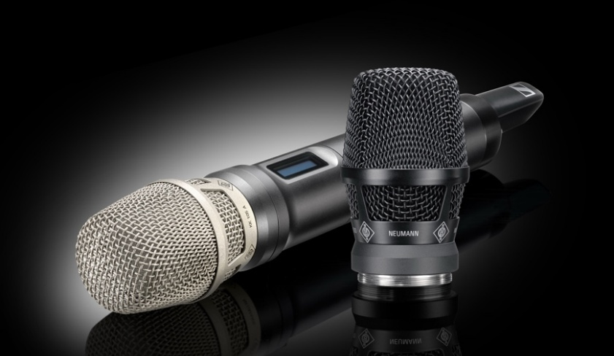
At IBC 2026, Neumann will unveil two new capsule heads, the KK 104 A (cardioid) and KK 105 A (supercardioid)

Capture, augment, monitor: a complete broadcast audio journey
A third area of the booth presents a workflow-oriented Sennheiser Group showcase, illustrating how professional audio solutions support every stage of broadcast production. The demonstration is built around end-to-end workflow optimisation, showing how seamless integration between technologies drives greater efficiency and operational reliability, and how audio excellence is maintained across every stage of production. Underpinning it all is broadcast integration and connectivity across SMPTE 2110, Dante, NMOS and Lawo HOME.
The Sennheiser Group workflows section walks visitors through the journey step by step, following the audio signal from capture through to monitoring and augmentation. Capture is handled by Sennheiser’s MKH series of RF condenser microphones and EW-DX handheld microphones with interchangeable mic capsules, paired with the EW-DX EM4 four-channel digital wireless receiver. Signals are feeding into Merging Technologies’ HAPI modular audio interface for the studio or OB van.
On the monitoring side, Neumann’s KH series of studio monitors is joined by Sennheiser’s latest HD 480 PRO and HD 490 PRO reference headphones, giving engineers consistent, accurate monitoring in any work environment.
Rounding out the chain, augmentation is demonstrated via Ovation playout and show sequencer, and Pyramix digital audio workstation.

The Sennheiser HD 480 PRO closed-back studio headphones | 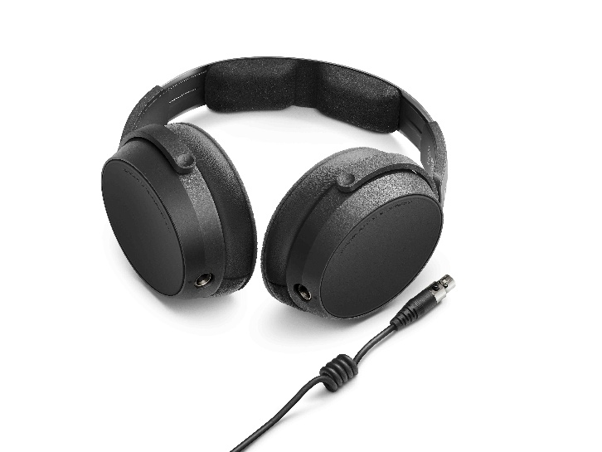
Come and meet us at the Sennheiser Group booth (8.D50) at IBC from 11 to 14 September 2026.
(Ends)

The images accompanying this media release can be downloaded here.

About the Sennheiser Group
Building the future of audio and creating unique sound experiences for our customers - this is the aspiration that unites the employees of the Sennheiser Group worldwide. The independent family-owned company Sennheiser was founded in 1945. Today, it is managed in the third generation by Dr Andreas Sennheiser, and is one of the leading manufacturers in the field of professional audio technology.

Press Contact:
Burson Finland Oy (previously Hill and Knowlton)
sennheiser.finland@hkstrategies.com

