Perfect Clarity: Glass Conference Rooms and Huddle Spaces
Tuned to Acoustic Perfection by WSDG

Research points to growing market for purpose-designed huddle rooms for video conferencing

Zurich, Switzerland, August 13, 2019 — Global acoustic consulting and audio-visual integration firm WSDG has just announced the completion of work on a series of futuristic glass conference and huddle rooms for a top Zurich-based firm, who have asked to remain anonymous. Designed by architect Nadja Zürcher (www.nadjazuercher.com) in cooperation with Vera Gloor AG (www.veragloor.ch), the visually striking transparent spaces are designed for the modern workspace with full A/V integration and meticulous acoustic treatment to ensure superior speech intelligibility and a calm, echo-free conversational environment for video conferencing purposes.
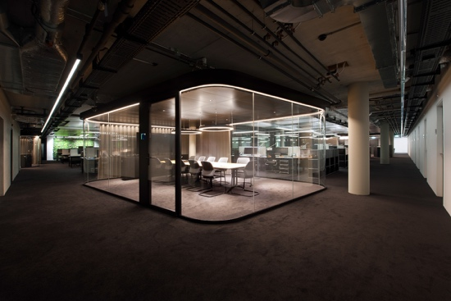
According to a recent article in UC Today*, huddle rooms such as these currently handle approximately 8.1% of all video meetings and are poised to represent almost 70% of all video conferencing by 2022. With Wainhouse Research estimating approximately 50 million huddle rooms in existence globally, they are quickly becoming an integral part of modern office infrastructure and market need is pushing architects to design innovative spaces to meet the increased demand.

Zürcher’s vision for glass enclosed huddle and conference rooms was there from the beginning, to ensure that the rooms would be aesthetically pleasing as well as take advantage of natural light sources, but she was aware of the danger of any glass-heavy space becoming an echo-chamber. WSDG had been a frequent partner of Zürcher’s on previous projects, and the firm’s acoustic engineering know-how would ensure calm, quiet environments with superior speech intelligibility.

“When helping to design these spaces it was important to us that we give people who would be using these rooms a comfortable space to hold meetings with the best possible sound quality,” said WSDG Senior Acoustician Gabriel Hauser. “Making sure that the glass walls weren’t parallel and that we were using appropriate materials to dissipate sound were key to this process.”
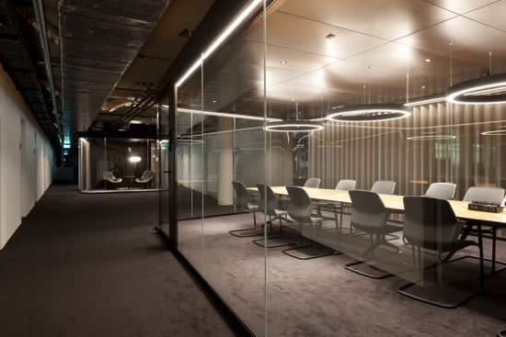
The two large conference rooms are 430 ft²/39.9 m² apiece and feature very efficient sound-absorptive curtains and ceiling materials in order to achieve the desired acoustic environment. In addition to the conference spaces there are several smaller huddle rooms – designed for more private meetings involving 2-3 people – that are 160 ft²/14.8 m² and benefit from the same treatment. All of the spaces also use a heavily absorptive 4-inch-thick metal cooling ceiling to ensure that the spaces are comfortable from a temperature standpoint as well as a sonic one. Finally, all of the rooms are full integrated with A/V equipment for presenting and video conferencing.

“Having improved speech intelligibility in the room benefits the people inside the room as well as people connecting to them remotely,” explained WSDG Senior AV Systems Engineer Michael Chollet. “Good room acoustics obviously benefit the local side, but they are even more relevant for the remote end in a video conferencing session as the echo-cancelling algorithms can work better resulting in much improved audio quality – which is the most critical communication path in any video conference.”

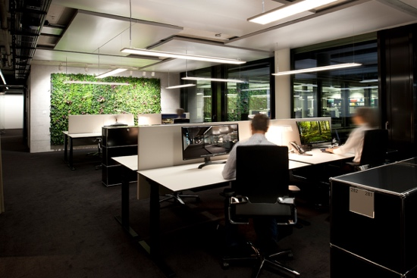
In addition to these rooms, WSDG also specified acoustic treatments for the open-plan office spaces that take up the rest of the floor. “It’s a very inspiring place to work,” concluded Hauser. “The glass rooms and open office plan allows for a lot of natural light, and our acoustic treatments make it a very calm, quiet and efficient place to get your work done.”

For more information on WSDG, visit https://wsdg.com/

*Source: UC Today, “Huddle Room Statistics” – January 14, 2019

ABOUT WSDG, LLC
For nearly 50 years, acoustic consulting and A/V integration firm WSDG has designed approximately 4,000 media production facilities worldwide and counting. Projects range from Jimi Hendrix’s Electric Lady Studio and Jazz At Lincoln Center in New York, to broadcast facilities for The Food Network, CBS and WNET, over twenty teaching studios for The Art Institutes, and corporate clients such as Sony, IBM and Novartis. Recent credits include Jungle City in New York, The Church Studio, in London, private studios for Green Day, Jay-Z, Bruce Springsteen, Alicia Keys and Academy Award-nominated film composer Carter Burwell. WSDG has collaborated with such noted architects as Frank Gehry, Philippe Stark, Rafael Viñoly, Santiago Calatrava, Grimshaw, and Norman Foster. An eleven-time winner of the prestigious pro audio NAMM TEC Award for outstanding achievement in Acoustics/Facility Design, WSDG maintains U.S. offices in New York, Washington, DC, San Francisco and Miami and global offices in Barcelona, Basel, Berlin, Belo Horizonte, Buenos Aires, Guangzhou, Mexico City and Mumbai.

Contact:
Steve Bailey
Hummingbird Media, Inc.
+1 (508) 596-9321
steve@hummingbirdmedia.com

Jeff Touzeau
Hummingbird Media, Inc.
+1 (914) 602-2913
jeff@hummingbirdmedia.com

