every detail matters
Sennheiser’s new IE 900 flagship audiophile earphones set a new benchmark for portable audio fidelity

Wedemark, May 11, 2021 – With the new IE 900 audiophile earphones, Sennheiser has brought together technical innovation, meticulous attention to detail, and an uncompromising demand for perfection to deliver a listening experience without compromise. Manufactured at the audio specialist’s headquarters in Germany, every aspect of the in-ear headphones has been engineered to work in harmony to achieve the desired acoustic tuning and to reduce resonances and masking effects. The new IE 900 boasts Sennheiser’s proprietary X3R transducer, a refined version of the audio specialist’s 7mm audiophile Extra Wide Band transducer featuring a unique triple-chamber absorber system. This ensures brilliant, natural high-end sound reproduction and reveals even the finest details in the music.
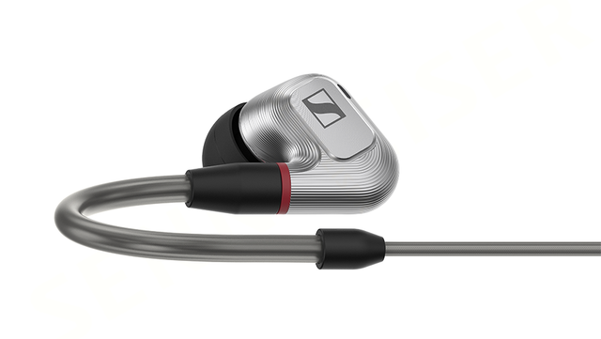

Sennheiser’s IE 900 flagship audiophile earphones set a new benchmark for portable audio fidelity

A unique triple-chamber absorber system
Sennheiser’s quest for delivering highest-fidelity sound begins with the housings of the
IE 900’s earpieces. They are milled from a single block of aluminum to create the earphones’ unique triple-chamber absorber (T3CA) system. Originally developed for the audio specialist’s acclaimed IE 800, the IE 900 features the next generation of the patented absorber system, which uses three chambers and an acoustic vortex milled into the nozzle to counter the masking effect. This acoustic phenomenon arises as the human ear cannot perceive high frequency sounds at a low volume if louder sounds in a lower frequency range occur at the same time. By removing the energy from masking resonances, the absorber system prevents undesired peaks, making even the subtlest nuances of sound audible.

The housings of the IE 900’s earpieces are milled from a single block of aluminum to create the earphones’ unique triple-chamber absorber (T3CA) system

“No detail is too small when you’re striving to set a new benchmark in portable audio fidelity. We designed every component of the IE 900 to work together to deliver extraordinary audio performance,” said Jermo Köhnke, Product Manager at Sennheiser. “Whether in long listening sessions at home or on the go, listeners will never have to compromise on their music experience.”

Sonic expertise and manufacturing precision
Compared to traditional multi-driver concepts, single-driver technology promises greater fidelity for listeners. The IE 900 therefore features Sennheiser’s new X3R transducer, a refined version of the audio specialist’s 7mm audiophile Extra Wide Band transducer, engineered for tighter tolerances and expertly tuned to achieve even greater fidelity. The IE 900 transducer is coupled with the acoustic back volume in the fully automated transducer manufacturing facility at the audio specialist’s headquarters in Germany, resulting in the lowest unit-to-unit variations in miniature, dynamic drivers.

A specialist team in Wedemark, Germany designs, engineers, and manufactures the IE 900 to the highest production standards in the audio industry. Its unique housings are precision milled from high-performance aluminum alloy to retain its pristine appearance for years to come. Precision cameras examine the transducer components closely during production, and completed transducers are tested before and after pairing. For optimal performance, the assembled left and right-side earphones are paired by hand to work together.
Extremely light and pliable, the audio specialist’s broadband transducers prevent distortion, deliver natural, balanced sound, and ensure audio transparency, regardless of listening volume. A newly developed membrane foil provides a high degree of inner dampening, ensuring minimized natural resonances and distortion (THD: 0.05% at 94 dB, 1 kHz). With a frequency response of 5 Hz – 48,000 Hz, the IE 900 reveals even the finest details in the music.

Supreme convenience and comfort
Thanks to the high-performance Fidelity Plus MMCX connector, audiophiles have the freedom of cable choice with the IE 900. Deeper integration into the housing provides better stability for the gold-plated connector. The earphones come with an unbalanced cable with a 3.5mm connector and balanced cables with 2.5mm and 4.4mm connectors. Tested and improved for robustness and longevity, the para-aramid-reinforced cables can withstand thousands of bending cycles. For a comfortable and secure fit, the IE 900 offers ergonomic features, including individually adjustable ear hooks as well as silicone and memory foam ear adaptors in three sizes, perfect for extended periods of personal music enjoyment.

The Sennheiser IE 900 will be available from June for 1,299 EUR (MSRP).

ABOUT SENNHEISER
Shaping the future of audio and creating unique sound experiences for customers – this aim unites Sennheiser employees and partners worldwide. Founded in 1945, Sennheiser is one of the world’s leading manufacturers of headphones, loudspeakers, microphones and wireless transmission systems. Since 2013, Sennheiser has been managed by Daniel Sennheiser and Dr. Andreas Sennheiser, the third generation of the family to run the company. In 2019, the Sennheiser Group generated turnover totaling €756.7 million.
www.sennheiser.com

Global Press Contact
Sennheiser electronic GmbH & Co. KG
Jacqueline Gusmag
Communications Manager Consumer
T: +49 (0)5130 600-1540
jacqueline.gusmag@sennheiser.com

