Follow your own track
Sennheiser introduces the SPORT True Wireless – fit for any challenge
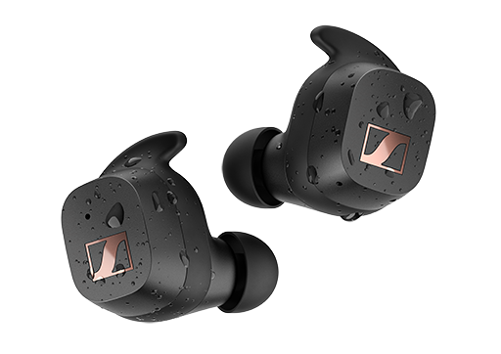
Marlow, April 21, 2022 – The new Sennheiser SPORT True Wireless brings superior audio performance for fitness enthusiasts and athletes no matter how intense the workout. Its unique Adaptable Acoustic feature also offers a choice of open and closed ear adapters, allowing athletes to tailor their listening experience to their sport. Thanks to its secure, customisable fit, the SPORT True Wireless is ready for even the most active challenges - all with the unique Sennheiser sound.
SPORT True Wireless delivers an exceptional sound experience thanks to Sennheiser's TrueResponse transducer. Designed and engineered in Germany, the acoustic system is powered by a unique 7mm dynamic driver that delivers full bass and superior clarity without distortion - even at high volume. The SPORT True Wireless also puts athletes in control of how they experience sound and perceive their surroundings. The unique Adaptable Acoustic feature allows athletes to choose either open or closed ear adapters and adjust EQ settings for the perfect custom training sound.

The open ear adapters in combination with the Aware EQ settings help to reduce body-borne noise and allow some outside sounds to enter for better situational awareness. In this mode, runners hear fewer distracting noises such as their own heartbeat or footsteps and more of their surroundings, blending their favourite exercise playlist with sounds of nature or the city while improving awareness. Those who prefer their own music in noisy gyms and don't want to be distracted by the busy environment will find peace of mind with the closed ear adapter and Focus EQ settings.
In addition to the Sennheiser Smart Control App’s Focus and Aware EQ settings, athletes can make fully customisable presets for their listening experience via the Sound Check feature. The intuitive touch controls of the SPORT True Wireless let users personalise the sound to their preferences and facilitate access to audio navigation and voice assistants. Bluetooth 5.2 compatibility and support for audio codecs like SBC, AAC and aptX also make it easy to stay connected to mobile devices, smartwatches, smart TVs, and connected fitness devices for a seamless audio experience.
A secure fit that can be counted on
“Every movement during sports is a challenge for your earbuds fit to keep delivering great sound. For anyone who likes to listen to music while exercising, it's important to be able to concentrate fully on the sport without fear of the earbuds slipping out of place. As all ears are unique in shape and size ‘one fits all’ is not secure, so we have focused on providing a fully customisable solution for maximum wearing comfort and a secure fit.” says David Holm, Sennheiser Sports Product Manager.
The ergonomic design of the SPORT True Wireless was developed precisely for this purpose. The earbuds can be customised with a choice of ear adapters in three sizes and four different ear fins to withstand any workout. With an IP54 rating, the SPORT True Wireless is dust and splash resistant and can also easily withstand sweat, runs in the rain, and even workouts at the beach.
Runs longer than you can
The SPORT True Wireless doesn't just stand up to the physical challenges. With a battery life of 9 hours, and another 18 hours with the charging case, it offers uncompromising performance to go the distance.
Pricing and availability
The Sennheiser SPORT True Wireless can be pre-ordered starting today and will be available on May 3, 2022, with an MSRP of 119.99 GBP/129.90 EUR.
About the Sennheiser Brand
We live and breathe audio. We are driven by the passion to create audio solutions that make a difference. Building the future of audio and bringing remarkable sound experiences to our customers – this is what the Sennheiser brand has represented for more than 75 years. While professional audio solutions such as microphones, meeting solutions, streaming technologies and monitoring systems are part of the business of Sennheiser electronic GmbH & Co. KG, the business with consumer devices such as headphones, soundbars and speech-enhanced hearables is operated by Sonova Holding AG under the license of Sennheiser.

www.sennheiser.com
www.sennheiser-hearing.com

Global Press Contact
Milan Schlegel
PR and Influencer Manager Consumer – EMEA Sennheiser Consumer Audio GmbH
milan.schlegel@sennheiser-ce.com
T +49 (0)5130 600 1139

Emily Ackland
Harvard
sennheiser@harvard.co.uk
T +44 2078 613 945
T +44 7393 758442

