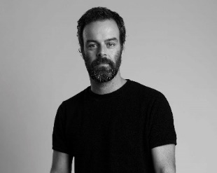
ARJAN BEVERS

AVANTI KAPPERS

NETHERLANDS

His relationship with the profession began when he was 15 and started working in a salon. From then on, his passion for hairdressing grew and at only 19 he began to participate in creative hairdressing contests. At 23, in 2003, he began to run his own salon and sometime later he met a client there who today is his wife, Mireille, and with whom he shares the business.

Avanti Kappers, located in the south of the Netherlands, is one of the most beautiful salons in Europe. The pink tiles, the black ceiling and plants everywhere create a creative and cozy space at the same time. The philosophy of the salon is to enhance personal identity as expressed in their own words: "We believe that your hair is the reflection of your personality!". They believe that a haircut should reflect the character of the person who wears it, since when it is well executed it is a clear statement about how they feel and who each one is. The Avanti Kappers team aims to enhance the beauty that is hidden in the hair and each person. Therefore, customization is key, as each type of hair and face needs a different treatment and has its own requirements and possibilities. Its hairdressers intend to make the image of each client flourish, creating an exclusive look for each, and they achieve it with care and dedication.

Awards and nominations:
- 2021 Winner Best Male, Coiffure Award.
- 2019 Winner Best Team, Best Male, Best Female & Hairdresser of the Year, Coiffure Award.
- 2019 Winner AIPP Award.
- 2019 Finalist Live Fashion Hair TCT Award.
- 2018 Winner Best Male & Best Female, Coiffure Award.
- 2016 Winner Best Team, Coiffure Award.
- 2015 Winner Best Female & Hairdresser of the Year, Coiffure Award.
- 2014 Winner Best Male, Coiffure Award.
- 2012 Winner Best Male, Coiffure Award.

With Avanti, they have won:
- 2018 Best Avant-Garde Collection, Behind the Chair, One Shot Award.
- 2018 Avant-Garde, TCT Awards Live Fashion Hair.
- 2016 Young Talent, Coiffure Award.

In addition, he has been part of Hairdressers United - Digital Hair Festival 24h, WORLD GUINNESS RECORD, with 41 artists from 19 different countries, led by Schwarzkopf Professional.

Since 2021, Arjan Bevers has been a Global Color Ambassador for Schwarzkopf Professional.

