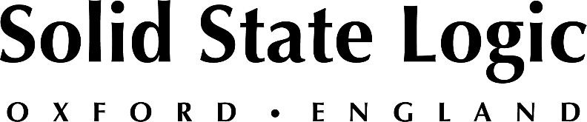

Solid State Logic's System T New Tempest Engines Offer Scalable and Agile Signal Processing Capacity
New pay-as-you-go licensing enables operators using the new lightweight and compact TE1 and TE2 Tempest Engines to flexibly scale processing capabilities according to broadcast production requirements
Oxford, UK, August 26, 2021 —Solid State Logic’s recent System T V3.1 software release introduces pay-as-you-go licensing that enables operators using the new TE1 and TE2 Tempest Engines to flexibly scale processing capabilities according to broadcast production requirements. Software licenses for five different processing packs, defined by the total number of mono All-Paths equivalent channels supported, from 85 to 800, are now available as perpetual or short-term, time-based rental upgrades.

The new TE1 Tempest Engine supports Processing Pack 1 (140 paths) or 2 (256 paths) while the TE2 engine supports all five packs, from 140 to 800 paths at 48 kHz or 85 to 500 paths at 96 kHz. The TE1 is equivalent to the original T25 engine for System T, which offered a maximum of 256 paths, while the TE2 matches the previous 800-path T80 engine. The two new engines and five processing packs expand beyond those configurations to offer a wider variety of channel path capacities that align with a broader range of applications and budgets.

SSL’s new licensing reflects a trend within the broadcast industry toward a pay-as-you-go model, which allows users to temporarily scale up equipment capabilities by adding software processing for a limited time for special events, thereby providing better utilization of capital expenditure. For example, a production rental company or centralized broadcast hub operation might purchase an SSL System T running a processing pack supporting 256 paths, then license a pack supporting 800 paths for a client working on a large-scale entertainment or sports event for a couple of weeks.

The bus and stem mono path count, processing resources such as path EQ and dynamics, and effects rack are dependent on a system’s hardware configuration. System T’s Compatibility Mode allows a user to allocate processing resources on lower capacity engines or software processing packs, or lower capacity when working at a higher sample rate. This means that a showfile built on a larger engine or processing pack can be loaded onto any system, even one with a lower capacity. The user simply chooses which channels, buses and effects modules not to use on the lower capacity engine.

System T V3.1 software additionally provides alerts and warnings as any processing pack license nears its expiration. SSL has also built a licensing platform through which the company can deliver and manage licenses and clients can retrieve them and add them to their console systems.

Tom Knowles, SSL Broadcast Product Manager comments; Client feedback is one of the key aspects of System T development, with many broadcasters, particularly ones focused on events, sports and entertainment programming, requesting scalable DSP systems to work in harmony with their varying production requirements. System T’s ability to deliver both short term and perpetual licensing thanks to V3.1 update allows them to exactly do this, in an agile and cost effective way.

For more information on SSL System T’s new TE1 and TE2 engines, processing packs and V3.1 software, please visit: https://www.solidstatelogic.com/broadcast

Solid State Logic is the world’s leading manufacturer of analogue and digital audio consoles and provider of creative tools for music, broadcast, live and post production professionals. For more information about our award-winning products, please visit: www.solidstatelogic.com.

###
For further information contact:
Jeff Touzeau
+1 (914) 602-2913
jeff@hummingbirdmedia.com

Ross Gilbert
+44 (0) 1865 842300
rossg@solidstatelogic.com

