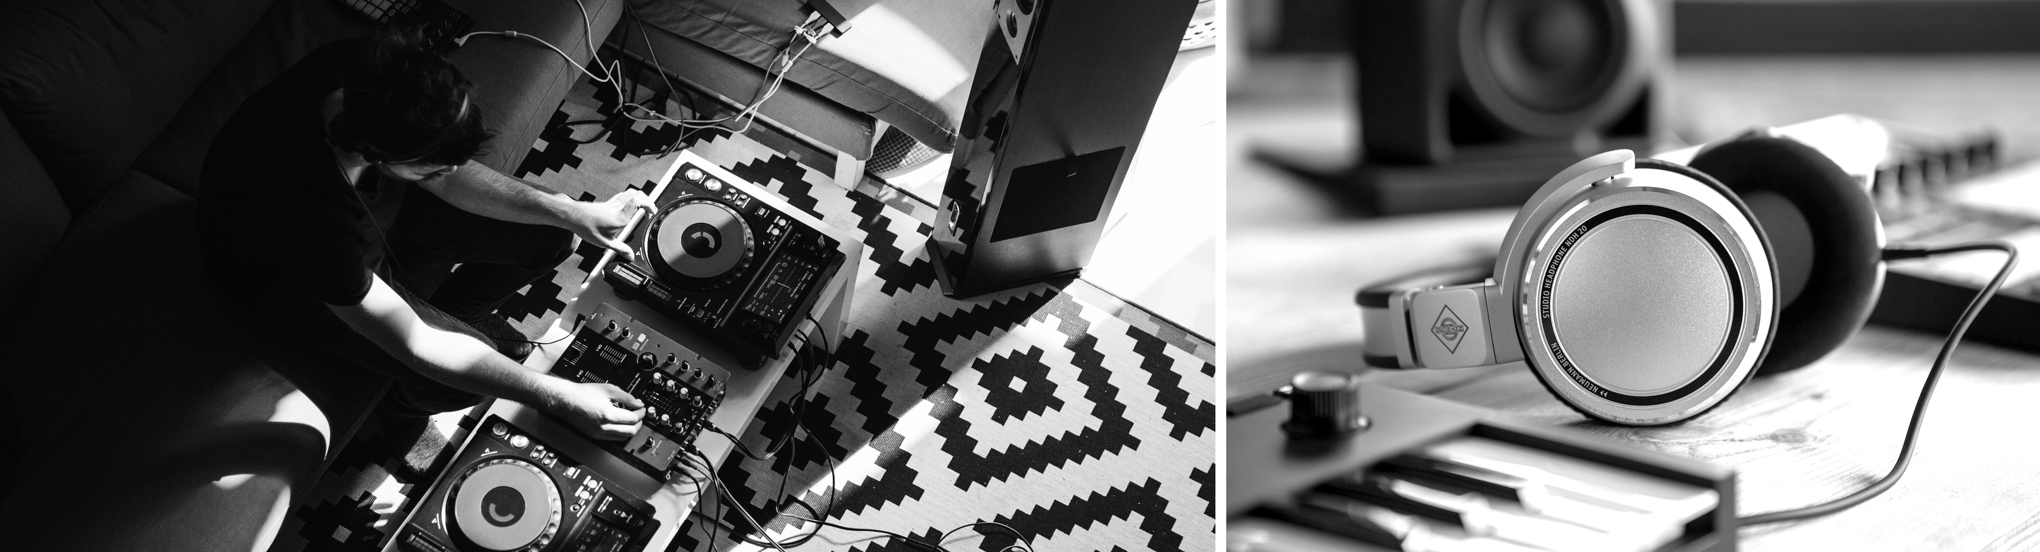

NAMM 2020
Sennheiser and Neumann showcase solutions for the stage and studio

Wedemark/Berlin, January 7, 2020 – At NAMM 2020, Sennheiser and Neumann will showcase the gear that makes a musician’s heart beat faster – with solutions for everyone from seasoned professionals to those starting out in the music business. Sennheiser will present a new version of the HD 25 LIGHT, which now brings the original sound signature of the iconic HD 25 to bedroom DJs. In professional wireless systems, the audio specialist will launch a link density mode for its Digital 6000 series. A large selection of Neumann studio and stage microphones – supplemented by the KU 100 binaural head – can be tested live. A separate demo room on the stand is available for demonstrations of the KH Line studio monitors. Naturally, Neumann will also be presenting its NDH 20: Anyone that hasn’t yet heard these studio monitoring headphones can hear firsthand why Neumann’s debut in this market has already attracted such acclaim.

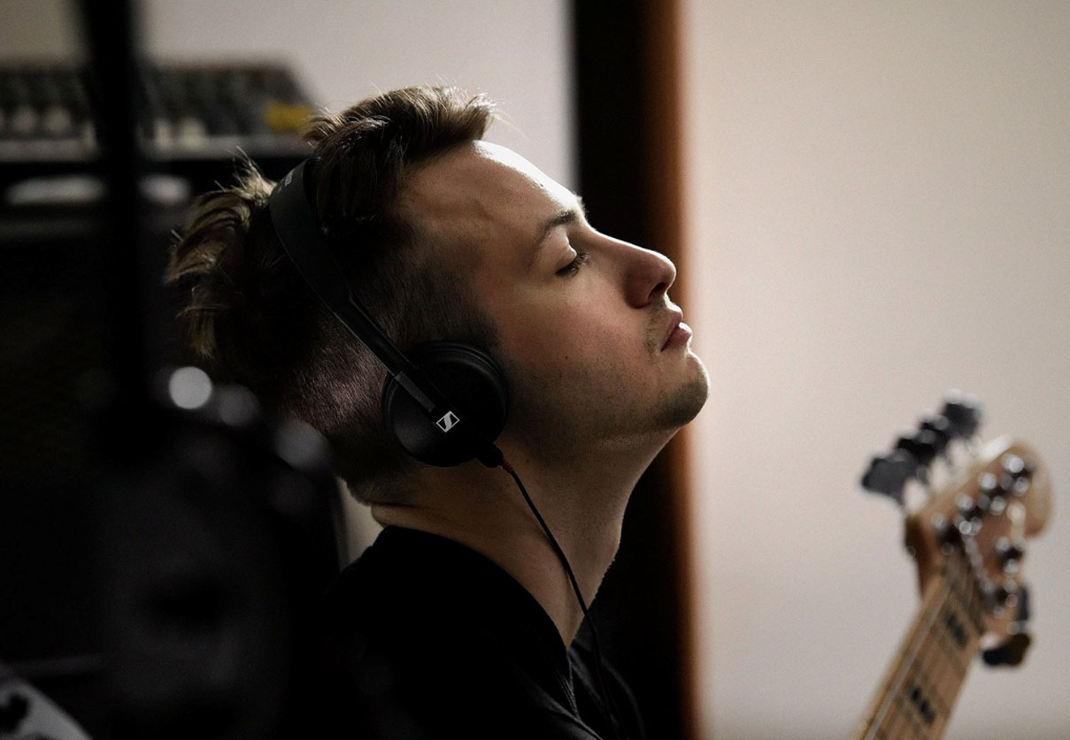 | The HD 25 has been part of the Sennheiser portfolio for more than 30 years – the new HD 25 LIGHT now features the sound signature of the original but a simpler headband design

This is also a special year for Sennheiser, which in 2020 is celebrating its 75th anniversary. A dedicated 75-year anniversary section of the booth will provide visitors with an opportunity to revisit milestone products and magical moments from Sennheiser’s accomplished history. As well as a passion for audio, Sennheiser has always placed its customers first: the celebration also brings to life the passion of Sennheiser users, and visitors can hear compelling stories from fans from across the industry describing their relationship to the audio specialist’s gear.

For a look to the future, vocalists will want to take a closer look at the audio equivalent of a ‘concept car’: Sennheiser will be presenting a high-rejection stage microphone which will be made available for testing on the showfloor prior to its launch later in 2020.

The Neumann TLM 107 with its five directional characteristics is valued by users as an extremely versatile studio microphone with a breathtaking realism | 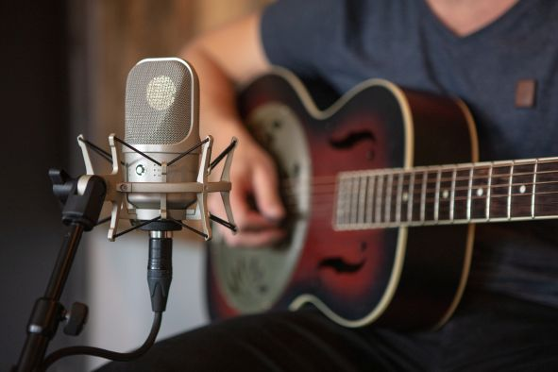

Live music has always been a key element of the Sennheiser and Neumann NAMM booth, and 2020 is no exception: A line-up of outstanding artists will be putting Sennheiser’s popular evolution stage microphones to best use:

Thursday, Jan 16th - Day 1
11:00 a.m. Chris Pierce
12:00 p.m. The Campbells
1:00 p.m. Shelita Burke
2:00 p.m. George Krikes, Jessie Payo, Leeann Skoda
3:00 p.m. Ronee Martin
4:30 p.m. Media event
5:00 p.m. Ari and the Alibis

Friday, Jan 17th - Day 2
11:30 a.m. Mackenzie Sol
12:30 p.m. Nina Storey
1:30 p.m. Ari and the Alibis
2:30 p.m. Dilana
3:30 p.m. Talkback
4:30 p.m. Michelle Willis
5:00 p.m. Marcus Eaton

Saturday, Jan 18th - Day 3
10:30 a.m. Gran Sur
11:30 a.m. Sugar in the Gourd
12:30 p.m. Debby Holiday
1:30 p.m. Ari and the Alibis
2:30 p.m. Victor Wooten
3:30 p.m. Judith Owen
4:30 p.m. Louisiana Love Act
5:00 p.m. Good Boy Daisy

Sunday, Jan 19th - Day 4
11:30 a.m. McKail Seely
12:30 p.m. Jacqueline Epcar
1:30 p.m. Ari and the Alibis
2:30 p.m. Alice Howe
3:30 p.m. Kacey Lansdale

Visit Sennheiser and Neumann at NAMM, Anaheim Convention Center North, Level 1, Booth No. 14108.

The Sennheiser images in this press release can be accessed here: https://sennheiser-brandzone.com/c/181/cVY261c9, the Neumann images are available here: https://www.neumann.com/exchange/Neumann_NDH20_TLM107.zip

About Sennheiser and Neumann
Shaping the future of audio and creating unique sound experiences for customers – this aim unites Sennheiser employees and partners worldwide. Founded in 1945, Sennheiser is one of the world’s leading manufacturers of headphones, loudspeakers, microphones and wireless transmission systems. Since 2013, Sennheiser has been managed by Daniel Sennheiser and Dr. Andreas Sennheiser, the third generation of the family to run the company. As part of the Sennheiser Group, Georg Neumann GmbH, known as “Neumann.Berlin”, is the world’s leading manufacturer of studio microphones. Founded in 1928, the company has been recognized with numerous international awards for its technological innovations. Since 2010, Neumann.Berlin has expanded its expertise in electro-acoustic transducer design to also include the studio monitor market, and has recently added studio monitoring headphones to its portfolio. In 2018, the Sennheiser Group generated turnover totaling €710.7 million.
www.sennheiser.com | www.neumann.com

Global Press Contacts

Andreas Sablotny Stephanie Schmidt
andreas.sablotny@neumann.com stephanie.schmidt@sennheiser.com
T +49 (30) 417 724 – 19 +49 (5130) 600 – 1275

