Step up your Wireless Audio

Sennheiser’s new HD 450BT and HD 350BT headphones are the ideal choice for experiencing great sound every day
London/Las Vegas, January 6, 2020 – Experience great Sennheiser sound every day with the new HD 450BT and HD 350BT around-ear Bluetooth headphones. First presented during CES 2020 in Las Vegas (January 7-10), they build on the popular predecessors HD 4.40BT and HD 4.50BTNC, offering a winning combination of audio quality, wireless freedom, a 30-hour battery life and instant voice assistant access. The HD 450BT also features active noise cancellation so no matter how loud the environment, it’s possible to enjoy a truly captivating audio experience without any distractions.
The new closed-back wireless headphones from Sennheiser have been created to deliver a superior audio experience with deep dynamic bass. They feature the latest wireless technology including Bluetooth 5.0 compatibility and high-quality wireless codec support, including AAC, AptX™ and AptX™ Low Latency for perfect audio synchronisation with video. “Our new HD 350BT and HD 450BT headphones were made for everyone seeking to step up their everyday audio experience”, said Jermo Köhnke, Product Manager at Sennheiser. The HD 450BT’s active noise cancellation ensures captivating sound that can be enjoyed without any distraction – even in loud environments. For added versatility, the HD 450BT can also be used in wired mode.
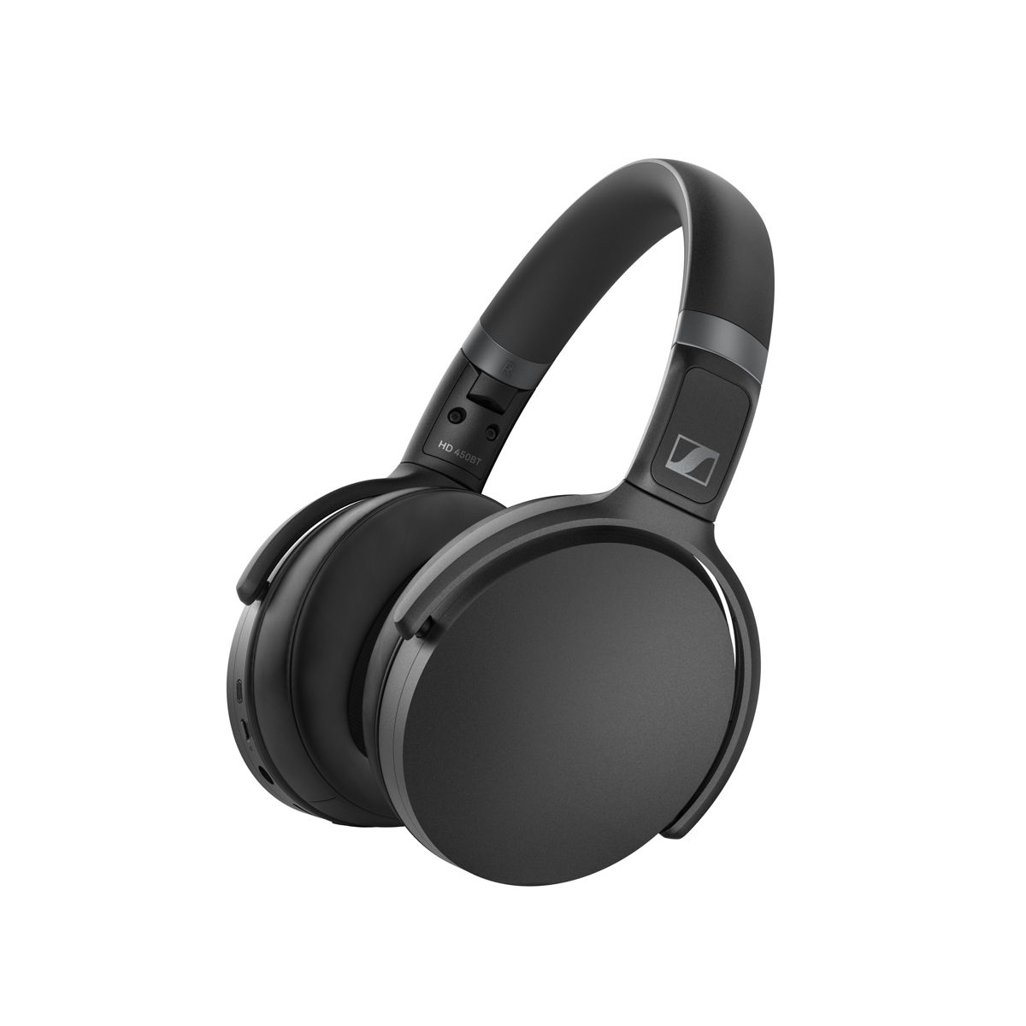
The new HD 450BT (pictured here) and HD 350BT offer a winning combination of audio quality, wireless freedom, impressive battery life and instant voice assistant access.
Whether seeking to turn up the bass or achieve a neutral sound, it’s easy to tailor the sound of the new HD 350BT and HD 450BT headphones according to personal taste with the equaliser feature on the Sennheiser Smart Control app. The app also offers a podcast mode that optimises intelligibility of podcasts, audio books and other speech content. In addition, it provides access to battery status, a quick guide, and firmware updates.
Both the HD 450BT and HD 350BT are ideal companions for travel, with impressive 30-hour battery lives and convenient and rapid charging via USB-C. Their compact, folding designs offer the perfect fusion of minimalist style, ergonomic comfort, and take-anywhere durability.

The HD 450BT’s active noise cancellation ensures captivating sound that can be enjoyed without any distraction.

HD 450BT and HD 350BT are available in black or white colour variants. As well as looking and feeling great, the new headphones provide an effortless everyday user experience. A dedicated voice assistant button enables voice interaction with Siri or Google Assistant at a touch, while intuitive physical buttons on the earcups make it easy to control music and calls.
The new HD 350BT is available from mid-January for 89.99 GBP (MSRP), while the HD 450BT will be available from mid-February for 159 GBP (MSRP).
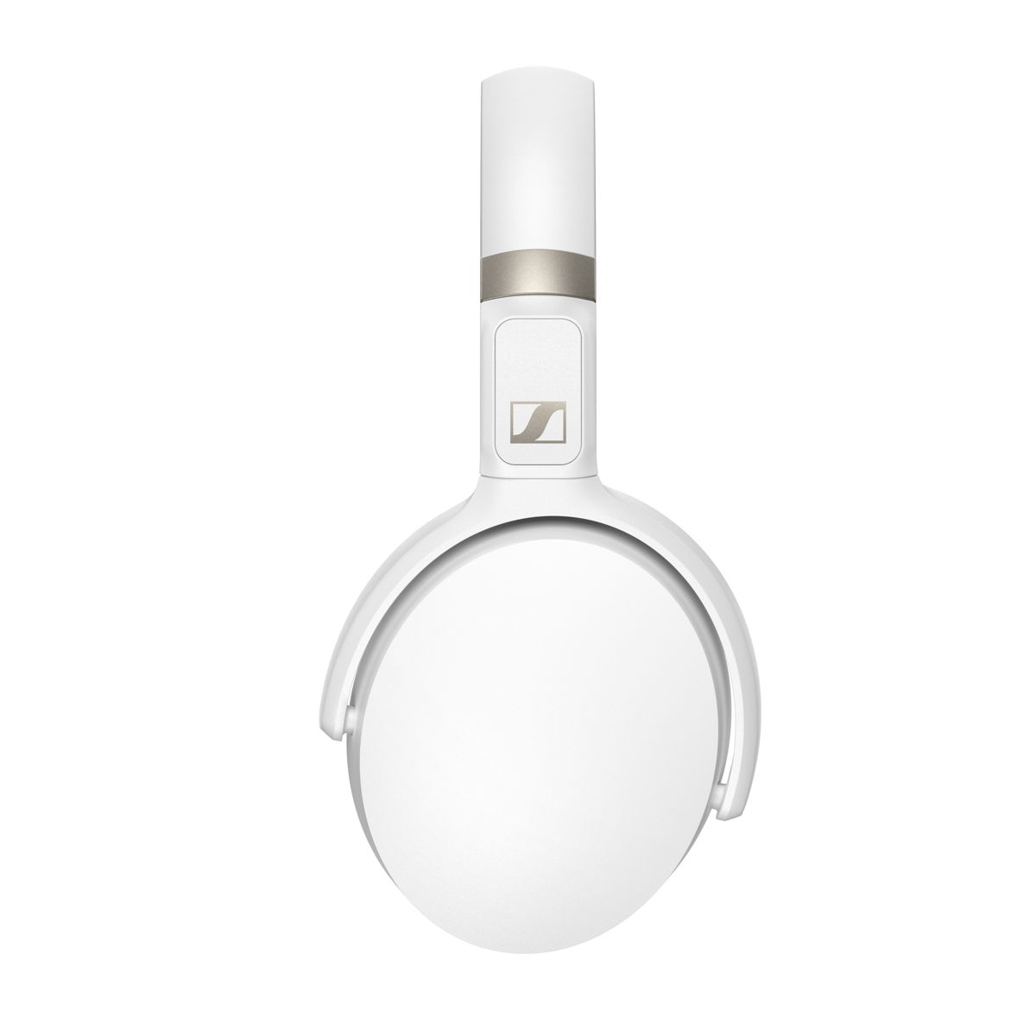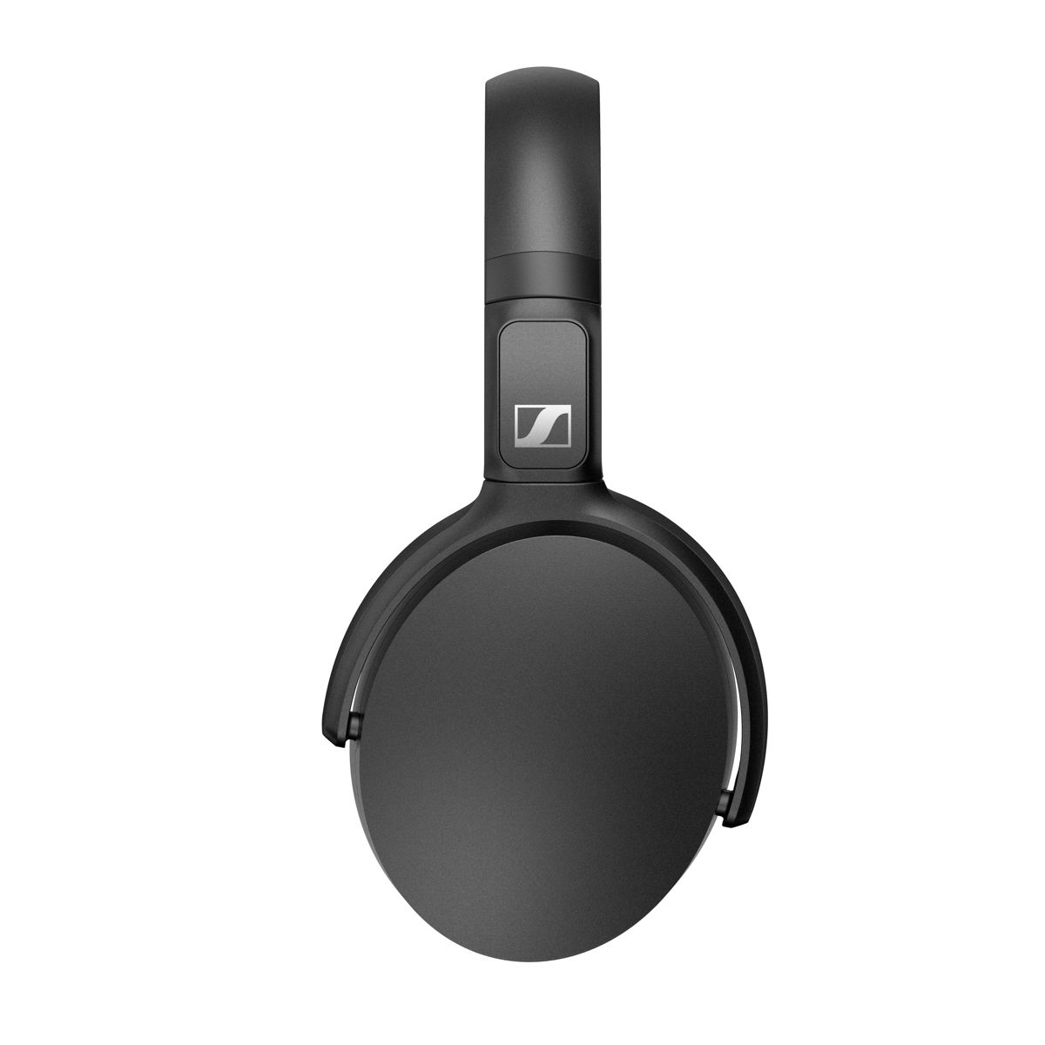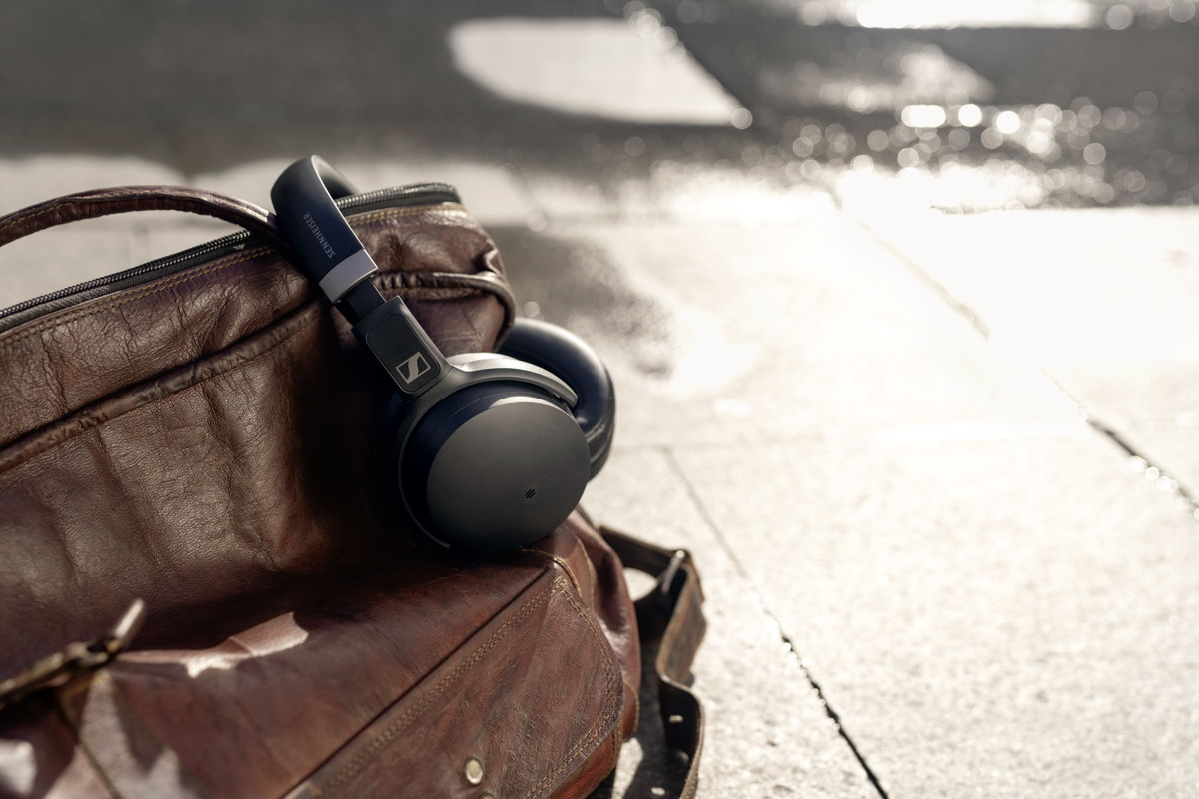
Images can also be downloaded from the Sennheiser Brandzone.
About Sennheiser
Shaping the future of audio and creating unique sound experiences for customers – this aim unites Sennheiser employees and partners worldwide. Founded in 1945, Sennheiser is one of the world’s leading manufacturers of headphones, loudspeakers, microphones and wireless transmission systems. Since 2013, Sennheiser has been managed by Daniel Sennheiser and Dr. Andreas Sennheiser, the third generation of the family to run the company. In 2018, the Sennheiser Group generated turnover totaling €710.7 million. www.sennheiser.com

North and East Europe Press Contact
Sennheiser electronic GmbH & Co. KG
Maik Robbe
Communications Manager UK & Nordics
maik.robbe@sennheiser.com

