EMBARGOED UNTIL Thursday, June 18, 2026, at 06:00 AM EST (UTC-4)

ACCENTUM Clip: Music and Life in Perfect Sync
Sennheiser’s ACCENTUM Clip open-ear true wireless earbuds combine sublime acoustics, Bluetooth® 6.0, and LDAC streaming capability into a featherlight, IP54-rated design with 36-hour battery life and natural ambient awareness.

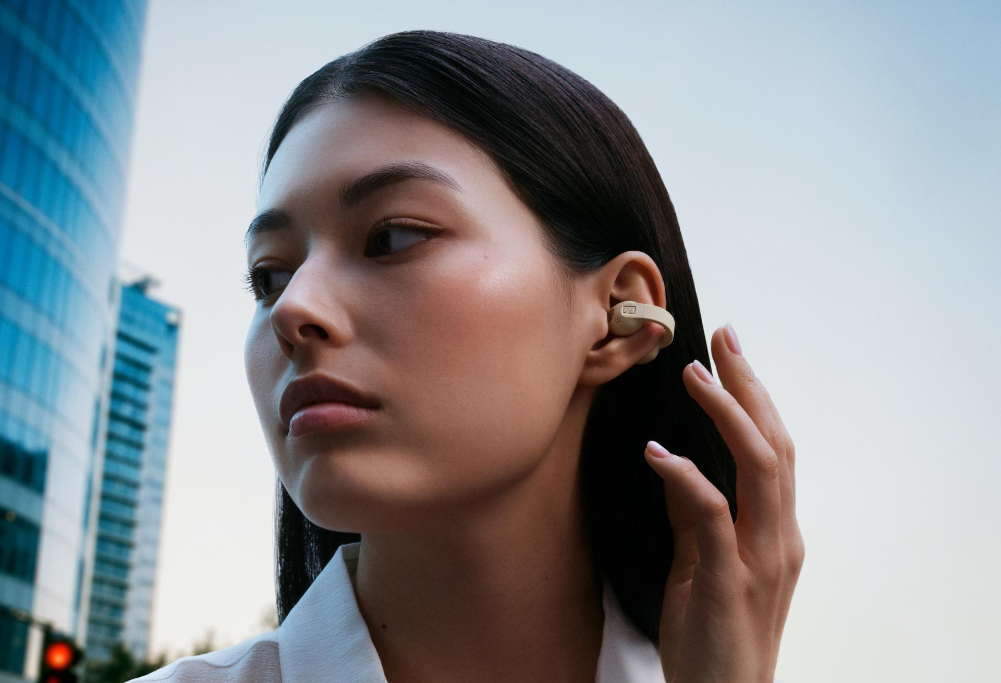

Hanover, Germany – June 18, 2026 – The Sennheiser brand today announced ACCENTUM Clip, a new benchmark for audio performance in the open-ear true wireless category. With natural ambient awareness, impressive bass response, modern wireless capabilities and all-day comfort, the compact ACCENTUM Clip complements life on the move.
“In creating ACCENTUM Clip, we wanted to elevate the standard of acoustic performance that open earbuds have traditionally struggled with,” said Friederike Menking, ACCENTUM Clip Product Manager. “Whether you are tackling productivity, out on your own adventures, or managing the transitions in between, its thoughtful design empowers you to navigate your world without sacrificing the essence of your music.”

Situational Awareness Meets Exceptional Sound
Daily life doesn’t happen in neat little boxes; the lines between work and play are constantly blurred. From streaming the latest album drop at the train station to picking up your coffee order mid-conference call, multitaskers demand situational awareness and impressive sound. Until now, the growing demand for truly open earbuds has come with sonic compromises. Backed by decades of expertise tuning open headphones, ACCENTUM Clip delivers both natural ambiance and stunning audio reproduction without the need for electronic pass-through modes. This ensures the essential cues of everyday life stay with you, wherever you immerse yourself in your music.

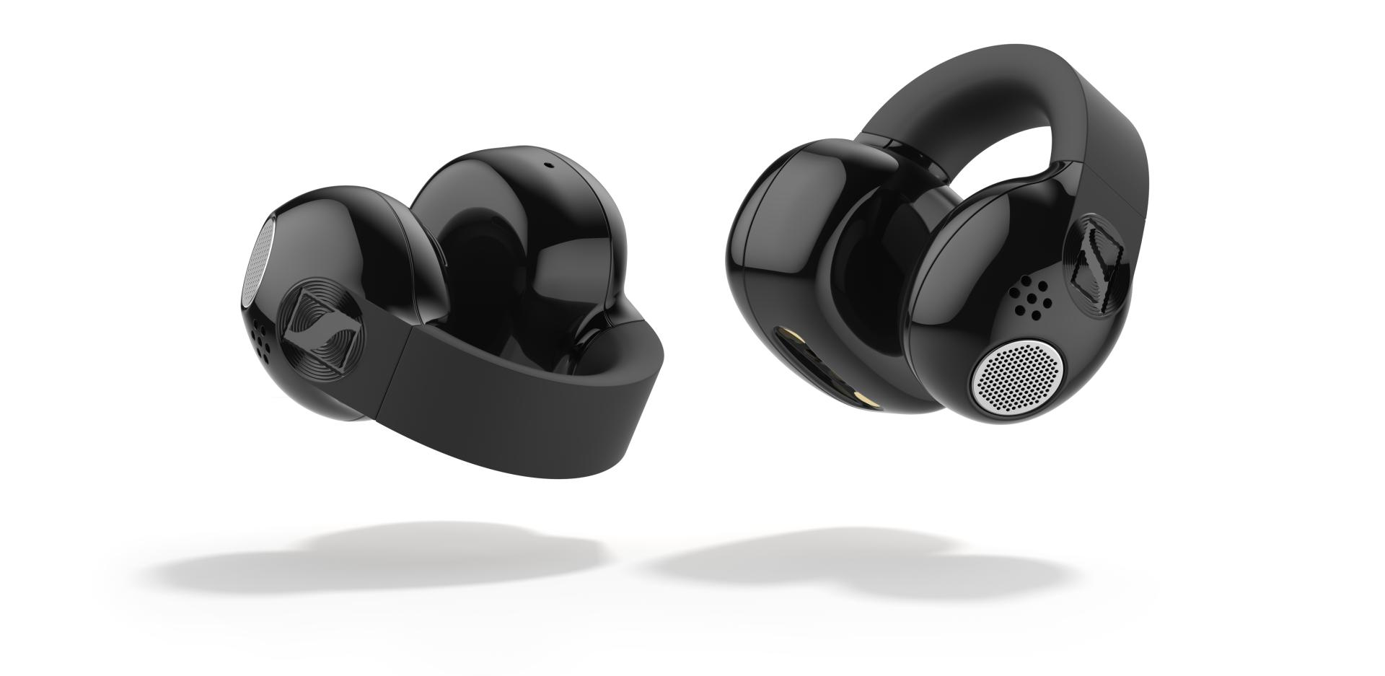
ACCENTUM Clip allows for complete situational awareness with full, rich Sennheiser sound

Brilliant Sennheiser Sound
At the core of the Hi-Res Audio Wireless® certified ACCENTUM Clip is a 12 mm dynamic driver, tuned for clarity and punchy bass with smooth treble that is delightful to listen to in long stretches. To ensure brilliant Sennheiser sound in every situation, the certified earbuds utilize a Dynamic EQ for seamless compensation of tonal shifts when playback volume is lowered. As the volume level increases, the equalization curve steps back to maintain balance while preventing unpleasant distortion.
For the ideal blend of sound quality, battery life and reliable connection on millions of devices, ACCENTUM Clip uses the versatile SBC and AAC codecs and Google Fast Pair™. On compatible devices, listeners wanting to take advantage of high-resolution streaming content may enable the LDAC codec¹ for high bitrate audio transmission. The critically acclaimed Sennheiser Smart Control Plus app lets ACCENTUM Clip users further personalize its sound and connectivity with a 5-band EQ, shareable presets, Sound Check’s guided prompts, and more.

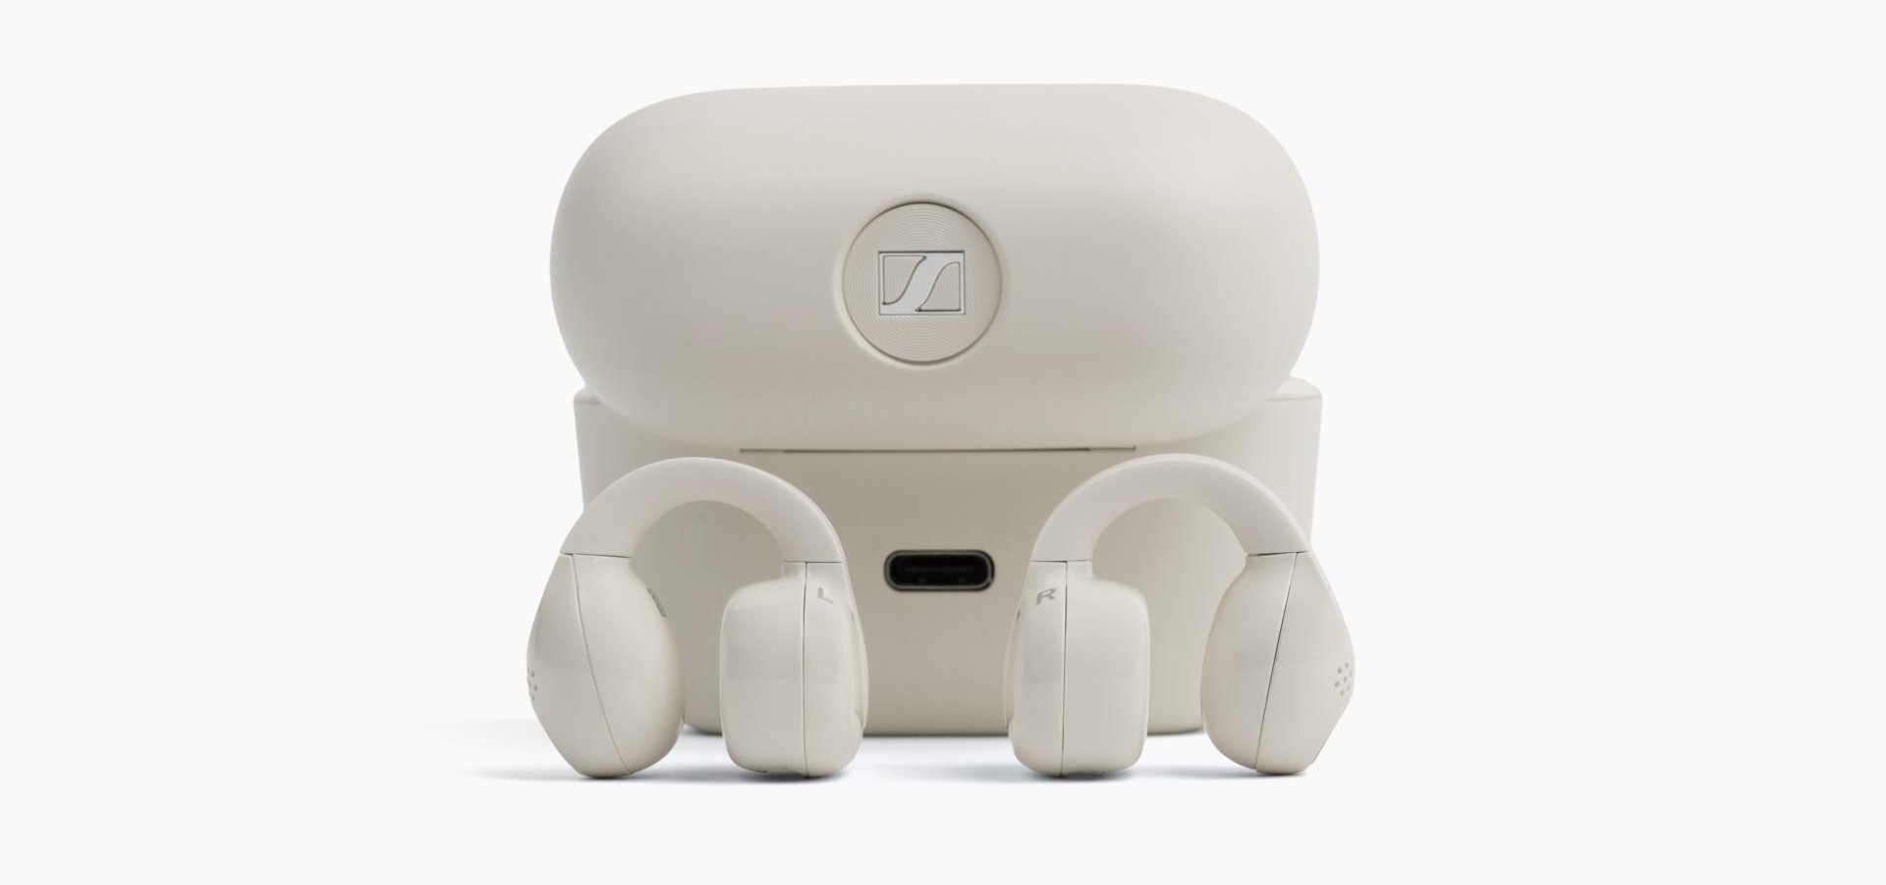
ACCENTUM Clip earbuds are IP54 rated and last up to nine hours per charge with three additional top-ups in the case

Built for Real Life
Engineered for a secure, "barely there" fit, the ACCENTUM Clip earbuds weigh just 6.8g each—about as much as a hotel key card and its sleeve. A flexible silicone bridge keeps the earbuds positioned in the sweet spot of practically any ear for optimum sound and stability during commutes and intense gym sessions. Meant to be used everywhere, their IP54 rating protects against dust and sweat. Responsive, easy-to-find textured touch controls keep volume, calls, and playlists a tap away, while the meticulous speaker geometry and built-in damping ensure the only one listening is the wearer. A pocketable charging case provides three additional top-ups, extending the 9-hour single-charge battery to 36 hours total. A 10-minute rapid charge over the USB Type-C cable (included) delivers 2 hours of playback.
Powered by Bluetooth 6.0, ACCENTUM Clip offers speedy pairing, smooth multipoint connectivity, and independent earbud use. For clear voice communication, each earbud features a dual-microphone system paired with an AI noise reduction algorithm to isolate the wearer’s voice from ambient backgrounds.

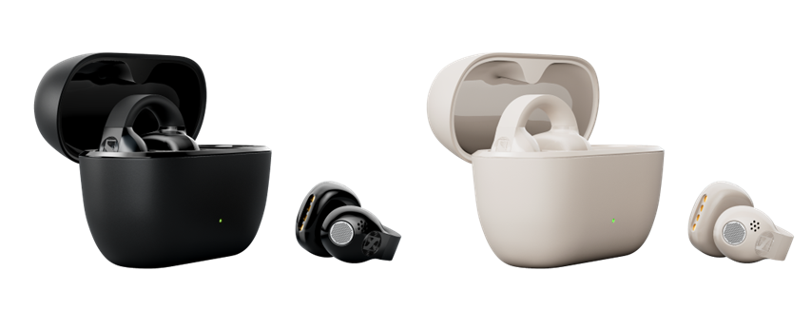
ACCENTUM Clip is available in two colorways

Availability
ACCENTUM Clip is available in Black and Cream colorways, and ships in zero-plastic eco-friendly packaging. The earbuds will be available in Canada starting July 23rd from sennheiser-hearing.com and Best Buy with a suggested retail price of $269.95 CAD.

¹LDAC audio streaming requires a compatible, LDAC-enabled source device.

The Bluetooth® word mark and logos are registered trademarks owned by Bluetooth SIG, Inc. and any use of such marks by Sonova Consumer Hearing is under license. Hi-Res Audio Wireless" logo is a registered trademark of Japan Audio Society. Google, Android, and Google Fast Pair are trademarks of Google LLC. LDAC is a trademark of Sony Corporation. All other company and product names mentioned herein may be trademarks of their respective companies.

About the Sennheiser Brand – 80 Years of Building the Future of Audio
We live and breathe audio. We are driven by the passion to create audio solutions that make a difference. This passion has taken us from the world’s greatest stages to the quietest listening rooms – and made Sennheiser the name behind audio that doesn’t just sound good: It feels true. In 2025, the Sennheiser brand celebrated its 80th anniversary. Since 1945, we have stood for building the future of audio and bringing remarkable sound experiences to our customers. While professional audio solutions such as microphones, meeting solutions, streaming technologies and monitoring systems are part of the business of Sennheiser electronic SE & Co. KG, the business with consumer devices such as headphones, soundbars and speech-enhanced hearables is operated by Sonova Holding AG under the license of Sennheiser.

sennheiser.com
sennheiser-hearing.com

About Sonova Consumer Hearing
Sonova Consumer Hearing offers premium headphones and hearables – primarily in the true wireless segment – as well as audiophile headphones, hearing solutions and soundbars under the Sennheiser brand. The business is part of the Sonova Group, a global leader in innovative hearing care solutions with headquarters in Switzerland and more than 17,000 employees worldwide.

Press contact
Eric Palonen
PR Manager | Americas
Sonova Consumer Hearing USA
T +1 860 908 1210
eric.palonen@sonova.com

