

Biuro prasowe better. gaming agency
bettergamingagency.prowly.com

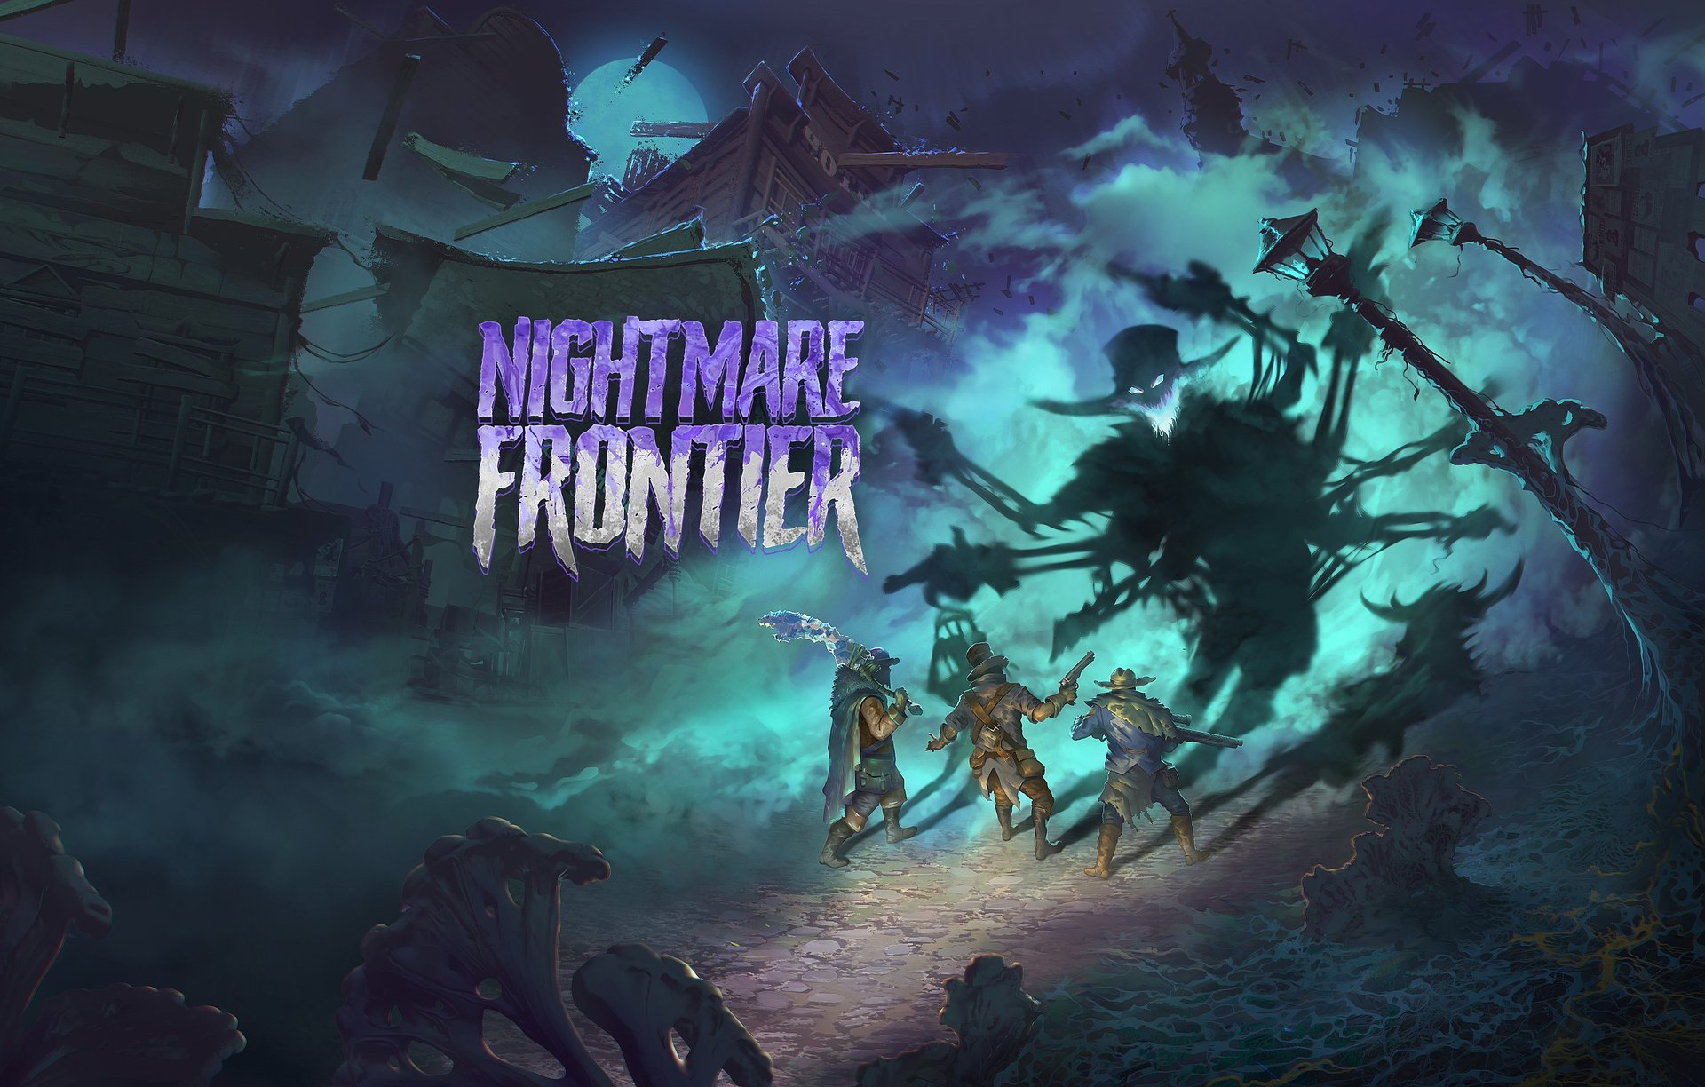

American Dream becomes horror – Nightmare Frontier coming this summer

Nightmare Frontier is the latest game from Ice Code Games, the studio behind the acclaimed Hard West 2 and Rogue Waters. The West was nearly tamed – until the Nightmare appeared, a dark force from another dimension that players must now confront. The reveal trailer introduces a group of brave – but far from selfless – souls fighting to survive in this innovative tactical extraction looter. Nightmare Frontier is set to launch this summer, with a playable demo coming soon.

The story of Nightmare Frontier unfolds in an alternate version of 19th-century America, shortly after a mysterious event that forever changed the world. The line between reality and an unknown horror has started to fade, and those who remain are left to uncover what truly happened that night – and what’s behind the titular Nightmare. The streets were overrun by monsters emerging from the dark abysses of the terror dimension – the survivors called these creatures Dreadweavers. These beings are the physical embodiment of people's deepest fears. Players will step into the shoes of the ringleader, who, despite overwhelming terror, finds a chance for survival in this new reality. Leading other scavengers, they venture deep into the city, risking everything they have left in search of loot.

Nightmare Frontier – reveal trailer

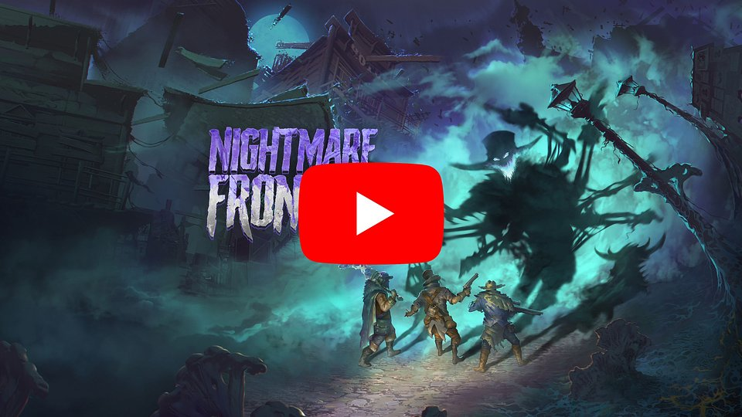
https://www.youtube.com/watch?v=dFoqfJ0CTwg

If you played Hard West 2, you know that our take on the West is far from the Hollywood classics. Nightmare Frontier offers a fresh take on tactical turn-based strategies, showcasing our passion and experience in the genre. We’re combining the bold gunfights from Hard West 2 with fierce melee combat from Rogue Waters, spicing it up with roguelite elements, and steering the experience toward extraction looter games. Managing risk will play a crucial role – the player, tempted by the promise of valuable loot, can lose almost everything in an instant. This 'push your luck' element will not only force a more strategic approach but also the need to be prepared to deal with the consequences of greed.

– said Mateusz Pilski, CEO of Ice Code Games.

Set in a dark and ruthless universe, Ice Code Games' latest game offers players something truly unique – a blend of tactical turn-based gameplay with elements typical for roguelites and extraction looters. One of the key gameplay features is the constant need to take risks, which go hand in hand with potential rewards – Dreadweavers controlling the city are merciless, and reckless pursuit of loot can have tragic consequences. The Nightmare grows stronger with each turn, increasing in power and numbers.

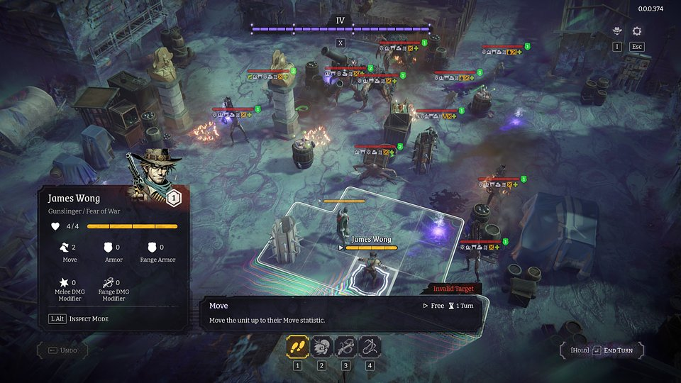

As the terrifying events unfold, the city is mostly consumed by the Nightmare – a metaphysical and mysterious force. As it grew, the surroundings became increasingly tangled and destroyed. The chance that deadly anomalies will allow for enhancement of combat abilities goes up as well. Only a team willing to face their darkest fears is able to venture deeper into it and survive. However, the terror has left its mark on everyone, and each character will struggle with their own inner demons, which will influence challenges.

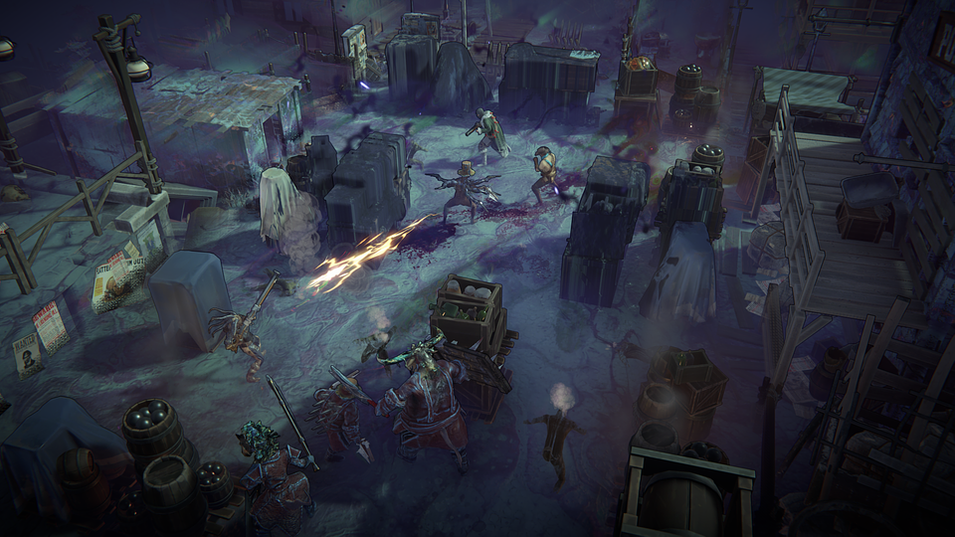

Nightmare Frontier – key features:

● Turn-Based Gun 'n' Slash – a combat system where every detail matters. Nightmare Frontier blends deep tactical gameplay with dynamic combat, using well-known and beloved mechanics from Ice Code Games' previous titles. Push enemies around the battlefield, use the environment to your advantage, chain skills, and get the most out of turn. Showcase your tactical creativity like never before.

● No risk, no reward – in the spirit of extraction looters, players walk the path that leads between risk and opportunity, deciding whether to push deeper into the dark city, risking everything, or retreat to safety and preserve their gains. The greater the risk, the more tempting the rewards – valuable items, resources, and upgrades that can alter the course of the game.

● Otherworldly terror – the titular Nightmare affects all aspects of gameplay – from shaping locations and challenges to the abilities of team members and enemies. Its growing power brings new challenges – every choice and battle is influenced by its increasingly strong presence.

● One more fight – Oversee your team, complete missions, and gather resources to forge powerful weapons. Explore the Nightmare and its dark capabilities by sending your team on dangerous raids into the devastated city, where every step deeper brings you closer to uncovering terrifying secrets.

● Crafted by veterans – Nightmare Frontier builds upon refined and highly praised mechanics known from Hard West 2 (including the famous Bravado), as well as the innovative approach to melee combat showcased in Rogue Waters. Thanks to their previous projects, Ice Code Games has earned a reputation as experts in tactical turn-based games.

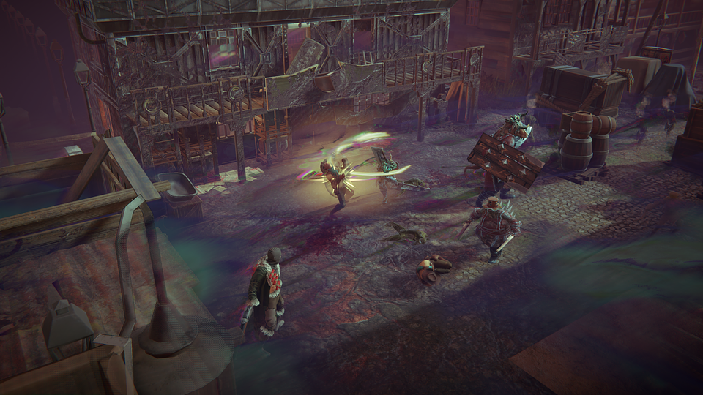

Nightmare Frontier will immerse players in the dark events of the West Coast this summer. Anyone interested in the game can wishlist it on Steam. More details about Nightmare Frontier can be found on the official game website and on social media - Facebook, Bluesky and X.

From May 8th to 11th, Ice Code Games will showcase Nightmare Frontier at PAX in Boston at the Games From Poland booth (number: 15078). A demo version will soon be available on Steam.

Full press kit is available HERE.

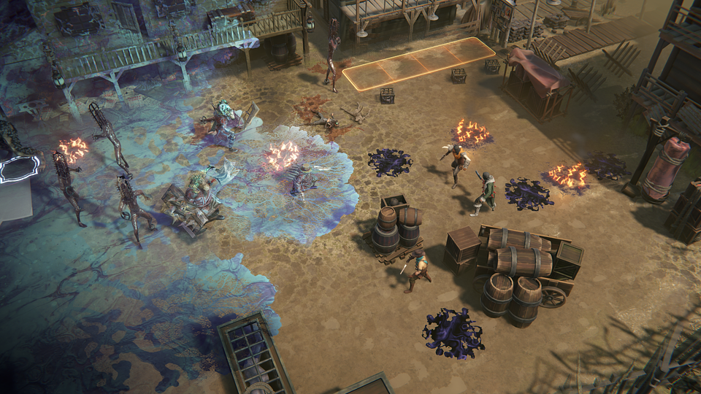

About Ice Code Games:

Ice Code Games is an independent studio based in Warsaw, Poland, best known for the award-winning Hard West 2 and Rogue Waters, released in 2024. The studio specializes in developing strategy, turn-based, and tactical games, and is currently working on a new project titled Nightmare Frontier. At the same time, it is conducting a research and development initiative focused on expanding the use of machine learning in the game testing and balancing process. More details about the company can be found on its official website.

