Sennheiser presents business and education solutions at InfoComm 2021
Audio manufacturer confirms show attendance, highlighting technology for the ultimate hybrid meeting and lecture experience

Wedemark, October 11, 2021 – One of the largest and most exciting industry events in North America, InfoComm returns to Orlando (FL) on October 27-29. The trade event not only offers Sennheiser a welcome platform to show its exciting portfolio of business and education solutions but is also an opportunity to affirm its support of the AVIXA organization during these difficult times. Balancing safety with an enthusiasm to meet customers in person again, the audio specialist has decided to downsize its booth and forgo any active demonstrations to contribute to a safe event. On the Sennheiser booth, visitors will be able to see Sennheiser’s TeamConnect Ceiling 2 beamforming microphone array, the app-based wireless microphone system Evolution Wireless Digital, MobileConnect wi-fi based assistive listening system, and the company’s workhorse SpeechLine Digital Wireless microphones.

Hybrid meetings and seminars continuously on the rise
Just over a year ago, very few people used the term ‘hybrid meeting’ or even ‘hybrid lecture’. Nowadays, such hybrid events have become the new norm for many businesses and education establishments who see added opportunities with the inclusion of remote participants beyond the constraints of a pandemic. On its booth, Sennheiser will showcase the TeamConnect Ceiling 2 (TCC2) beamforming microphone, a tool that makes hybrid meetings a place where people can connect and unfold their creativity and productivity together. TCC2 not only reliably picks up a speaker no matter where they are moving within the room, but also caters to voice-lift applications for larger rooms via its TruVoicelift function.

“The biggest challenge with going hybrid is being able to freely interact with each other and hear each other well, no matter whether you are an online or on-site participant,” says Jens Werner, Portfolio Manager Business Communication at Sennheiser. “TeamConnect Ceiling 2 meets all of the associated challenges: It ensures ‘touchless audio’ and best-in-class in-room amplification. People can keep a safe social distance and hear everything that is being said at the far end of a room.”

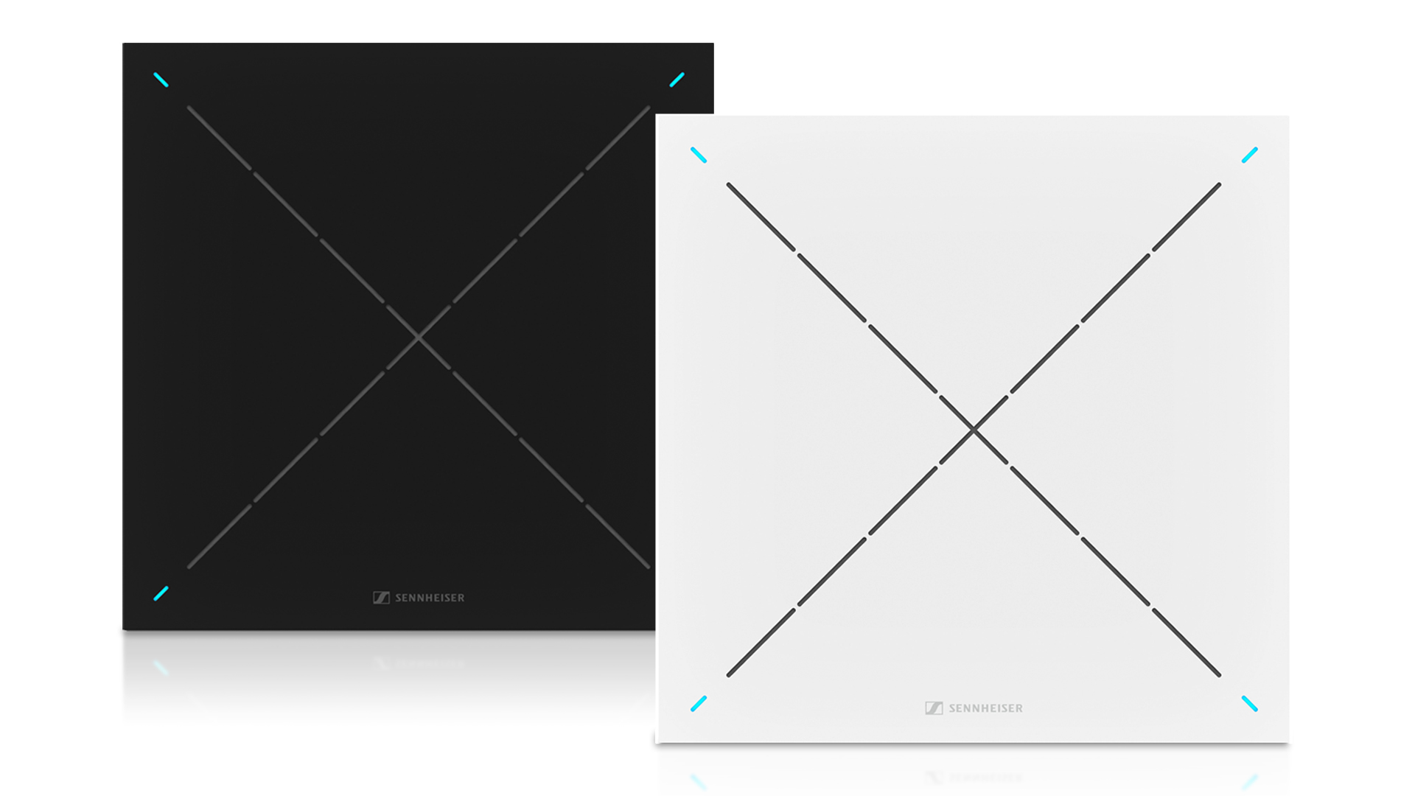 | TeamConnect Ceiling 2 offers automatic, adaptive beamforming for reliable speech pick-up and a TruVoicelift function for in-room audio amplification

TCC2’s TruVoicelift is able to deliver higher gain before feedback, includes a feedback prevention function and pre-definable audio threshold, as well as ‘advanced exclusion zones’ for eliminating noise sources and a ‘priority zone’ for a consistent audio pick-up.

Going wireless
SpeechLine Digital Wireless, Sennheiser’s networkable microphone system for campus-wide audio with central monitoring capabilities, will also be on show, as will Evolution Wireless Digital (EW-D). The latter is ideal for corporations and education facilities that are not in need of a fully scaled, networked and centrally monitored system, but are looking for a straightforward and versatile wireless microphone solution. Introducing an easy, app-based workflow, EW-D retains all the professionality, multi-channel capability and reliability that users have come to expect of Sennheiser’s UHF and 1G8 microphones.

Evolution Wireless Digital transmitters feature an input dynamic range of 134 dB, five times more than the usual 120 dB, enabling it to pick up anything from a very soft whisper to a jet engine at 50 yards’ distance. Borrowing tech from Sennheiser’s top Digital 6000 and Digital 9000 series, EW-D does not generate any significant intermodulation products, so more channels can be accommodated in a given frequency window. The systems have exceptional specs in every detail, be it a low latency of 1.9 milliseconds and a transmitter battery life of up to 12 hours with the BA 70 rechargeable battery pack, or the bandwidth of 56 MHz with up to 90 channels per band, which makes it easy to find space even in crowded RF environments.

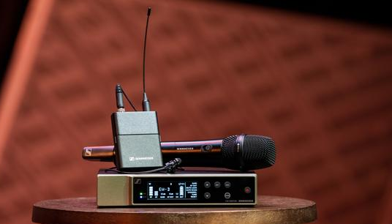 | Evolution Wireless Digital offers easy, app-controlled wireless

Transforming university experiences with MobileConnect
With tens of thousands of hearing-impaired students attending universities globally, it is imperative to create an atmosphere where assistive listening systems can help break audio barriers and make learning truly inclusive.

MobileConnect is a BYOD solution for assistive listening that overcomes the limitations of traditional technology | 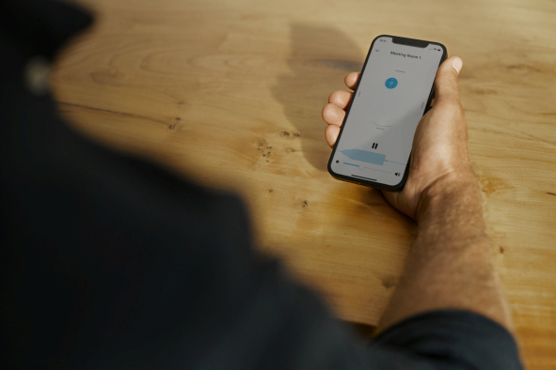

Often, limitations of traditional assistive listening technology can be a significant hurdle for hearing-impaired students, diminishing their listening experience and unnecessarily highlighting disabilities. By contrast, assistive listening over Wi-Fi as offered by MobileConnect overcomes these limitations: Students are able to hear their instructors’ lessons in crystal-clear audio using their own mobile phones as receivers, while professors can lecture with full confidence that all students are hearing critical lesson points and can fully participate in discussions.

Sennheiser is very much looking forward to welcoming you at InfoComm, Orlando (FL), Orange County Convention Center, West Concourse, October 27 to 29.

(Ends)

The images accompanying this press release can be downloaded here.

About Sennheiser
Shaping the future of audio and creating unique sound experiences for customers – this aim unites Sennheiser employees and partners worldwide. The independent family company, which is managed in the third generation by Dr. Andreas Sennheiser and Daniel Sennheiser, is today one of the world’s leading manufacturers of headphones, loudspeakers, microphones and wireless transmission systems. In 2020, the Sennheiser Group generated turnover totaling €573.5 million. www.sennheiser.com

Global Press Contact

Stephanie Schmidt
Stephanie.schmidt@sennheiser.com
+49 (5130) 600 – 1275

