RICKY SKAGGS DELIVERS TIMELESS PERFORMANCES WITH SENNHEISER DIGITAL 6000 AT 2018 CMA AWARDS
Country Music Hall of Famer and Next Generation Artists Depend On Sennheiser for Outstanding Wireless and Clarity
Nashville, November 15, 2018 – The 52nd Annual Country Music Association (CMA) Awards rounded up some of the biggest names in country music for an evening of memorable performances. Millions of viewers tuned in to watch the awards carrying country music's highest honors and to listen to heartfelt performances by their favorite artists. Sennheiser and Neumann wireless microphones performed flawlessly throughout the evening and were used by country music legend Ricky Skaggs, as well as Kelsea Ballerini, Luke Combs and pop music singer/songwriter Bebe Rexha.
Ricky Skaggs: Coming Home on a Sennheiser Digital 6000
The evening featured a performance by multiple Grammy Award-winning artist Ricky Skaggs, on a Sennheiser Digital 6000 wireless system coupled with a Neumann KK 204 cardioid capsule, which was also used by his entourage of backup singers. Skaggs, who was recently inducted into the Country Music Hall of Fame, as well as the International Bluegrass Music Association (IBMA) Bluegrass Music Hall of Fame, had an all-acoustic lineup featuring his bluegrass band Kentucky Thunder. They performed a heartfelt rendition of the old-time standard "Black Eyed Suzie," before moving into some of his own country music hits.

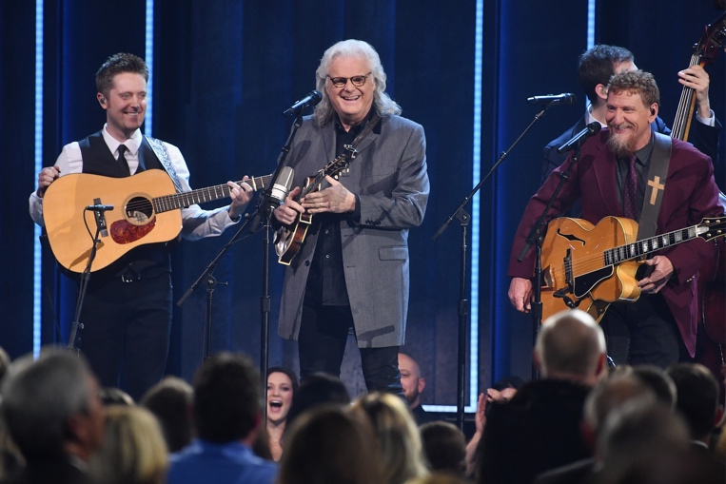 | Ricky Skaggs performs onstage during the 52nd annual CMA Awards. (Photo by Erika Goldring/WireImage)

A longtime advocate of Neumann microphones, Skaggs also relied on a Neumann TLM 49 to capture his signature mandolin sound. His band was also outfitted with Sennheiser and Neumann products, including the Sennheiser e 914 and Neumann KM 184, which were chosen to transparently reproduce the accompanying acoustic guitars; an additional Neumann TLM 49 was used with the banjo, as well as a Neumann KMS 104 for fiddle.

Skaggs' drummer — relying on Sennheiser e 904 and e 902 microphones on toms and kick drums, respectively, as well as Neumann KM 184 overhead mics — then revved up the medley, ushering in a full acoustic and electric band for a performance of some of Skaggs' iconic country hits. Joined first by Keith Urban, plus John Osborne the from Brothers Osborne, for a rendition "Highway 40 Blues," Skaggs' set crescendoed into a performance of "Country Boy," as he was joined by country music stars Brad Paisley and Marty Stuart, as well as young musicians Carson Peters, Sierra Hull, and Justin Moses.

When it came to choosing the mics Skaggs would use for the CMA Awards, his tour manager and monitor engineer Grant Hartford said that Sennheiser and Neumann were the ideal choice, in terms of both reliability and transparency. "Ricky is very well acquainted with audio equipment, and he's got a long history with Neumann because of the build quality and sound quality of each mic," Hartford said. "He's been a longtime user of Neumann on the stage, as well. A big part of our sound on the road comes from the Neumann mics, both on his vocals and especially the mandolin, with the TLM 49, which helps him to get a good bark and chop out of his mandolin playing. It's just always been a part of our workflow."
Country Music's Next Generation Chooses Sennheiser
The CMA Awards also featured performances by country music's next generation of artists, including New Artist of the Year winner Luke Combs, who used a Sennheiser SKM 5200 handheld transmitter coupled with a Neumann KK 104 microphone capsule for his performance of "She Got The Best Of Me," and Female Vocalist of the Year nominee Kelsea Ballerini, who performed her hit "Miss Me More" using a Sennheiser Digital 6000 wireless system and MD 9235 capsule combination.

In addition to the evening's memorable country music performances, Sennheiser was featured prominently throughout the CMA Awards. Pop music artist Bebe Rexha, whose co-writing credits on the song "Meant To Be" with Florida Georgia Line have earned her two nominations, performed the song using a Sennheiser Digital 6000 wireless system and MD 9235 capsule combination.

All in all, it was another memorable awards ceremony for both the performers and audience, with Sennheiser wireless and wired microphones delivering outstanding clarity, reliability and audio quality throughout the entire evening.

Please visit www.sennheiser.com for more information.

About Sennheiser
Shaping the future of audio and creating unique sound experiences for customers – this aim unites Sennheiser employees and partners worldwide. Founded in 1945, Sennheiser is one of the world’s leading manufacturers of headphones, microphones and wireless transmission systems. With 21 sales subsidiaries and long-established trading partners, the company is active in more than 50 countries and operates its own production facilities in Germany, Ireland, Romania and the USA. Since 2013, Sennheiser has been managed by Daniel Sennheiser and Dr. Andreas Sennheiser, the third generation of the family to run the company. In 2017, the Sennheiser Group generated turnover totaling €667.7 million. www.sennheiser.com

About Ricky Skaggs
Earning 12 #1 hit singles, 15 GRAMMY® Awards, 13 IBMA Awards, nine ACM Awards, eight CMA Awards (including Entertainer of the Year), two Dove Awards, the ASCAP Founders Award, three honorary Doctorate degrees, inductions into the Country Music Hall of Fame, IBMA Bluegrass Music Hall of Fame, National Fiddler Hall of Fame, Musicians Hall of Fame and GMA Gospel Music Hall of Fame, the 2013 Artist-In-Residence at the Country Music Hall of Fame® and Museum, an Americana Music Association Lifetime Achievement Award in the Instrumentalist category along with countless other awards, Ricky Skaggs is truly a pioneer of Bluegrass and Country music. Since he began playing music more than 50 years ago, Skaggs has released more than 30 albums and has performed thousands of live shows. He started his own record label, Skaggs Family Records, in 1997 and has since released 12 consecutive GRAMMY®-nominated albums. His latest release, Hearts Like Ours, with his wife, celebrated artist Sharon White of The Whites features the couple dueting on handpicked country love songs. And the Grand Ole Opry member has released his first-ever autobiography, "Kentucky Traveler." The book details the life and times of Skaggs and provides a descriptive history of Country and Bluegrass music, as told by the master himself. In addition to his regular touring schedule with his band, Kentucky Thunder, he has performed a string of dates with his better half Sharon White along with guitar legend Ry Cooder on the critically-acclaimed "Cooder-White-Skaggs" tour and from time to time hits the road with versatile singer/songwriter and pianist Bruce Hornsby on another critically-acclaimed tour, "Ricky Skaggs & Bruce Hornsby with Kentucky Thunder." Most recently, Skaggs has added Country tour dates as he plugs in and plays full shows of his chart-topping hits.

Local Contact Global Contact

Jeff Touzeau Stephanie Schmidt
jeff@hummingbirdmedia.com stephanie.schmidt@sennheiser.com
+1 (914) 602-2913 +49 (5130) 600 – 1275

