For more information, please contact Marta de Paco
On +34 670 780 664 or email press@comunicahair.com

Important:
These images are only available for editorial content.
Credits must be included.
Notification of their publication is expected.

IVAN RODRÍGUEZ
MÉXICO
Geometrik Collection

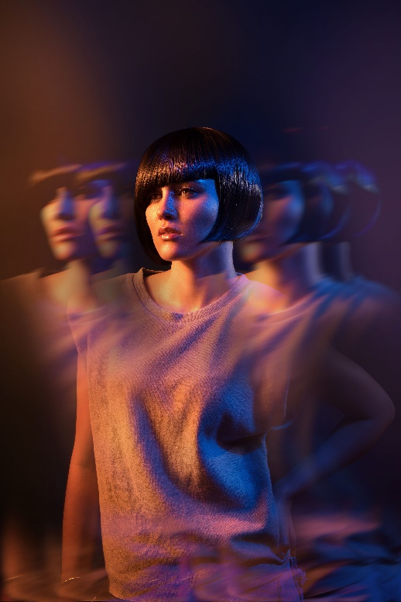
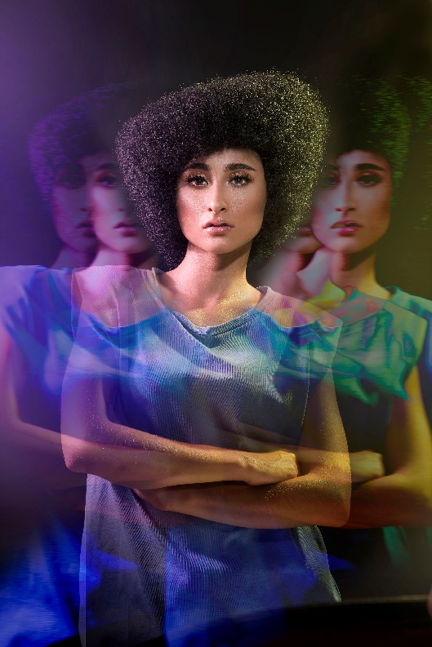
Hair: Ivan Rodríguez @ivanrohair
Photography: Luis Arzate @luissarzate
Make up: Thessa Peralta & Greg del Toro @thessaperalta_mua
Styling: Ivan Rodríguez

#ivanrohair #ivanrodriguezhairdresser

IVAN RODRÍGUEZ
MÉXICO
Geometrik Collection

Geometry measures the relationship of an object in space, and following the footsteps of two masters, that of geometry, the Greek Euclid, and that of straight hairlines, Vidal Sassoon, this collection reflects on our relationship with our environment through them. Straight lines that move in a block or slide in asymmetries to let the light show all the nuances on hair dominated by solid colors. A masterful exercise of precision in which measurements seem to reproduce the hidden world of mathematics, what concerns us with ourselves and with others

