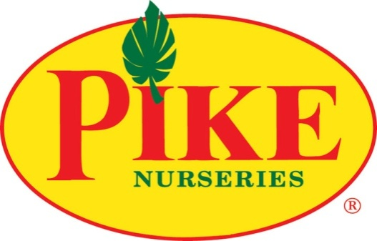

For more information
Laurel Haislip/Becca Meyer
BRAVE Public Relations
404.233.3993
lhaislip@bravepublicrelations.com/
bmeyer@bravepublicrelations.com
FOR IMMEDIATE RELEASE
Pike Nurseries cultivates tips for cool, tasty harvest
Local garden center experts share cool weather veggies and fall gardening tips
ATLANTA (September 25, 2017) – Autumn has officially arrived! Lower temperatures usher in the perfect time for fall planting, as many veggies thrive in cooler weather. For gardening beginners and seasoned green thumbs alike, Pike Nurseries has expert advice to kick start cool weather veggies for backyard beds and container gardens alike.
Most fall veggies and herbs need at least six hours of sunlight per day, along with rich soil to produce the tastiest produce. When planting in the garden and raised beds, amend the native garden soil at a 50/50 ratio with an organic vegetable planting soil. Be sure to use potting soil for veggies growing in containers and hanging baskets!
Veggies That Keep Their Cool
- Lettuce
Lettuce is an excellent cool weather veggie that everyone will enjoy! An ideal plant for containers gardens due to its shallow roots, lettuce comes in many varieties, including romaine, butterhead and red leaf. Plant a mix of varieties to ensure salad never gets boring and simply snip off outer leaves to allow the center leaves to keep growing for future harvests. Stagger planting and harvesting for best results all season long!
- Spinach
Spinach is the perfect addition to any salad, smoothie or even casserole! It’s an adaptable veggie, able to handle the cold and frost, and can even grow in containers due to its shallow roots. While a spinach plant prefers full sun, it is one of the few vegetables that can adapt to partial sun as well. It’s best to harvest spinach when the leaves are young; they will get bitter as they mature.
- Kale
Ah kale, the delicious and healthy supergreen. Kale chips, salads and dinner sides - the list goes on. In the garden, kale is a hardy vegetable that is tolerant of the cold and frost. Gardeners will also love how simple it is to harvest: once the leaves grow to about the size of a hand, it’s time to enjoy. The outer layer goes first, leaving the inner layers to keep on giving.
- Cabbage
While cabbage needs a bit more care and regular fertilization, it’s the perfect addition to cozy fall meals. Avoid growing cabbage beside broccoli and cauliflower, because they are all heavy feeders and will deplete soil nutrients faster together. Cabbage is ready to harvest when the head appears nice and firm.

(More)

- Broccoli
Broccoli is a delicious and versatile addition to many recipes. Broccoli grows best with regular fertilization, plenty of water (only around the soil) and lots of sunlight! It’s ready to harvest when the buds of the head are firm and tight. When cut at an angle, broccoli will sprout side shoots for additional harvesting well into fall.
- Cauliflower
Cauliflower is the perfect staple in fall dishes, even though it may need a little extra TLC. Cauliflower must be consistently watered and kept away from both extreme hot and cold temperatures. This plant grows a bit slower, but once the heads are six to eight inches in diameter and are firm, white and tight, they are ready to be harvested!
- Onions
Onions are the universal veggie for almost any cuisine and any season! They are planted as bulbs, in either white, yellow or red, and come in a variety of sizes. Onions are a heavy feeder and require regular fertilization in order to produce big bulbs. If scallions sound more savory, a simple trick is to harvest immature onions!
- Herbs
Herbs don’t end with summer - many thrive in cooler weather. Spice up autumn dishes with some delicious herbs, including parsley, thyme, oregano, sage, rosemary, chives and cilantro. Plant in pots on the patio for easy access while stirring up culinary creations in the kitchen!

For more tips on growing fall edibles, customers can visit the experts at Pike Nurseries’ 17 locations to learn how to plant and care for the delicious harvest. For information on locations and other gardening needs, visit PikeNursery.com.

ABOUT PIKE NURSERIES
Ever committed to its customers’ gardening success, Pike Nurseries takes pride in taking the guesswork out of gardening and helping its customers play in the dirt. Offering superior knowledge, quality and selection in a friendly, caring environment, Pike Nurseries has been an Atlanta icon for over 50 years. Founded in 1958 by Pete Pike, its ability to adapt to market conditions and community needs has made it a respected Southern institution. As Atlanta’s oldest garden chain, Pike Nurseries has 17 retail locations in the Atlanta, Ga. and Charlotte, N.C. areas. Now led by CEO Mike Kunce, Pike Nurseries looks forward to continued growth as it keeps Atlanta and Charlotte beautiful, one landscape at a time.
Visit Pike Nurseries on Facebook, Twitter, Pinterest and Instagram.

# # #

