Embargoed until 1 June 2020, 10 a.m. CEST

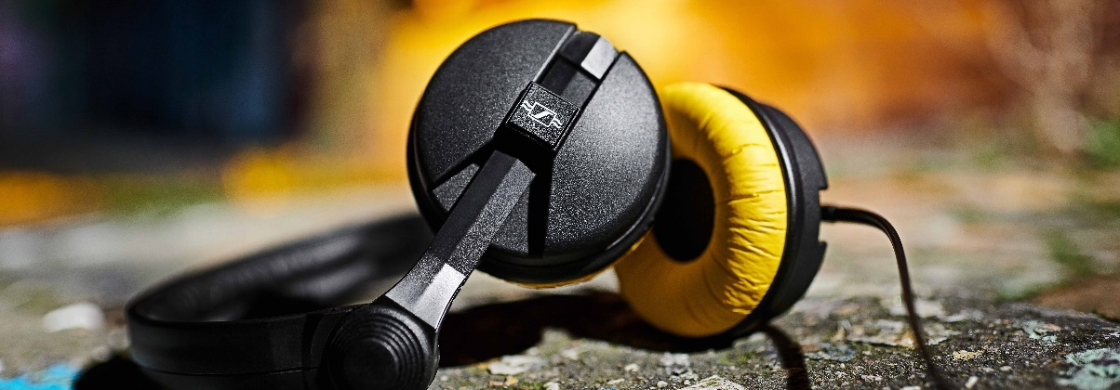Anniversary offer

The HD 25 – A legend at the DJ decks and in monitoring

Wedemark, 1 June 2020 – A very special anniversary deal is waiting for you in June, Sennheiser’s birthday month: The HD 25, Sennheiser’s legendary monitoring and DJ headphones, will be available for only EUR 99 (MSRP) / USD 99.95 (MAP) instead of EUR 149 (MSRP) / USD 149.95 (MAP). Even better, to celebrate the company’s 75th anniversary, anyone who orders the HD 25 in June has a chance of receiving a limited-edition version of the headphones instead. You have to be lucky, as there are just 25,000 HD 25 Limited Editions available worldwide. Please visit www.sennheiser.com/special-deals for a list of dealers offering the HD 25 price promotion.

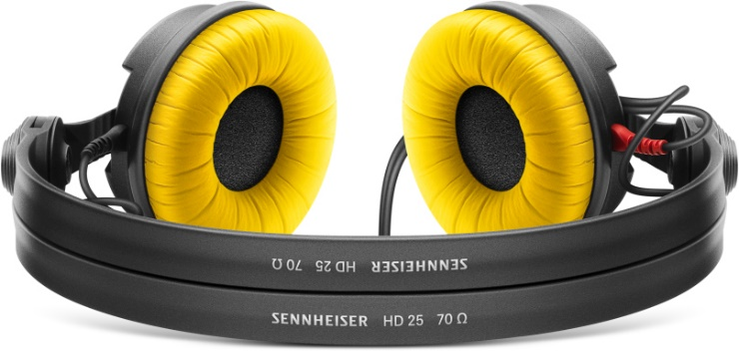 | The HD 25 monitoring headphones are on special offer during the month of June. If you are lucky, you will receive the Limited Edition model instead, which includes both black and yellow ear pads

For more than 30 years, the iconic HD 25 headphones have set a standard for professional monitoring applications – whether for outside broadcasting or in DJ booths the world over. As Sennheiser’s most successful professional headphones, the HD 25 are a legend in their own right.
For those that get lucky an HD 25 Limited Edition model will arrive when you order a standard HD 25 model. Besides the usual black earpads, the limited edition includes additional yellow earpads, inspired by the famous colors of another icon – Sennheiser’s HD 414, the world’s first open headphones. The HD 25 Limited Edition headphones also feature a retro Sennheiser logo on the earcups and come packaged in a box with a stylish retro sleeve.

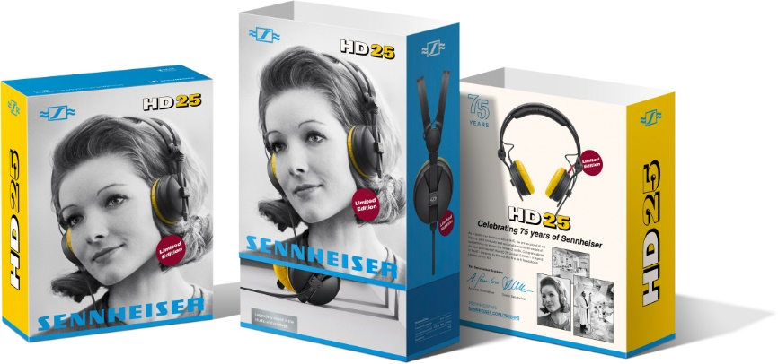 | Retro sleeve of the HD 25 Limited Edition

Watermelons and concordes – Must-see videos
Award-winning filmmaker Geert Verdickt has tested the legendary durability of the HD 25 in a series of scientific watermelon tests… don’t try this at home! https://www.youtube.com/watch?v=nGukxejLEM4

Interested in how the HD 25s made their way from outside broadcasting to the DJ booth? Then watch https://www.youtube.com/watch?v=wB7Nhq5HQFA!

The images accompanying this press release plus additional photos can be downloaded at https://sennheiser-brandzone.com/c/181/i69x8RvW.

About Sennheiser
Founded in 1945, Sennheiser is celebrating its 75th anniversary this year. Shaping the future of audio and creating unique sound experiences for customers – this aim unites Sennheiser employees and partners worldwide. The independent family company, which is managed in the third generation by Dr. Andreas Sennheiser and Daniel Sennheiser, is today one of the world’s leading manufacturers of headphones, loudspeakers, microphones and wireless transmission systems. In 2018, the Sennheiser Group generated turnover totaling €710.7 million. www.sennheiser.com

Global Press Contact

Stephanie Schmidt
Stephanie.schmidt@sennheiser.com
+49 (5130) 600 – 1275

