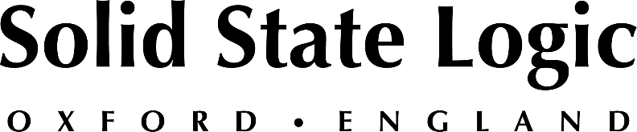

Solid State Logic to Host Music Production Sessions at NAMM’s Believe in Music Week Including SiX, Fusion, ORIGIN and SSL 2 & 2+ audio interfaces.

Product and application sessions will feature SSL experts demonstrating hybrid production techniques, desktop audio solutions, mixing live sound and much more

OXFORD ENGLAND, January 12, 2021 — Solid State Logic (SSL) announced it will be offering several music tool and application sessions at this year’s Believe in Music — NAMM’s new online digital event. The sessions — which run between Tuesday, January 19th and Friday, January 22nd — will cover SSL’s latest music and audio production tools including SiX, Fusion, ORIGIN, and the new SSL 2 / 2+ interfaces, as well as the cutting edge in SSL Live event space, installed sound and church production platform.

SSL invites you to join its team of experts along with some very special guests as we walk through product features and real-world application scenarios using our latest audio production tools. Following is a detailed description of each session, including dates and times:

- January 19th, 10:00 a.m. PST — SSL SiX Console and Fusion Audio Processor
Professional hybrid production at home with SSL SiX and Fusion
(hosted by SSL studio specialist Marc De George)

- January 19th, 2:00 p.m. PST — SSL 2 & SSL 2+ Audio Interfaces
Bringing Solid State Logic quality and performance to a new generation of creatives: why you should choose an SSL 2 / 2+ audio interface for your desktop (hosted by SSL studio specialist, Marc DeGeorge)

- January 21st, 2:00 p.m. PST — SSL ORIGIN Recording/Mixing Console – Famous mixing engineer Chris Lord-Alge will discuss his thoughts on the legendary SSL sonics and workflow of SSL latest in-line audio production console - ORIGIN. (hosted by SSL studio specialist, Fadi Hayek)

- January 22nd, 2:00 p.m. PST — SSL Live, Including New V4.11 Software
Join two live sound veterans — Simon Thomas (FOH Halsey, Mark Knopfler) and SSL’s Fernando Guzman — and get up to speed on how the SSL Live production platform is elevating theatres, event spaces and houses of worship to create a superior sonic experience. (Hosted by SSL Live Product Specialist, Fernando Guzman)

In addition to the live sessions, private meetings are available with SSL’s team of studio and live sound experts to discuss the best way to upgrade your sound.

For more information, to register or attend one of the above sessions or to schedule a private consultation, register here: https://attend.believeinmusic.tv/

###

Solid State Logic is the world’s leading manufacturer of analogue and digital audio consoles and provider of creative tools for music, broadcast, live and post production professionals. For more information about our award-winning products, please visit: www.solidstatelogic.com.

###
For further information contact:
Ross Gilbert
+44 (0) 1865 842300
rossg@solidstatelogic.com

