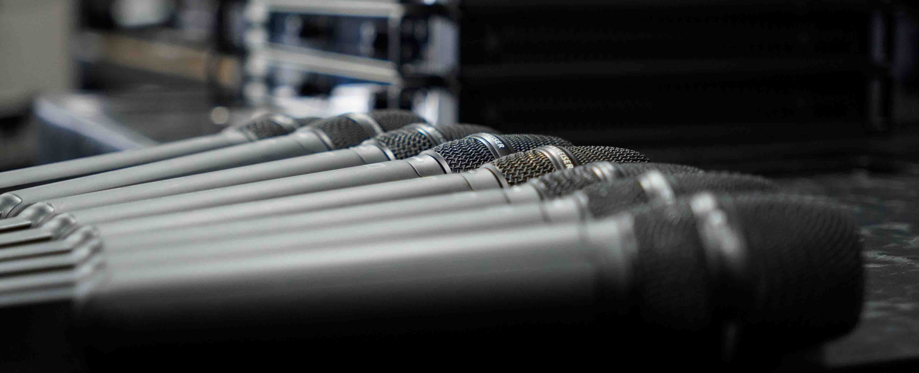

Sennheiser’s Digital 6000 Series introduced to Arxiduc Audio
PA company’s chief engineer relies on 6000 Series for its ability to bring vocals to the fore

Japan, 27 November 2025 – Founded in Yokohama in 2013, Arxiduc Audio has gained a reputation as a PA company providing comprehensive audio solutions for music, sports, gaming and corporate events. Since joining the company in February this year, Tokihiko Tokuda has served as chief engineer and is responsible for the sound design and operation of the company’s concert touring work.

Tokihiko Tokuda - Director / Chief Engineer at Arxiduc Audio | 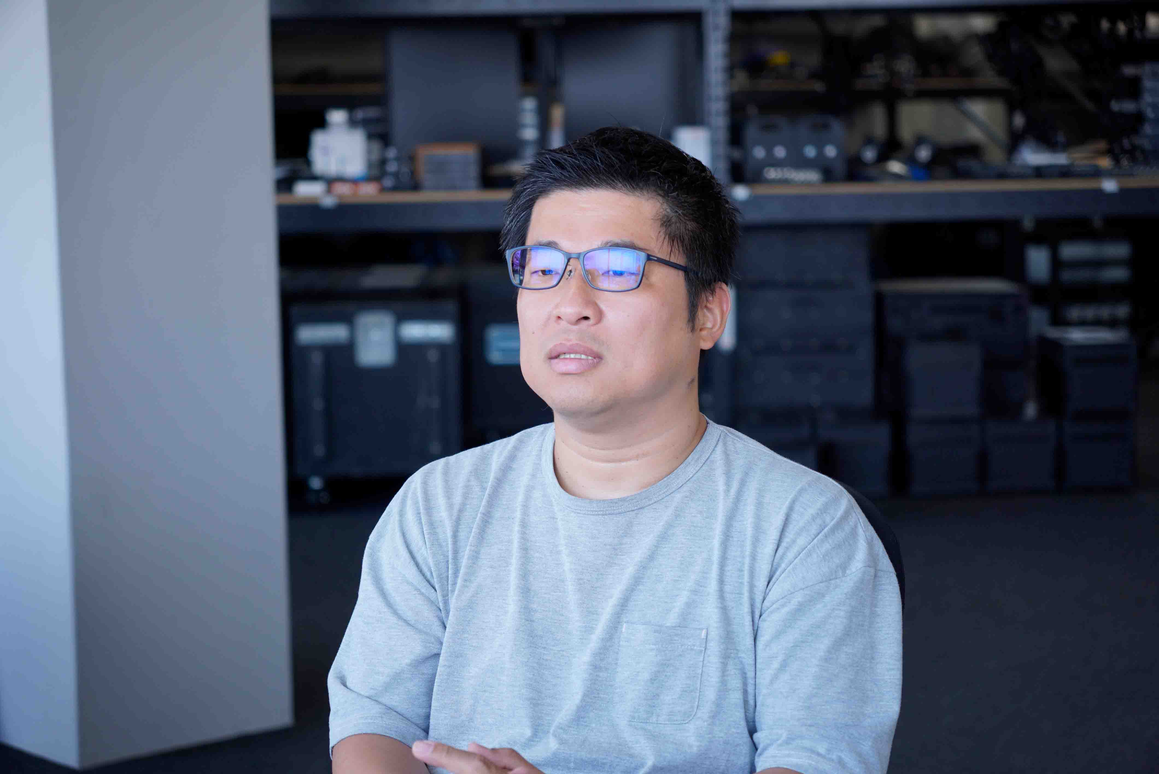

Tokihiko’s first experience using Sennheiser products goes back more than 20 years. "I think it was a 3050 Series IEM. I remember how amazing they sounded. It was the beginning of IEMs, and everything was groundbreaking.” He then used Sennheiser’s iconic 5000 Series and, later, the next-generation 5200 transmitters for live performances across a variety of genres for many years, before he made the switch to digital Sennheiser systems.

Sennheiser products are often requested for projects that Tokihiko is in charge of and so, in April 2025, he introduced the Digital 6000 Series at Arxiduc Audio.

Daiki Mori, sales manager at Bestec Audio, one of Sennheiser’s Japanese dealers, has been trusted by Arxiduc Audio for over a decade: “I strongly felt Tokihiko’s passion for Sennheiser when we demoed the 6000 Series to him,” he says. “We look forward to seeing this trusted product being used on even more of his projects.”

Sennheiser microphones bring vocals forward
Tokihiko cites the “proximity of the vocals” as a major reason for choosing the 6000 Series: “I think the reason why the 6000 Series is used so often in the NFL Super Bowl halftime show is because vocal proximity is so important. In the many live performances I work on, I often need to deliver the artist’s vocals more powerfully and clearly than in their recordings, so this sound quality is an essential element.”

He continues: “I think Sennheiser is extremely good at bringing vocals to the front of the mix. Increasing the volume to make vocals more audible is a common practice, but there is a difference between ‘increasing the volume’ and ‘bringing the sound to the forefront.’ Even if the volume is kept constant in the mix, due to the structure of the human brain if the sound ‘comes to the front’, we hear the sounds that are closer to us first. With Sennheiser, the sound naturally comes to the front, so there is no need to forcefully turn up the volume – achieving this presence is a breeze.”

Arxiduc Audio’s SMK 6000 handhelds with MMD 935-1 microphone capsules | 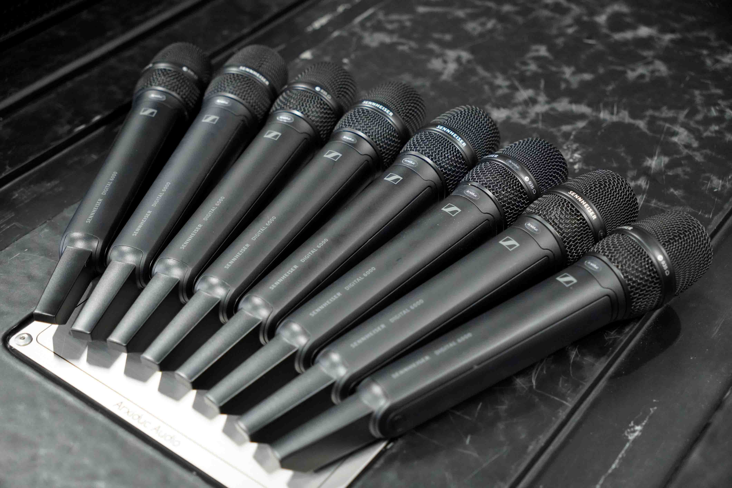

Tokihiko works on a wide range of events, from rock concerts to idol concerts and live hip-hop shows. Regardless of genre or size of venue he relies on the highly versatile MMD 935-1 microphone capsule. “I’ve been using the wired e 935 for many years, so I chose a similar model, the MMD 935-1, as my main microphone capsule. Particularly when there are multiple musicians, I use the MMD 935-1 because it varies little both in terms of compatibility and overall balance. Depending on the characteristics of the artist, I sometimes use an MM 445 or MM 435.”

Stable connectivity and diverse applications
Tokihiko says that a major appeal of the 6000 Series is its stable connectivity. “The live shows I work on can sometimes attract audiences of more than 10,000, and the larger the venue, the more difficult it is to manage the RF. We are often impacted by signals from mobile devices and LED screens. Even in such challenging environments, the 6000 Series maintains a stable connection, so we have no concern whatsoever. Being able to scan with the receiver is also an advantage. There are surprisingly few manufacturers that allow direct scanning with the receiver, but it’s convenient because it eliminates the need for additional equipment.”

Four EM 6000 DANTE 2-channel receivers and two L 6000 charging stations have been added to Arxiduc Audio’s inventory | 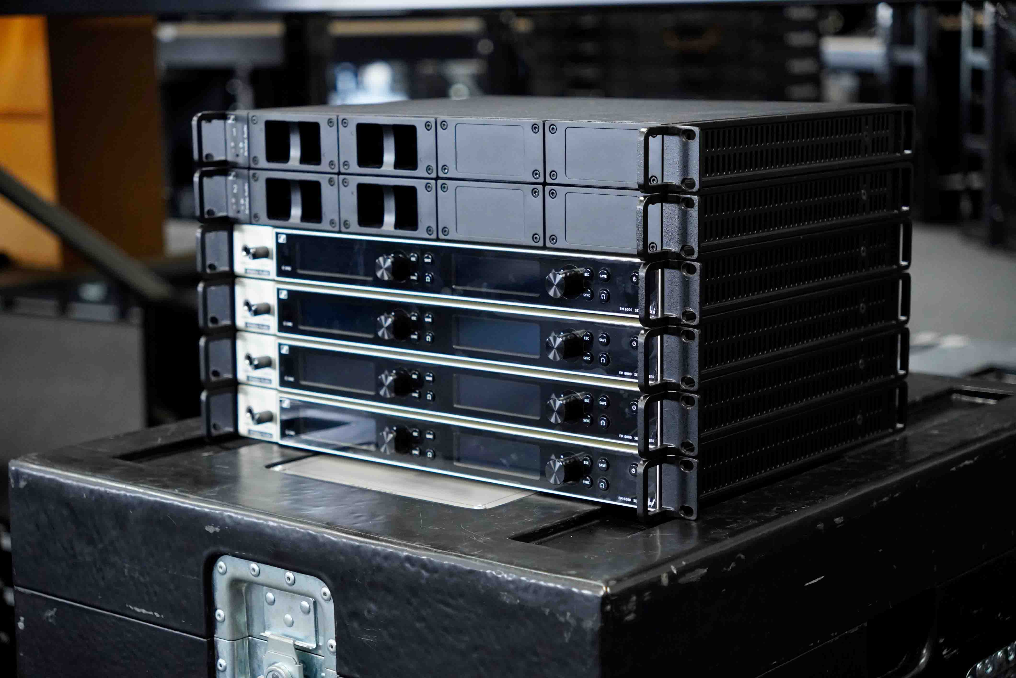

Tokihiko says that the introduction of the 6000 Series to Arxiduc Audio’s inventory will broaden the range of applications it can work on. “I’d like to try the SK 6212, a compact bodypack transmitter, with horn sections. During the 5200 series era, I always used the SK 5212 II P. When I attach microphones to the trumpets in the horn section, other manufacturers’ microphones are too large, and the artists have often complained that the size makes it difficult to play with them. Also, with trombones, the microphone body is secured in place with tape, but some musicians have pointed out that if it’s too heavy, it can affect posture during performance and the performance itself. That is why I’m thinking a compact, lightweight model would be ideal.”

Expectations for the next-generation wireless SPECTERA
Tokihiko also has high expectations for Spectera, the world’s first wideband bidirectional digital wireless ecosystem that Sennheiser launched in 2024. “I think we can expect a great deal from the stability of the signal and ease of planning, and I’m keeping an eye on reports of projects it’s being used on so I can hear what other engineers think of it.”

(Ends)

The high-resolution images accompanying this media release can be downloaded here.

About Arxiduc Audio
Founded in Yokohama in 2013, Arxiduc Audio is a PA company that sets up and operates sound equipment for a wide range of events, including stadium music events, gaming, sports, and corporate conferences. The group has three companies in Japan and one each in Taiwan and Thailand and is actively involved in concert business both in Japan and overseas.
https://arxiduc.jp/

About the Sennheiser Brand – 80 Years of Building the Future of Audio
We live and breathe audio. We are driven by the passion to create audio solutions that make a difference. This passion has taken us from the world’s greatest stages to the quietest listening rooms – and made Sennheiser the name behind audio that doesn’t just sound good: It feels true. In 2025, the Sennheiser brand celebrates its 80th anniversary. Since 1945, we have stood for building the future of audio and bringing remarkable sound experiences to our customers. While professional audio solutions such as microphones, meeting solutions, streaming technologies and monitoring systems are part of the business of Sennheiser electronic SE & Co. KG, the business with consumer devices such as headphones, soundbars and speech-enhanced hearables is operated by Sonova Holding AG under the license of Sennheiser.
www.sennheiser.com
www.sennheiser-hearing.com

Sennheiser Press Contact
Teruishi Nagatomi
Teruishi.Nagatomi@sennheiser.com
+81 364068911

